Generation Life Investment Bonds
Adviser & Paraplanner Handbook
LifeBuilder
ChildBuilder
FuneralBond



July 2023

Contents

Contents 2
Important information 3
Instructions 3
About Generation Life 4
About Generation Life investment bonds 4
Who are investment bonds suitable for? 11
Client needs, goals and objectives 13
Strategy Text 15
Invest into a Generation Life LifeBuilder investment bond 16
Invest into a Generation Life LifeBuilder using the Bonds Custodian Trust 19
Withdraw from super and / Invest into a Generation Life LifeBuilder investment bond 21
Invest into Generation Life FuneralBond 25
Invest into a Generation Life ChildBuilder Investment bond on behalf of your child/grandchild 27
Invest into a Generation Life LifeBuilder investment bond on behalf of your child/grandchild 29
Make regular withdrawals from your investment bond 32
Make regular contributions into your Generation Life investment bond 33
Use the Automatic Rebalance facility in your investment bond 34
Rebalance your investment bond’s portfolio 35
General transactions 36
Investment allocation 36
Projection/Modelling Assistance (Xplan) 38
Investing in an Investment bond 38
Withdrawing / Transferring the total amount of an Investment bond after 10 years 38
Withdrawing / Transferring the total amount of an investment bond before 10 years 39
Adding a LifeBuilder investment bond within a Bonds Custodian Trust (BCT) 42
Adding a Funeral Bond 43
Aged Care Calculations 43
Product Cost Tables 44
Alternative strategy and product types 46
Appendix 1: References material 47
Appendix 2: Suggested fact-finding questions 48
Appendix 3: Flowcharts 50
Appendix 4: LifeBuilder or ChildBuilder? 52

Important information
The product description and sample wording below have been prepared by Generation Life Limited (‘Generation Life’) ABN 68 092 843 902 AFSL 225408 as a guide only to assist you in developing your own Statement of Advice (SoA) when offering Generation Life investment bond products to your clients.
This information may not be considered complete as it does not consider your clients’ personal situation, needs or objectives – it is your responsibility to consider these aspects when formulating the SoA for your clients. Before making an investment decision or tendering of advice based on anything in this document, you need to consider, whether any general advice in this document is appropriate to the particular investment needs, objectives and financial situation of the person/s making the investment and/or receiving the advice.
This document may contain general advice in relation to financial products. Generation Life is not authorised to provide personal advice and accordingly has not considered any individual person’s financial situation, need or objectives. Generation Life is not responsible for any personal advice you provide, even if it is based on this document.
It is important to note that some product features may not be fully explained, some words or phrases have a specific meaning and rules may apply to the availability of certain features and options. For these reasons, this SoA should be used in conjunction with the terms and conditions set out in the Generation Life Investment Bonds Product Disclosure Statement (PDS)
Should you choose to use all or part of this template to fit with your particular SoA, this is at your discretion. The law applying to SOAs is subject to amendment and reinterpretation at any time. This document is based on information from the Generation Life Investment Bonds PDS.
The document contains references to financial products issued by Generation Life in its capacity as a life insurance company under the Life Insurance Act 1995 and as the issuer of the interests in Generation Life Investment Bonds. This document does not constitute an offer of interests in the Investment Bonds. Such offers will only be made in a copy of the PDS and anyone wishing to acquire interests in the Investment Bonds will need to complete the application form accompanying the PDS.
Generation Life believes that any advice and information in this document is accurate and reliable, but no warranties of accuracy, reliability or completeness are given (except insofar as liability under any statute cannot be excluded). No responsibility for any errors or omissions or any negligence is accepted by Generation Life or any of its directors, employees, or agents.

Instructions
This document provides an example of wording that can be inserted into an SoA to explain the benefits of the product and why it has been recommended. Fees are not included in this template and should be included in the fee disclosure section of the SoA.
The wording is provided as a guideline and advisers should seek guidance from their own compliance area to ensure all licensee and ASIC requirements have been met.
You should read carefully any text taken from these samples and ensure that the context in which it is used is appropriate for your client’s circumstances.
Individual client information/circumstances should be inserted where <indicated> and advisers should ensure non relevant insertion <indicators> are deleted.
In some sections, there are several options for wording to allow advisers to tailor the advice to the client’s circumstances. Instructions for tailoring are shown in blue text and in [brackets]. Advisers should insert their own details or delete any sections that do not apply to the advice given, as well as delete the instructions. In some cases, advisers may need to modify or provide additional wording to suit the client’s unique circumstances.
The samples are not exhaustive and other circumstances and strategies for Generation Life Investment Bonds may not be covered by this document.
The ‘About Generation Life investment bonds’ section can be inserted whole or in part into relevant sections of an SoA.

About Generation Life
We understand that finding the right investment partner is important to you. As the pioneer of Australia’s first truly flexible investment bond, Generation Life has been at the forefront of providing innovative tax-effective investment solutions since 2004. As an innovation led business, Generation Life constantly strives to enhance its products and processes to optimise after-tax investment performance for its investors.
Generation Life is a leading specialist provider of tax optimised investment and estate planning solutions – managing over $2.3 billion on behalf of its investors as at 31 December 2022. Generation Life is a regulated life insurance company and its parent company is listed on the Australian Securities Exchange. Generation Life’s focus is to continue to provide Australians with market leading tax-effective investment solutions that provide a flexible investment alternative to meet both their personal and financial goals.
Their investment solutions are designed to help you grow your wealth, meet your day-to-day investment needs and to help you plan for your future needs including the transfer of wealth to the next generation.

About Generation Life investment bonds
[This section can be inserted whole or in part into relevant sections of an SoA]
Investment bonds (sometimes referred to as insurance bonds) are a long-term investment vehicle that can offer a tax effective way of accumulating wealth for some investors.
Investment bonds provide access to a range of underlying investment options which allows you to adopt an investment strategy consistent with your investment preferences and risk tolerance. Income and growth on the underlying investments is not distributed to investors, but is instead reinvested within the investment bond. This can also help with managing personal tax liability and income levels.
Investment bonds have been designed to be held for at least 10 years in order to provide the optimal maximum tax advantage. However, there is no requirement to hold the investment for that period, with access to funds available at any time.
An investment bond is a type of life insurance investment contract, which means there will be an investment bond owner (investor) and a life insured (which can also be the investment bond owner). Similar to superannuation, beneficiaries can also be nominated (including entities such as companies) to receive the investment bond’s proceeds in the event of the death of the life insured.
An investment bond can help with estate planning and providing for the next generation, including children and grandchildren. In some cases, you also have the flexibility to transfer the investment bond as a whole to another person or entity in the event of the death of the bond owner or at a future nominated date.
An investment bond can provide a tax effective and social security friendly way of funding future funeral expenses through a special type of investment bond called a funeral bond.
The following general information describes the key advantages of Generation Life’s investment bonds and highlights some important factors you should be aware of when considering our advice.

Tax advantages
Investment bonds are tax-paid investments where tax on the investment bond’s earnings are paid by Generation Life at a maximum tax rate of 30%, rather than your personal marginal tax rate - these earnings do not contribute to your personal income.
From year to year, the actual tax paid by an investment bond can be less than 30% depending on the asset class invested in. This is because of the favourable effects of imputation and foreign tax credits and tax provisioning undertaken for your investment. The amount of tax paid can also be reduced based on the level of assessable income generated by our investment bonds.
The returns and performance from Generation Life investment bonds are provided on an after- tax basis – unlike other investments such as managed funds, shares, and term deposits where the returns received are before the deduction of tax at your marginal tax rate. Over the long term, the compounding effect of a potentially lower tax rate on your earnings can be significant when compared to other direct investment options such as bank accounts, shares, or managed funds where tax on earnings is paid by the investor directly at their marginal tax rate.

After-tax investment outcomes
Generation Life’s investment bonds are designed to provide a highly tax-efficient investment outcome for investors with three levels of tax efficiency available:
- Tax Advantage – The foundation of Generation Life’s tax effective investment approach, essential to maximising investment returns. The Tax Advantage level offers the core benefits of the investment bond’s tax structure where ongoing earnings are taxed within the investment bond at a maximum tax rate of 30%. These earnings are not included as part of an investor’s personal assessable income, irrespective of their marginal tax rate.

- Tax Enhanced – An enhanced tax aware investment and trading approach that aims to improve after tax returns. The Tax Enhanced level is designed to carefully manage how the underlying investments are bought and sold within a pooled investment arrangement where investments are held in underlying managed funds.

- Tax Optimised – The pinnacle of our tax aware investing process designed to maximise performance on an after-tax basis. The Tax Optimised level generates tax efficiencies by structuring the holding of the investment through direct ownership of the underlying assets (rather than through a pooled investment arrangement). This level of tax aware investing is designed to maximise after-tax return outcomes and optimise the full benefits of the investment bond tax structure through the direct acquisition and sale of the underlying investments in a tax efficient manner.

Expected long term tax outcomes
The level of additional tax efficiency able to be generated for an investment option will be determined by the type of underlying assets held by the investment option. Generally, the higher the level of capital growth that an investment option is expected to deliver, the greater the potential to generate a more tax efficient investment outcome. Conversely, the more defensive or income focused an investment option is, the less potential to provide additional tax efficiency beyond the 30% tax rate on the investment options earnings.
The level of tax efficiency will vary between investment options and will be subject to the investment composition and the tax components of an investment option’s earnings.
Generally, growth style assets (such as shares) have the potential to deliver a more tax efficient outcome, although this should not be the sole determinant of the suitability of an investment option or asset class.

Current personal tax rates
Income tax rates (not including the Medicare Levy or any other levies which may apply) for an Australian resident, adult tax payer are as follows:
Taxable Income | Rate | Tax payable (FY 2023/24)
$0 - $18,200 | 0% | Nil
$18,201 - $45,000 | 19% | 19 cents for each $1 over $18,200
$45,001 - $120,000 | 32.5% | $3,572 plus 32.5 cents for each $1 over $45,000
$120,001 - $180,000 | 37% | $29,467 plus 37 cents for each $1 over $120,000
$180,001 and over | 45% | $51,667 plus 45 cents for each $1 over $180,000

The Medicare levy is currently 2% of your taxable income, which is in addition to the tax you pay on your taxable income. The Medicare levy surcharge may also be levied if you do not have an appropriate level of private patient hospital cover and earn above a certain income.

Income from investments held in the name of a minor (under age 18) is generally taxed as follows:
Taxable Income | Income Tax
$0 - $416 | Nil
$417 - $1,307 | 66% of the income in excess of $416
Over $1,307 | 45% of the total amount of income that is not excepted¹ income.
¹ Excepted income may include (but is not limited to) income derived from employment or some trust distributions.
There are no personal capital gains tax consequences in the event of switches in the underlying investment options, the receipt of any investment growth by the original investor or on the transfer of an investment bond to a subsequent investor.
The capital component of a withdrawal from an investment bond is free from personal income tax. The earnings component may be subject to personal tax depending on when the withdrawal is made. There is no need to provide a tax file number and no annual tax reporting is required while you hold your investment, provided you do not make a withdrawal within the first 10 years.

10-year advantage
[Does not apply to a FuneralBond investment]
After holding your investment for 10 years, earnings will not attract any personal tax liability - this is known as the ‘10-year advantage’. Importantly, unlike superannuation, you have access to your investment at any time, including before 10 years. The 10-year period begins on the date you first establish your investment.
If you make a withdrawal (partial or full) within 10-years of your initial investment date you will generally need to include a portion of the earnings generated by your investment bond as part of your tax assessable earnings for that year. The amount of earnings that need to be included as part of your tax assessable earnings will depend on the size of the withdrawal and how long after your 10-year starting date the withdrawal is made.
The portion of earnings that would be included as assessable income is determined as follows:
Year of withdrawal | Portion of earnings tax assessable
Within first 8 years | 100%
In year 9 | 2/3rds
In year 10 | 1/3rd
After 10-years | None
If you make a withdrawal within 10-years, you will receive a compensating tax offset (currently 30%) which you can use to offset any personal tax payable in the financial year that the withdrawal was made.
If your marginal tax rate is below 30%, the tax offset can be used to reduce tax payable on other income you earn (including tax on ordinary income, including PAYG, as well as capital gains tax). This means you will only pay the difference between your marginal tax rate (if above 30%) and the 30% tax already paid by the investment bond provider on the earnings. The 10-year period can be reset in certain circumstances (see the 125% opportunity below).
You should seek advice from a taxation specialist to confirm the implications of investing in an investment bond based on your personal circumstances.

Additional contributions and the 125% opportunity
[Does not apply to a FuneralBond investment]
Unlike superannuation, investment bonds give you much greater flexibility on how much you can contribute to your investment. With an investment bond, there are no limits on the amount you can invest in the first investment year. In each subsequent investment year, additional contributions of up to 125% of the previous investment year’s total contributions can be made without resetting the 10-year advantage period.
These additional contributions benefit from being treated as if they were invested at the same time as your initial contribution. This means these additional contributions do not have to be invested for the full 10-years to be included as part of the 10-year advantage.
Importantly, you can continue the benefits of the 125% opportunity by making additional investments beyond the 10-year advantage period.
It is important to remember that if you do not make an additional contribution in a particular investment year you won’t be able to make further contributions in any subsequent investment year without restarting the 10-year advantage period.
Also, you can make contributions in an investment year that exceed 125% of the previous investment year’s contributions, however, your 10-year advantage period will re-start as a result. This is where Generation Life’s investment bonds with a Regular Savings Plan facility and the ability to automatically increase the regular savings amounts each year can provide a simple and effective way to take advantage of the 125% opportunity.
It is important that care is taken when deciding how much to contribute to an existing investment bond to ensure the tax advantages of this type of investment are retained.

Estate assets
For the purposes of managing your estate, your assets are broken into two categories; estate and non-estate assets.
Estate assets are those which you personally own and have ultimate control over. The distribution of these is managed through your will. Non-estate assets are those that you do not legally ‘own’ (although you may have beneficial ownership) and cannot directly control. These assets cannot be directly distributed via your will.
Some typical examples of estate and non-estate assets are provided below.

Estate asset | Non-estate asset
Direct property (held as tenants in common or owned individually) | Superannuation
Personal assets and possessions | Investment bonds (where beneficiaries are nominated or where a Future Event facility transfer occurs due to the death of the policyowner)
Shares | Life insurance policies
Managed funds | Company assets
Some assets may be classified as either estate or non-estate assets depending on how they are owned, or the elections made by the owner(s). For example, a superannuation benefit can be an estate asset where the nominated beneficiary is the individual’s estate.
Using investment bonds for estate planning
Estate planning is about ensuring that the right assets go to the right people at the right time as intended.
Investment bonds are an efficient and cost-effective way of providing for family and loved ones after your death. Any benefits paid to the recipients are tax-free, irrespective of how long you have held the investment bond. You control how your wealth is transferred.
Generation Life’s LifeBuilder lets you establish tax effective inheritances with the flexibility to structure your investment, as part of, or outside of your will and legal estate through the EstatePlanner options. If you do not elect to use EstatePlanner your investment will pass under your will and legal estate.
Using LifeBuilder’s EstatePlanner feature together with, or as an alternative to, a will or a testamentary trust gives you the ability to bypass the delays, uncertainties and costs sometimes associated with administering an estate.
A unique feature of EstatePlanner is the ability to select a future date (including your death) for the automatic transfer of your investment to another investor without any tax payable. The Future Event Transfer facility is a convenient way to automatically transfer your investment to a new individual owner.
The Future Event Transfer facility also provides the ability to control how the recipient of the transferred investment accesses funds. With the Future Event Transfer facility, you can pre-arrange when the new owner accesses funds and how much can be accessed by the intended recipient each year after transfer by setting up a regular income payment arrangement. There is also the flexibility to nominate a Co-Signatory to authorise special one-off withdrawal requests when required.
To provide more certainty regarding who will look after your account after your death but before your nominated recipient is able to own the investment in their own right, an Account Guardian can be appointed to hold and administer your investment. If you appoint an Account Guardian, they will hold the investment on trust on behalf of the child until the child reaches 16 years of age, after which ownership will revert to the child.
EstatePlanner’s beneficiary nomination feature is an alternative to the Future Event Transfer feature, where you can set one or multiple beneficiaries to receive the proceeds of your investment proceeds tax free on the death of the nominated life insured or last surviving insured. Nominating a beneficiary is not possible where the owner is a company or trust. You can nominate individuals, companies, trusts or charities as beneficiaries to receive the investment bond’s proceeds.
When paying to beneficiaries, your investment will be redeemed and paid to your nominated beneficiaries (if any have been nominated) with no additional tax payable.

Investing for children
ChildBuilder is designed for anyone (parents, grandparents, family, and friends) wanting to establish a tax-effective investment for a child’s future financial needs and goals. It is simple, cost-effective and can also create inheritances for children and transfer wealth between generations without the uncertainties and complexities of wills.
ChildBuilder is particularly suited to parents or grandparents who want to ensure their wishes will be met and their wealth or inheritance will be passed onto a child or grandchild.
ChildBuilder is a child advancement policy that allows you to invest funds on behalf of a child without being exposed to the penalty tax rates which otherwise apply to investments held by minors. This type of investment bond is established by a single adult investor for a child under 16 years of age.
The adult investment bond owner nominates an age for the child (between 10 and 25 years of age) for the investment bond to be transferred into the name of the child (who is also the life insured). This is known as ‘vesting’. Until this time, the adult investment bond owner retains full control over the investment bond and can make investment switches, additional contributions or withdrawals as required.
For the duration, the balance of the ChildBuilder investment (and any additional contributions) enjoys the same taxation benefits as any investment bond. On transfer (vesting), the balance of the ChildBuilder investment is not subject to stamp duty or capital gains tax and is transferred to the child in full.

Funeral bonds
Funeral bonds can be used by individuals to tax effectively save and pay for funeral expenses. Like other investment bonds, a funeral bond’s earnings are taxed up to at a maximum rate of 30%. There is no requirement to report investment earnings in your personal tax return each year.
Generation Life’s FuneralBond can be assigned to a funeral director of your choice as part of a pre-paid funeral arrangement.
The FuneralBond is also exempt (up to certain contribution limits) from the social security assets test and deeming provisions for the income test that applies to the age pension, service pension and other means tested Government entitlements.
Funds can only be withdrawn after your death to pay for your funeral. The final benefit value of the FuneralBond death claim payout may include an additional amount (in addition to the end value of the investment). This additional amount comes about because Generation Life is entitled to claim a deduction for the investment income component of a funeral benefit when paid. The value of the recovery of any tax paid by Generation Life (by claiming the deduction) will be included in the final funeral benefit payment. The payment of the additional tax benefit is subject to Generation Life’s ability to claim a deduction.
Benefits will be paid after a claim is lodged and processed. On making a claim for benefits, the earnings are taxable in the hands of the deceased’s estate or if ownership was transferred to a funeral director as part of a pre-paid funeral arrangement, the proceeds are taxed in the hands of the funeral director.

Using private trusts to hold an investment bond
Investment bonds held within a trust structure such as a private, discretionary or family trust can assist in managing distributable income levels as well as in some cases reducing assessable income levels. There are different types of trust structures available, including what are known as bare trusts.
Generation Life’s Bonds Custodian Trust provides a cost effective and simple solution to establishing a trust structure to hold a LifeBuilder investment bond. Additionally, the need for a separate trust bank account and additional tax reporting is removed, yet still providing full access and control over the LifeBuilder investment.
The Bonds Custodian Trust can assist with a range of strategy-based financial and estate planning outcomes by holding investment bonds inside a private trust structure. These strategies include reducing the impact of various income tested qualification thresholds that apply to Centrelink/Department of Veterans Affairs pensions and income-tested aged care accommodation or services.
As the LifeBuilder investment bond is held as the bare trust’s sole investment, it means that the trust will not derive annual taxable income or annual distributable trust income. As a result, there is no Centrelink assessable income generated. however, your investment will generally be subject to the assets test. The trust (and its beneficiaries – being the LifeBuilder owner(s)) will also not be subject to any annual tax reporting or any on-going accounting or finance record keeping, provided there are no withdrawals within the 10-year advantage period.

Borrow against
Investment bonds (other than for a funeral bond) can be used as security against a loan. If your loan is used to generate income, interest and other loan-related costs may be tax deductible.

Bankruptcy protection
Similar to superannuation, if you own a LifeBuilder or FuneralBond as an individual and you or your spouse (including de facto spouse) are nominated as a life insured, you will receive protection from creditors in the case of bankruptcy (provided your intention to contribute wasn’t to defeat creditors). This protection applies to the investment bond itself as well as any proceeds from the investment bond received on or after the date of bankruptcy.
In the event of the bankruptcy of a ChildBuilder account owner, the receiver or trustee must hold the investment on trust (on behalf of the child). You should seek independent legal advice to determine if this applies to your circumstances.

Dollar cost averaging
Dollar cost averaging is an investment technique that helps you manage the risks associated with investing in a single upfront investment. With this strategy you progressively invest in selected investment options on a regular schedule, regardless of the investment price.
Generation Life’s Dollar Cost Averaging facility lets you set a period to progressively, on a monthly basis, invest your initial and additional contributions (excluding Regular Savings Plan contributions). Because your progressive investments will be applied for at varying prices, the cost of gaining exposure to the particular investment option(s) is ‘averaged’ over time.

Portfolio re-balancing
Over time, markets and your circumstances change and your investment strategy needs to be adjusted to respond to these changes. The value of your investment in any particular investment option will change over time and this movement may cause your investment portfolio allocation to deviate from your set investment strategy (known as your Default Investment Allocation).
Generation Life’s auto-rebalancing facility helps re-align your investment portfolio to your selected investment option weightings annually. It is, in effect, a form of automatic switching. An auto-rebalancing facility provides a simple way for you to maintain your investment strategy.

Investment bond transfers (change of ownership)
You can transfer ownership of your investment at any time subject to the restrictions noted below. The transfer of ownership normally occurs without personal tax or capital gains tax implications provided it is done for nil consideration (for example as a gift, or transferring ownership from single to joint names).
Importantly, the 10-year advantage is maintained and not reset as a result of the transfer.
For tax purposes, the new investment bond owner simply steps into the shoes of the former owner. It is important to understand that transferring your ownership will generally void the nomination of beneficiaries and any estate planning instructions previously provided.
With a ChildBuilder a transfer can only be made to a natural person (i.e. not an entity such as a company or trust) and only prior to the child reaching the vesting age.
The FuneralBond can only be transferred to a funeral director (as part of a pre-paid funeral arrangement). The funeral director will then become the legal owner of the investment, will be able to change the investment strategy and will receive all future communications.

Who are investment bonds suitable for?

Higher income earners, those looking to accumulate wealth, high net wealth individuals
All earnings are taxed within the investment bond at a maximum rate of 30%, making this a tax effective long-term investment solution for investors with a marginal tax rate higher than 30%. Provided you hold your entire investment for at least 10-years, you pay no additional tax on your investment’s earnings, and you will not have to declare any income in your annual tax returns.
This can also potentially minimise the impact of additional personal tax due to Government levies and surcharges.
Those looking for an alternative to, or wanting to complement their superannuation
Investment bonds are a tax effective way to save for your retirement. Unlike superannuation, there are no restrictions such as contribution caps, age limits or ‘work tests’ – investment bonds let you decide how much and when you want to contribute.
You can make one-off investments or use the Regular Savings Plan that lets you automatically increase contribution amounts annually. You also have access to your money at any time - ideal if you are looking to fund an early retirement, meet an unexpected expense or make a major purchase.

For those wanting certainty over how their wealth will be managed on their death
You can nominate beneficiaries to receive the proceeds of your investment on the death of the last surviving life insured or the nominated life insured (which can also be the bond owner) or arrange for someone else to continue holding your investment.
EstatePlanner’s unique ‘Future Event’ feature gives you the control to arrange the automatic transfer of your investment at a future set date or on your death. Importantly, the investment’s tax status will be preserved for the future recipient as the 10-year advantage period is not reset. For extra peace of mind, you can also control when the recipient can make withdrawals and limit the amount they can withdraw each year.

Those looking to manage income levels within trusts
Private trusts, including family or discretionary trusts, can manage their distributable income by using LifeBuilder. While the trust continues to own a LifeBuilder investment there will be no income for the trust to distribute from its investment.

People needing a regular income stream
By using the Regular Withdrawal facility, you can set up a tax-effective regular income stream. This can be particularly useful for early retirement where access to superannuation is not available.

Age Pension recipients and Aged Care residents
When held through a trust arrangement (such as the Bonds Custodian Trust) LifeBuilder may assist with means-income tested age pension entitlements and reducing aged care resident fees.

People looking to qualify for other government benefits
There are a number of government payments and services that use ‘Adjustable Taxable Income’ as a criteria to determine eligibility and the level of benefit available. The annual investment earnings of an investment bond are excluded from Adjustable Taxable Income calculations provided no withdrawals are made. If a withdrawal is made, then the tax assessable component of the withdrawal would be included as part of the Adjustable Taxable Income.
Because an investment bond’s earnings are not required to be included in your tax return, it can also help you qualify for other government benefits including:
- Seniors Health Card
- Family assistance payments
- Child support
- Carer Allowance and Carer Allowance Health Care Card
- Low Income Supplement and Low Income Family Supplement
- Medicare Levy Surcharge thresholds
- Private Health Insurance rebate
- Higher Education Loan Program (HELP) repayments
- Dependant (invalid and carer) tax offset.

Client needs, goals and objectives
These goals are provided as a guide only and you should follow your Licensee guidelines on how to construct client goals.

Product | Strategic Benefit Area | Possible Client Goal Wording
LifeBuilder | Invest for growth (High Income Earners) | You have indicated that you have $X to invest for long term wealth creation into tax effective investments, where possible.
LifeBuilder | Reduce Taxable Income to qualify for benefits | You would like to restructure your investments to help reduce your adjusted taxable income so you can qualify for [Centrelink or other benefit].
LifeBuilder | Tax deferred on earnings | You want to invest for <insert required outcome> which will require a lump sum of money to be available in <insert number of years> years. Given your high marginal tax rate at this time, you would like to minimise any assessable income during the investment period, where possible.
LifeBuilder | Alternative to Super | As you cannot contribute to super, you wish to find an alternative investment that offers comparable tax concessions to super, where possible.  You have $X that you wish to invest outside of the superannuation environment for long-term wealth creation, in a tax effective manner.  You do not want to lock your funds away in super as you would like to have flexibility to access funds before you retire (preservation age).
LifeBuilder | Estate Planning | You would like to ensure certain funds are distributed to beneficiaries in accordance with your wishes and cannot be contested, in the event of your death.  You want to ensure that your assets are transferred to your non-dependent beneficiaries with minimal tax paid.  You would like to pass on your wealth to your child/partner/other, tax effectively.
LifeBuilder | Reduce assessable income for Centrelink means testing. | You are currently being assessed against the income test for Centrelink means testing purposes and would like to reduce your assessable income to increase your benefits.  You are looking to reduce the level of aged care fees you need to pay.
LifeBuilder | Trust Income Distribution | You are looking to better manage the amount of income distributed from investments held within your private or family trust.
LifeBuilder | Children’s Education | You would like to invest funds (initially and on an ongoing basis) for the purpose of funding your children’s future education/other costs, in a tax effective manner.
LifeBuilder | Investment | You have $X to invest for wealth creation purposes over the long term. Given your current personal tax position, you would like to consider investments that are tax effective, where possible.
LifeBuilder | Creditor Protection | As you are a business owner, you are looking for an investment that can potentially provide protection against creditors.
ChildBuilder | Invest for minors | You would like to invest for the long-term on behalf of your children, tax effectively.  You would like to tax-effectively invest for your children’s future education expenses, whilst having the flexibility to use the funds for other purposes, if required.
ChildBuilder | Funds transfer/Estate Planning | You would like to invest with the intention of providing an amount for your children with minimal tax to be paid, and one that can be easily transferred to your preferred beneficiary, upon death/at a certain date.
FuneralBond | Funding funeral costs | You would like to invest funds specifically for your funeral expenses.  You have arranged a pre-paid funeral and would like to structure your assets to have funds paid to your funeral director, quickly and efficiently, at the time of death.
General | Make Additional Contributions | You would like to start a savings plan with your surplus funds to help meet your long-term wealth creation objectives.  You would like to make additional contributions into your existing investment bond and are seeking advice on the appropriate way to do this, so you don’t exceed the investment bond’s contributions rules.
General | Investment Allocation | You would like to invest your available cash into an investment that aligns to your risk profile, for long term growth.
General | Rebalance Investment | You would like to review the underlying investment strategy within your existing investment bond, ensuring that the funds are invested appropriately considering your investment preferences, timeframe, and risk tolerance.

Strategy Text
The following strategy text has been provided to help you write the SoA strategy section.
- [Red Text] indicates areas you need to complete with recommendation or client specific information.
- [Blue Text] indicates that the ensuing text should be left in or removed, depending on your advice and the client situation.
This text is not all inclusive – if your client situation or your recommendations differ from the text, please adapt as necessary.
How to use the sample text provided:
We have created four main strategy sections, that concentrate on the main benefits of investment bonds and general text:
- Wealth Accumulation, reducing tax or managing income;
- Estate Planning
- Investment for Minors
- General Strategy Text
Please refer to the relevant section, depending on the overarching benefit of your advice. You can also use text from other areas, if required.
We have also included General Strategy Text at the end of this section for advice like Regular Savings Plans and Withdrawals.

Wealth Accumulation, Tax & Income Management
LifeBuilder

Invest into a Generation Life LifeBuilder investment bond

Client Situation
Client, you have indicated that you have $X to invest for long term wealth creation into tax effective investments, where possible.
[Reduce Adjustable Taxable Income to receive government entitlements] Client, you currently hold investment assets which produce income of approximately $X per annum. To pass the income test your adjusted taxable income must not exceed $X per annum. To get below this amount, you need to reduce your assessable income by $X per annum. You have asked us to restructure your assets to help reduce your assessable investment income to qualify for [the benefit].
[Defer Tax Payable] You want to invest for <insert required outcome> which will require a lump sum of money to be available in <insert number of years> years. Given your high marginal tax rate at this time, you would like to minimise any assessable income during the investment period, where possible.
[Alternatives to Super] You want to save for your retirement however you [cannot contribute to super/do not want to lock your funds in super until preservation age]. You have therefore requested we investigate alternatives to super for your retirement saving needs.
[Managing Trust Distributions] You are looking to manage the amount of income distributed from investments held within your private or family trust.
[Creditor Protection] You want to structure your assets to prevent any creditors that may make claims against your assets in certain circumstances during your life or after your death against your estate. You would like to avoid this where possible and make any transfer of benefits to your nominated beneficiaries as timely and low-cost as possible.
Recommendation
[Funds from Cash] We recommend that you invest $X into Generation Life LifeBuilder Investment Bond using funds from your [cash account/other source].
[Sell Assets/Restructure] We recommend that you redeem the following assets and invest $ X into Generation Life LifeBuilder investment bond:
- Redeem [Asset] in full ($X)
- Make a partial withdrawal of $X from [Asset].

[Trust Investment] We recommend that you invest $X into Generation Life LifeBuilder Investment Bond in the name of [Trust]. We recommend you sell funds from [Source] within the trust for this investment.
[Future Event Transfer nomination] As you wish to transfer this investment to [party] in the future, we recommend you set up a Future Event Transfer nomination to [party] on death or on [specific date].
[Regular Savings Plan] We recommend that you make additional contributions, taking advantage of the 125% contribution rule, via the Generation Life Regular Savings Plan facility. We recommend you establish a [monthly, quarterly, half yearly, annual] deduction from your bank account of $X with an escalation of $X p.a.
[Dollar Cost Averaging] We recommend that you progressively invest the initial amount over X instalments, via the Generation Life automatic dollar-cost averaging strategy.
We recommend that you invest these funds across investments in line with your risk profile. We have considered the level of tax effective benefits for the various investment options available and have sought to maximise the tax effectiveness where possible. These investments are detailed in the Investment Recommendation section of this document.
Benefits
- [Personal Ownership] The Generation Life LifeBuilder investment bond is taxed in the hands of the issuing company, instead of the investor. This means that you will not have any investment income assessable to you personally if you do not make a withdrawal within the first 10 years of investment, reducing the income tax you pay.
- [Reducing Adjustable Taxable Income to Qualify for Government Entitlements] By restructuring your investment and moving your funds into an investment bond, we estimate your adjusted taxable income will reduce to $X this financial year, allowing you to qualify for [benefit].
- [Defer Tax Payable] The Generation Life LifeBuilder is a ‘tax-paid’ investment designed to accumulate growth and does not distribute income. By investing in an investment bond you will be able to defer any personal assessable income to a future year (or over a series of years) when you may have a lower marginal tax rate.
- [Lower tax rate] The maximum rate of tax paid by investment bonds on earnings is 30% after imputation credits and other tax offsets have been taken into consideration. In some cases, the tax rate within the investment bond can be lower than 30% due to the way the funds are invested in the investment bond. Based on our recommended investment profile, the expected effective long term average annual tax rate will be lower that your current marginal tax rate of X%, making this investment more tax effective than investing in your own name.
- [Cannot Contribute to Super] The Generation Life LifeBuilder investment bond offers you a concessionally taxed environment to save for your retirement while still providing you access to your funds. You can contribute to this account without any contribution limits and contribution tax is not payable.
- [Withdrawal before preservation age] You do not have to wait until preservation age (55 and up to 65 years) to withdraw from an investment bond, giving flexibility as to when you can retire and draw down on retirement funds.
- [Personal Ownership] After 10 years and adhering to investment bond rules, there is no tax payable on withdrawals from your investment bond, making it an effective investment for long term growth as there will be no capital gains tax payable when withdrawing funds.
- [Trust Ownership] The Trust does not need to include any earnings from the investment bond in its tax return unless a withdrawal is made within the first 10 years of the initial investment date assuming you have adhered to investment bond rules. This reduces the necessity to distribute income each year to beneficiaries, helping reduce their assessable income.
- [Trust Ownership] The maximum rate of tax paid by the investment bond on earnings is 30%. This compares favourably to marginal tax rates of Trust beneficiaries, which can be up to 47%, including the Medicare levy, and 66% in the case of minors.
- [Trust Ownership] The Trust can nominate one or more beneficiaries receive the proceeds of the investment tax free on the death of the nominated life insured, subject to the Trust’s Deed.
- [Dollar Cost Averaging] Progressively investing in instalments allows you to take advantage of the regular movements in investment unit prices. Dollar cost averaging simply refers to the ‘averaging out’ of purchase prices over time, which reduces the timing risk associated with singular, large lump sum investments.
- If you decide to invest further funds in the future, you are able to make contributions of up to 125% of the previous year’s contribution, without having to start the 10-year investment rule again. You can continue to make additional contributions for longer than 10 years.
- Withdrawals can be made from the investment bond at any time. If funds are withdrawn within the 10-year investment period, a full 30% tax offset can be used against any tax liability including a tax liability from other income sources (which can be either income or CGT related). There are no tax assessable amounts in respect of withdrawals made after 10 years.
- The investment bond offers a wide choice of investment options, allowing us to invest in line with your risk profile/objectives of the trust in a tax effective environment.
- There are no personal capital gains tax consequences if you decide to switch from one investment option to another under the investment bond.
- If the nominated life insured dies or suffers an accident, serious illness or other disability within the 10-year advantage period, then no part of the proceeds are assessable and will be paid as a tax-free distribution. Similarly, in the event of unforeseen serious financial hardship being experienced by you within the 10-year advantage period, then the withdrawal proceeds will also not be assessable and will be paid tax-free to you.
- Transferring ownership of a LifeBuilder investment bond in the future will normally occur without personal tax or capital gains tax implications. However, if the transfer involves consideration or payment, we recommend you obtain taxation advice before transferring ownership. Regardless, the 10-year advantage period is maintained and not reset as a result of the transfer.
- [Creditor Protection] The recommended investment bond is generally protected from creditors in the case of bankruptcy.
- [Beneficiary Nomination] Generation Life will pay the proceeds of your investment bond to your nominated beneficiaries tax free on the death of the nominated life insured. These proceeds will not form part of the estate, therefore they will be paid according to your wishes.
- [Future Event Transfer nomination] Generation Life will transfer ownership of your investment bond automatically to [party] on death or on [specific date]. The transfer will occur tax-free, and the investment bond will not form part of your estate, therefore it will be transferred according to your wishes.
Potential risks and things to consider
- If you make a withdrawal within 10 years of your initial investment date, you/the Trust beneficiaries will have to declare any assessable earnings in your/their tax return. Some or all of the assessable earnings will be taxed at 30%, which may be higher than your/the Trust beneficiary’s marginal tax rate. A 30% tax offset is available to you/the Trust beneficiary to reduce any tax liability.
- If you do not make a contribution in any investment year, another contribution can’t be made without restarting the 10-year period. If you plan on making contributions in the future, please let us know so we can help recommend a suitable contribution strategy.
- If a contribution is made of more than 125% of the previous year’s contribution, the 10-year rule will restart, regardless of if a 10-year period has been met.
- [If Regular Withdrawal Facility not selected] You will not receive any income distributions as all earnings are retained within the investment bond. If you think you will need additional income in the future, please let us know prior to implementation so that we can establish a Regular Withdrawal Plan from the investment bond.
- [Personal Ownership] If your income reduces and your marginal tax rate drops below 30%, you may be paying more tax within the investment bond that you would if invested in your own name. This will however depend on the investment profile of the investments chosen which will have different expected long term effective annual tax rates. Please inform us if you experience any significant changes to your assessable income.
- [Personal Ownership] The issuer is subject to different tax rules than personal and superannuation investments, and the actual tax rate will depend on how the issuer manages the investments and earnings within the investment bond structure. Underlying investments within the investment bond are still exposed to market volatility and investment risk, that is, the value of the investment can move up or down.
- [Dollar cost averaging] Dollar cost averaging does not eliminate all market and investment risk. Your portfolio returns will still be subject to market volatility and investment performance as it would if it was invested in one lump sum.
- [Centrelink – LifeBuilder not BCT] Investment bonds are a financial asset and are therefore fully assessable for Centrelink’s assets and deemed for income testing purposes. This means that even though you are not actually receiving the income in your pocket it is still considered to be received for Centrelink deeming purposes.
- [Trust Ownership] Where the Trust does not distribute withdrawal proceeds it receives within 10 years from an investment bond to its beneficiaries, it may be subject to tax on any assessable amounts of up to 45%. This is like other distributing investments where undistributed income is assessable within the Trust and taxed at a rate of 45%.
- [Trust Ownership] On death of the nominated life insured, proceeds would be paid in accordance with the Trust’s trust deed provisions, or alternatively, the Trust may choose not to distribute the proceeds.
Please consult the Product Disclosure Statement provided in the appendix of this Statement of Advice for further details about the recommended strategy and specific investments.

Invest into a Generation Life LifeBuilder using the Bonds Custodian Trust

Client Situation
[Age Pension] You are looking to minimise your Centrelink/DVA assessable income for the purposes of increasing your entitlement to pension benefits.
[Aged Care] You are looking to reduce your income-tested fees for aged care purposes.
Recommendation
We recommend that you invest $X into Generation Life LifeBuilder Investment Bond using funds from your [cash account/other source]. We recommend you transfer the investment into the Bonds Custodian Trust as the sole asset type.
We recommend that you invest these funds across investments in line with your risk profile. These investments are detailed in the Investment Recommendation section of this document.
Benefits
- By using a bare trust structure to hold these assets, only the asset value will be tested and any income is not deemed or assessed for Centrelink. We estimate that this will increase your Age Pension entitlements by $X per fortnight and reduce your Aged Care Fees by $X per X. This represents a net benefit of $X per annum on top of your expected investment returns.
- [Health Care Card] The reduction of assessable income has allowed you to access Age Pension benefits, as well as the Health Care Card, providing you with cheaper medicines and discounts on utilities, public transport and rates, reducing your everyday living expenses.
- The Generation Life LifeBuilder investment bond is taxed in the hands of the issuing company, instead of the investor. This means that you will not have any investment income assessable to you personally if you do not make a withdrawal within 10 years, reducing the income tax you pay.
- After 10 years, there is no tax payable on withdrawals from your investment bond, making it an effective investment for long term growth as there will be no personal capital gains tax payable. Please note that the investment bond rules must be adhered to for this period.
- If you decide to invest further funds in the future, you can make contributions of up to 125% of the previous year’s contribution, without having to start the 10-year investment rule again.
- You can make withdrawals from your investment bond at any time. If you need to withdraw funds within the 10-year investment period, a full 30% tax offset can be used against any tax liability including a tax liability from other income sources (which can be either income or CGT related). There are no tax assessable parts on withdrawals made after 10 years.
- The Bonds Custodian Trust bare trust provides a simple and cost effective ‘off the shelf’ trust structure. There are no additional costs to establish the Bonds Custodian Trust.
- The Bonds Custodian Trust bare trust is a ‘non-distributing’ private trust. The trustee of the bare trust has only a very limited role, powers and functions. This means only you (the owner of the LifeBuilder investment bond) or your power of attorney can give instructions regarding the investment and distribution of the funds held within the bare trust.
- Using the bare trust means there is no additional ongoing trust administration, accounting or taxation reporting required.
- The investment bond offers a wide choice of investment options, allowing us to invest in line with your [Risk Profile] risk profile in a tax effective environment.

Potential risks and things to consider
- If you make a withdrawal within 10 years of your initial investment date, you will have to declare any assessable earnings in your tax return. Some or all of the earnings that form part of the investment bond will be taxed at up to 30%, which may be higher than your marginal tax rate. This will depend on the investment options chosen.
- If you do not make a contribution in any investment year, you will not be able to make another contribution without restarting the 10-year period. If you plan on making contributions in the future, please let us know so we can help recommend a suitable contribution strategy.
- If you make a contribution of more than 125% of the previous year’s contribution, the 10-year rule will restart, regardless of if a 10-year period has been met.
- You will not receive any income distributions as all earnings are retained within the investment bond. If you think you will need additional income in the future, please let us know prior to implementation.
- Your underlying investments within the investment bond are still exposed to investment risk, that is, the value of your investment can move up or down.
- The Bonds Custodian Trust bare trust can only hold LifeBuilder investment bonds, other asset types cannot be held.

Estate Planning
LifeBuilder, FuneralBond

Withdraw from super and / Invest into a Generation Life LifeBuilder investment bond

Client Situation
[Avoid Estate] You have indicated that you wish to leave an amount (as shown below) to [beneficiaries] and due to [complexities/family issues/other] you wish to bypass your Estate and ensure these funds are passed directly to your nominated beneficiary.
[Testamentary Trust] You have investigated the option of including a testamentary trust in your Will however you would like to investigate other options given the complexity, burden on executors, and costs of setting this up.
[Adult Tax Dependents] Client, you have indicated that you wish to leave an amount (as shown below) to your adult children from your super/pension account. As these beneficiaries are non-dependents for tax purposes, tax may be paid when paying out these funds to these beneficiaries.
You would like to ensure that your superannuation benefits can easily be passed on to your beneficiaries in a tax-effective manner, outside of your estate and not subject to the discretion of your superannuation fund’s trustee.
Based on our discussions, we understand that you are looking to leave the following:

Recipient name | Percentage | Tax Status
<insert name> | <insert % > | Dependent / Non-Dependent
<insert name> | <insert % > | Dependent / Non-Dependent
<insert name> | <insert % > | Dependent / Non-Dependent

[Non-Super Dependant] Client, you have indicated that you wish to leave an amount (as shown below) to [beneficiary] from non-super money. Based on our discussions, we understand that you are looking to leave the following to the following beneficiaries:
Recipient name | Percentage
<insert name> | <insert % >
<insert name> | <insert % >
<insert name> | <insert % >

[Creditor Protection] You want to structure your assets to prevent any creditors that may make claims against your assets in certain circumstances during your life or after your death against your estate. You would like to avoid this where possible and make any transfer of benefits to your nominated beneficiaries as timely and low-cost as possible.
[Future Date Transfer] You would like to invest funds for [objective] and would like to arrange for the transfer of the asset to your nominated recipient(s) at a future date.
[Withdrawal limits] You also want to restrict the nominated recipient’s ability to fully withdraw funds from the investment once transferred and establish a regular payment amount.
Recommendation
[Funds from Super] We recommend that you withdraw $X from your XX super/pension account and invest $X into Generation Life LifeBuilder investment bond.
[Funds from Cash/Other] We recommend that you invest $X into Generation Life LifeBuilder investment bond using funds from your [cash account/other source].
[Future Event Transfer Option - Death] Client, we recommend you invest into separate investment bonds for each of the above-named recipients and select the ‘Transfer on Death’ option for each. This will transfer the investment bond only when you pass away. The investment bond should be invested in your name only as an individual holding.
[Future Event Transfer Option – Future Date] Client, we recommend you invest into an investment bond for each of the above-named recipients and select to transfer ownership of the investment bond on [date/their XXth birthday]. If you pass away before this date, then your estate will hold the investment until the nominated transfer date is reached and the recipient is aged at least 16 years old.
[Future Event Transfer Option – Future Date or Death] Client, we recommend you invest into an investment bond for each of the above-named recipients and select to transfer benefits on the earlier of your death or [date/their XXth birthday].
[Future Event Transfer Option – Account Guardian] If your intended recipient is aged at least 16 years at the time the Future Event Transfer occurs your recipient will be able to receive funds directly at that time, and it will not form part of your estate assets. If the recipient is aged under 16 years of age at the time of transfer, your estate will hold the investment on behalf of the recipient until they reach 16 years of age. Alternatively, you have the option at any point of appointing up to two Account Guardians (being individuals aged at least 18 years old) to hold the investment until the recipient turns 16.
[Future Event Transfer - Restricting Access to Funds] As you would like to restrict the recipient’s access to their benefits before a certain date, we recommend that you apply a ‘restriction of access’ to the investment funds from [date of transfer/death until date].
[Future Event Transfer - Regular Income Payment] To ensure that your beneficiary does not withdraw funds all at once, we recommend you set a Regular Income Payment amount of $X per annum/X% of the value of the account balance at the point of transfer in monthly, quarterly, half yearly or annual instalments. The Regular Income Payment will apply for a period of X years from when they receive the access to funds.
[Future Event Transfer – Co-Signatory] As you would like to provide the option for your nominated recipient to have access to funds in special limited circumstances, notwithstanding that you have elected to restrict access to funds, we recommend that you appoint up to two Co-Signatories to authorise any one-off withdrawal requests initiated by the recipient.
[Nominated Beneficiary Option] Client, we recommend you invest the funds into one investment bond and use the nominated beneficiary feature to pay the benefits on the death of the nominated life insured to your intended recipients in the proportions as above. You/name of nominated life insured will be listed as the nominated life insured.
[Nominating Beneficiary - Joint Survivorship] You have indicated that you would like to nominate multiple beneficiaries of your investment bond. We recommend that you nominate to have the deceased beneficiary’s percentage entitlements re-distributed automatically on an equal pro-rata basis to the surviving beneficiaries, via a ‘Joint Survivorship’ option.
[Nominating beneficiary - Down the Line Nomination] You have indicated that you would like to nominate multiple beneficiaries of your investment bond and you would like to re-allocate the proceeds from the original beneficiary to pass to a nominated parent, child or other representative in the event of their passing. We therefore recommend that you apply a ‘Down-the-Line’ nomination option on your investment bond.
We recommend that you invest these funds across investments in line with your risk profile. These investments are detailed in the Investment Recommendation section of this document.
Benefits
- Your intended recipients will receive the investment or proceeds of the investment tax-free.
- Your investment will be passed outside of your will and legal estate, potentially avoiding a successful challenge or claim, and there is no discretion on the part of Generation Life to deviate from your instructions.
- There will be no delays associated with the granting of probate or the administration of your estate – funds are passed directly.
- [Super death tax] We have determined that the investment bond should provide a better tax position after considering super death taxes for your nominated beneficiaries than if you were to retain these funds in your super/pension account, provided your investment is held for less than XX years. Please refer to our detailed analysis for more information.
- [Protection Against Creditors] The recommended investment bond is technically an insurance contract, it is therefore protected from creditor actions under current bankruptcy laws.
- [Beneficiary nomination - Non-Super Dependent] Unlike super, you can nominate companies, trusts or charities to receive your investment, which allows you to nominate [beneficiary] as a beneficiary of your investment bond.
- [Beneficiary nomination - Joint Survivorship] By having beneficiary entitlements re-distributed when one of your beneficiary dies, you will have certainty that your benefits will always be received by your nominated beneficiaries, and not any other person related to the deceased beneficiary.
- [Beneficiary nomination - Down-the-Line] By having a nominated ‘down-the-line’ beneficiary, when the original beneficiary dies, you will have certainty that your benefits will always be received by your nominated beneficiaries and their preferred beneficiaries, and not any other entity.
- [Future Date Transfer - Death] By transferring to your beneficiaries when you die, you will have certainty that your <recipient/grandchildren> will receive the benefits on death and will not form part of your estate, as you have requested.
- [Future Date Transfer - Date] By transferring at a future date, you will have certainty that your <recipient/grandchildren> will not be able to access funds prior to the intended age. Your estate representative <will/will not> be able to make a withdrawal, create a charge over the investment or transfer or assign ownership should you pass away before the nominated future date. You may change this instruction at any time prior to your death or the nominated date of transfer.
- [Future Date Transfer - Restricting Access] By placing a restriction on access to the investment funds, your nominated recipient will not be able to access the funds until a date set by you, even after you pass away.
- [Future Date Transfer – Regular Income Payment] By establishing a regular income payment from the investment bond, you will have certainty that your nominated recipient will not be able to erode the funds too quickly.
- [Beneficiary nomination – beneficiaries] There are no restrictions on the number of beneficiaries you can nominate. You can also change or remove your nominated beneficiaries at any time prior to your passing. You can nominate individuals of any age, trusts, companies or charities to receive benefit proceeds.
- [Proceeds to a minor as a result of death] Where a minor (aged less than 18) receives proceeds from an investment bond as a result of your passing, then any future tax assessable amounts generated derived from the investment bond transferred to them, or from assets purchased with the proceeds of the investment bond will result in the assessable amounts being assessed as a standard taxpayer, rather than as a minor (who are subject to higher tax rates).
- [No Tax Payable on Withdrawal from super] As you are over age 60, funds withdrawn from your super/pension account to invest into your investment bond are tax free.
- [No Capital Gains Tax] Selling down assets from your super account will not incur any personal capital gains tax, however your superfund will have made a provision for capital gains in your benefit value.
- If you decide to invest further funds in the future, you are able to make contributions of up to 125% of the previous year’s contribution, without having to start the 10-year investment rule again.
- You can make withdrawals from your investment bond at any time to continue to fund your retirement, as required. If you need to withdraw funds within the 10-year investment period, a full 30% tax offset can be used against any assessable income.
- The investment bond offers a wide choice of investment options, allowing us to invest in line with your [Risk Profile] risk profile. This means you can create wealth in line with your objectives of long-term growth, in a tax effective environment.
- There are no personal capital gains tax consequences if you decide to switch from one investment option to another under the investment bond.
Potential risks and things to consider
- If you do not nominate a beneficiary or arrange for a future transfer, the benefit will be paid to your estate in the event of your passing.
- If you make a withdrawal within 10 years of your initial investment date, you will have to declare the earnings in your tax return. Some or all of the earnings will be taxed at 30%, which may be higher than your marginal tax rate.
- If you don’t make a contribution in any investment year, you will not be able to make another contribution without restarting the 10-year period. If you plan on making contributions in the future, please let us know so we can help recommend a suitable contribution strategy.
- If you make a contribution of more than 125% of the previous year’s contribution, the 10-year rule will restart, regardless of if a 10-year period has been met.
- You will not receive any income distributions as all earnings are retained within the investment bond. If you think you will need additional income in the future, please let us know prior to implementation.
- If your income reduces and your marginal tax rate drops below 30%, you may be paying more tax within the investment bond that you would if invested in your own name, depending on the investments selected. Please inform us if you experience any significant changes to your assessable income.
- The new owners (transferee(s)) will be required to complete all identification verification requirements and any other requirements Generation Life may have prior to registering the transfer. Natural person transferee(s) will be registered as an additional life insured to this LifeBuilder investment.
- Your underlying investments within the investment bond are still exposed to investment risk, that is, the value of your investment can move up or down.
- [Withdrawn from Super] The expected after-tax benefit is dependent on the actual after-tax returns of the selected investment options, and the length of time the investment is held for. Should the anticipated after-tax returns not be achieved or if your life expectancy is greater than expected, then the expected after-tax benefits may be worse than keeping funds in superannuation.
- [Joint Owners] Please note that as your investment is held by joint owners, the passing of the last-named owner will determine when the transfer occurs under the Future Event Transfer feature.
- [Creditor Protection] Creditor protection is only available to individuals where the life insured is the investor or the investor’s spouse (including a de facto partner).
- [Creditor Protection] Creditor protection is unlimited, but you should be aware that anti-avoidance rules can be applied if investment bonds are used specifically to avoid known creditors in case of bankruptcy.
- [Tax on super Withdrawal from Super] As you are under 60, you will pay tax on the taxable portion of your super withdrawal. Please confirm this amount with your tax accountant prior to withdrawing.
- [Capital Gains Tax on Withdrawal Super] Selling down assets in super may trigger capital gains which is paid by the fund and is not a personal tax liability for you.
- [Untaxed Amount] As you have an untaxed component in your super, you will pay tax on this amount. We estimate the tax to be deducted from your withdrawal to be $X.
- [Transaction Costs] There will be transaction costs when selling down from your super fund and purchasing investments. These are outlined in the ‘Product costs’ section of the advice we give you.
- [NSW investors only] In NSW, non-estate assets (such as superannuation death benefits and investment bonds) may in certain circumstances be open to challenge under Chapter 3 of the Succession Act 2006 (NSW) where: a beneficiary nomination is made within three years of the death of the life insured (being the investor); the Court make certain family provision orders; and where the beneficiary nomination was made with the intention of denying or limiting provisions of an eligible estate beneficiary. There are certain eligibility requirements and time restrictions for claimants. The Court must formally approve a claim, which may involve a ‘claw back’ of notional estate assets to meet claims that are not satisfied from the estate.
Please consult the Product Disclosure Statement provided in the appendix of this Statement of Advice for further details about the recommended strategy and specific investments.

Invest into Generation Life FuneralBond
Client Situation
You would like to fund the costs of your funeral and ease the burden of your death on your family.
[Centrelink] You are currently in receipt of <Centrelink Benefit> and want to take advantage of the income and asset test exemption applied to funeral bonds.
[Pre-Paid Funeral Arrangement] You plan on entering into a pre-paid funeral arrangement with a funeral director which you have estimated will cost $X.
Recommendation
Client, we recommend that you invest up to the maximum limit of $X into a Generation Life FuneralBond using funds from your [cash account/other source], to cover the cost of your pre-paid funeral. This funeral bond should be invested in your name.
[Transfer to Funeral Director] We recommend you elect to transfer the ownership of the funeral bond to the funeral director as part of your pre-paid funeral arrangement.
We recommend that you invest these funds across investments in line with your risk profile. These investments are detailed in the Investment Recommendation section of this document.
Benefits
- A Generation Life FuneralBond can be used to tax-effectively save and pay for funeral expenses. Like other investment bonds, a funeral bond’s earnings are taxed at a maximum rate of 30%. The expected long term effective tax rate may be less than 30% depending on the investment options chosen.
- You are not required to report any investment returns in your personal tax return each year. The value of your investment (including earnings) is also exempt from the social security assets test and deeming provisions for the income test that applies to the age pension, service pension and other means tested Government entitlements, provided your contributions (before any deductions) do not exceed allowable contribution limits.
- [Pre-Paid Funeral] As you have entered a pre-paid funeral arrangement and nominated to transfer the funeral bond to the Funeral Director, there is no limit on the amount you can contribute to the FuneralBond – the total recommended amount will be exempt for assets and income test purposes.
- [Not Prepaid] Your FuneralBond benefit will be paid to your estate or if directed by the estate, to a funeral director.
- [Pre-Paid Funeral] If you transfer your FuneralBond to a funeral director as part of a pre-paid funeral arrangement, then the benefit paid on your death will only need to be included as assessable income in the hands of the funeral director and not your estate.
- The FuneralBond offers a wide choice of investment options, allowing us to invest in line with your [Risk Profile] risk profile. This means you can create wealth to keep up with inflation and ensure the value of your funeral bond is still enough to meet your future funeral costs.
- There are no personal capital gains tax consequences if you decide to switch from one investment option to another within the funeral bond.
Potential risks and things to consider
- [Transfer to Funeral Director] By transferring ownership to the funeral director, they become the legal owner of the FuneralBond and the funeral benefit will be paid directly to the funeral director.
- Provided your contribution is within the allowable limit (for Centrelink and Department of Veterans Affairs pension purposes) this amount will reduce your assessable assets. If you exceed the allowable contribution limit, then no part of the FuneralBond will be asset or income test exempt.
- Funds cannot be withdrawn from your FuneralBond prior to your death. Your benefit will only be paid after a claim for funeral expenses is lodged by your estate (or your nominated funeral director where ownership is transferred) and processed.
Please consult the Product Disclosure Statement provided in the appendix of this Statement of Advice for further details about the recommended strategy and specific investments.

Investing for Children to fund future expenses
LifeBuilder, ChildBuilder

Invest into a Generation Life ChildBuilder Investment bond on behalf of your child/grandchild

Client Situation
You have <insert number of children/grandchildren> of ages <insert ages> for whom you wish to establish an investment to bequest assets/help pay for their education costs/other reason at a future date.
We understand that you intend to transfer the following amounts to your children at these dates:
Child’s name | Desired Investment Amount ($) | Current age (years) | Transfer/vesting age (years)
<Insert name> | <Insert $ amount> | <insert age> | <insert age>
<Insert name> | <Insert $ amount> | <insert age> | <insert age>
<Insert name> | <Insert $ amount> | <insert age> | <insert age>
[Additional Contributions] You have surplus disposable income of <insert $ amount> per annum to contribute regularly to help create further wealth.
Recommendation
We recommend you invest into a Generation Life ChildBuilder investment bond in your name by investing an initial amount of $X into each investment bond and nominate to transfer the investment bond to your children on the above dates to fund [reason for expenses].
[Funds from Cash] We recommend that you invest $X into Generation Life ChildBuilder investment bond using funds from your [cash account/other source].
[Sell Assets/Restructure] We recommend that you redeem the following assets and invest $X into a Generation Life ChildBuilder investment bond:
- Redeem [Asset] in full ($X)
- Make a partial withdrawal of $X from [Asset].

We also recommend that you contribute <insert $ amount> on a <select monthly/quarterly, half yearly or annual> basis, into each ChildBuilder investment bond.
If you wish to fund education or other expenses for the child, or if you require funds for your own use before the nominated transfer date, you are free to make a withdrawal at any time.
We recommend that you invest these funds across investments in line with your risk profile. These investments are detailed in the Investment Recommendation section of this document.
Benefits
- By investing into an investment bond on behalf of your children/grandchildren, they will avoid paying the higher marginal tax rates applied to minors when they earn income over $416 p.a. This is because investments bonds are taxed in the hands of the issuing company, instead of the investor. This means that they will not have any investment income assessable to them personally.
- Generation Life ChildBuilder will allow you to invest funds for [child/grandchild] over time, to be transferred to them on their XX birthday or a nominated date without any tax payable, so they can fund their expected [education expenses, car, house] costs.
- If you pass away before the transfer and the child has not reached the nominated transfer date, ChildBuilder will be transferred to your estate for the estate to manage for the benefit of the child. Alternatively, you can arrange for an Account Guardian to hold the investment on behalf of the child until the child’s transfer date is reached. Neither your estate nor Account Guardian can remove the nomination of the child, making it a secure way to ensure your children get the funds.
- When vested, the investment ownership transfers with the benefit of the 10-year advantage period not re-setting.
- The transfer is automatic and with no personal tax consequence, no stamp duty, and no additional fees or charges, provided the investment bond rules are adhered to.
- Until the ChildBuilder investment bond is vested, you retain full control and flexibility. You can change the vesting age or access your investment at any time, including making withdrawals for your own purposes or (for example) paying for a child’s education or maintenance expenses.
- After 10 years, there is no tax payable on withdrawals from the investment bond, making it a tax effective investment for long term growth as there will be no capital gains tax payable.
- When transferred, the investment ownership transfers without resetting the 10-year investment period.
- Your investment bond will continue beyond your death in the hands of your estate or nominated Account Guardian. The executors of your estate are required to hold the investment bond on trust for the benefit of your nominated child only.
- You can make contributions of up to 125% of the previous year’s contribution, without having to start the 10-year investment rule again.
- The ChildBuilder investment bond offers a wide choice of investment options, allowing us to invest in line with your investment objectives. There are also no personal capital gains tax consequences if you decide to switch from one investment option to another under the investment bond.
Potential risks and things to consider
- The ownership of the investment bond must be vested in the nominated child at an age between 10 and 25 years.
- When transferring ownership to a child you will vest full control of the investment bond to the child.
- The recommended investment strategy may not earn enough to meet the total education/other expenses of the child.
- You cannot change the nominated child once made. If the child passes away before the vesting age, the investment will mature with the proceeds paid to you (or your estate) as a tax-free payment.
- The child will be required to complete all identification verification requirements and any other requirements Generation Life may have prior to registering the transfer.
- If you make a contribution of more than 125% of the previous year’s contribution, the 10-year rule will restart, regardless of whether the 10-year period has been met.
- If you or the transferee child makes a withdrawal (partial or full) within 10-years of your initial investment date, generally a portion of the earnings generated by the investment bond will need to be included in the owner’s tax return for that year. The owner will be able to claim a tax offset of 30% against any tax payable, however.
- The issuer is subject to different tax rules than personal investments, and the actual tax rate will depend on how the issuer manages the investments and earnings within the investment bond structure.
- [Centrelink Gifting] These investments will be considered a gift for Centrelink purposes when transferred, which needs to be declared to Centrelink.
- [Centrelink Assessable] Investment bonds are fully assessable for Centrelink’s asset and deemed for income testing purposes. This means that even though you are not actually receiving the income in your pocket it is still considered to be received.
- Your underlying investments within the investment bond are still exposed to investment risk, that is, the value of your investment can move up or down.
Please consult the Product Disclosure Statement provided in the appendix of this Statement of Advice for further details about the recommended strategy and specific investments.

Invest into a Generation Life LifeBuilder investment bond on behalf of your child/grandchild

Client Situation
You have <insert number of children/grandchildren> of ages <insert ages> you wish to establish an investment to bequest assets/help pay for their education costs/other reason at a future date.
We understand that you intend to transfer the following amounts to your children at these dates:
Child’s name | Desired Investment Amount ($) | Current age (years) | Transfer/vesting age (years)
<Insert name> | <Insert $ amount> | <insert age> | <insert age>
<Insert name> | <Insert $ amount> | <insert age> | <insert age>
<Insert name> | <Insert $ amount> | <insert age> | <insert age>
[Additional Contributions] You have surplus disposable income of <insert $ amount> per annum to contribute regularly to help create further wealth.
Recommendation
[Funds from Cash] We recommend that you invest $X into Generation Life LifeBuilder Investment Bond using funds from your [cash account/other source].
[Sell Assets/Restructure] We recommend that redeem the following assets and invest $X into Generation Life LifeBuilder investment bond:
- Redeem [Asset] in full ($X)
- Make a partial withdrawal of $X from [Asset].

[Future Event Transfer Option – Future Date] Client, we recommend you invest into a LifeBuilder investment bond for each of the above-named recipients and select to transfer benefits on [date/their XXth birthday]. If you pass away before this date, then your estate/Nominated Account Guardian will hold the investment until the nominated transfer date and the recipient is aged at least 16 years old.
[Future Event Transfer Option – Future Date or Death] Client, we recommend you invest into separate investment bonds for each of the above-named recipients and select to transfer benefits on the earlier of your death or [date/their XXth birthday].
[Future Event Transfer Option – Account Guardian] If your intended recipient is aged at least 16 years at the time of the Future Event Transfer occurring your recipient will be able to receive funds directly at that time, and it will not form part of your estate assets. If the recipient is aged under 16 years of age at the time of transfer, your estate will hold the investment on behalf of the recipient reach 16 years of age. Alternatively, you have the option at any point of appointing up to two Account Guardians to hold the investment until the recipient turns 16.
[Future Event Transfer - Restricting Access to Funds] As you would like to restrict the recipient’s access to their benefits before a certain date, we recommend that you apply a “restriction of access” to the investment funds from [date of transfer/death until date].
[Future Event Transfer - Regular Income Payment] To ensure that your beneficiary doesn’t withdraw any proceeds all at once, we recommend you set a Regular Income Payment amount of $X per annum/X% of the value of the account balance at the point of transfer in monthly, quarterly, half yearly or annual instalments. The Regular Income Payment will apply for a period of X years from when they receive access to funds.
[Future Event Transfer – Co-Signatory] As you would like to provide the option for your nominated recipient to have access to funds in special limited circumstances, notwithstanding that you have elected to restrict access to fund, we recommend that you appoint up to two Co-Signatories to authorise any one-off withdrawal requests initiated by the recipient.
[Dollar Cost Averaging] We recommend that you progressively invest the initial amount over X instalments, via the Generation Life automatic dollar-cost averaging strategy.
We recommend that you invest these funds across investments in line with your risk profile. We have considered the level of tax effective benefits for the various investment options available and have sought to maximise the tax effectiveness where possible. These investments are detailed in the Investment Recommendation section of this document.
Benefits
- Generation Life LifeBuilder will allow you to invest funds for [child/grandchild] over time, to be transferred to them on their XX birthday without any tax payable, so they can fund their expected [education expenses, car, house] costs.
- The investment is taxed in the hands of the issuing company, instead of the investor. This means that you will not have any investment income assessable to you personally.
- [In Child’s name] By investing into an investment bond for your children/grandchildren, they will avoid paying the high marginal tax rates applied to minors when they earn income over $416 pa. This is because investments bonds are taxed in the hands of the issuing company, instead of the investor. This means that they will not have any investment income assessable to them personally when they withdraw the investment bond after the 10-year period.
- [Aged over 16] As your children are aged over 16, LifeBuilder will allow you to set up the investment in their name.
- After 10 years and adhering to investment bond rules, there is no tax payable on withdrawals from the investment bond, making it an effective investment for long term growth as there will be no capital gains tax payable when withdrawing funds.
- The transfer is automatic and with no personal tax consequence, no stamp duty, and no additional fees or charges, provided the investment bond rules are adhered to.
- [Future Date Transfer - Death] By transferring to your beneficiaries when you die, you will have certainty that your <recipient/grandchildren> will receive the benefits on death and will not form part of your estate, as you have requested.
- [Future Date Transfer - Date] By transferring at a future date, you will have certainty that your <recipient/grandchildren> will not be able to access funds prior to the intended age. Your estate representative <will/will not> be able to make a withdrawal, create a charge over the investment or transfer or assign ownership should you pass away before the nominated future date. You may change this instruction at any time prior to your death.
- [Future Date Transfer - Restricting Access] By placing a restriction on the investment funds, your nominated recipient will not be able to access the funds until a date set by you, even after you pass away.
- [Future Date Transfer – Regular Income Payment] By establishing a regular income payment from the investment bond, you will have certainty that your nominated recipient will not be able to erode the funds too quickly.
- Until the investment bond is transferred, you retain full control and flexibility. You can change the transfer age or date, and you can access your investment at any time, including making withdrawals for your own purposes or (for example) paying for a child’s education or maintenance expenses.
- If you decide to invest further funds in the future, you are able to make contributions of up to 125% of the previous year’s contribution, without having to start the 10-year investment rule again.
- [Dollar Cost Averaging] Progressively investing in instalments allows you to take advantage of the regular movements in investment unit prices. Dollar cost averaging simply refers to the ‘averaging out’ of purchase prices over time, which reduces the timing risk associated with singular, large lump sum investments.
- Withdrawals can be made from the investment bond at any time. If funds are withdrawn within the 10-year investment period, a full 30% tax offset can be used against any assessable income.
- The investment bond offers a wide choice of investment options, allowing us to invest in line with your risk profile/objectives of the child. This means you can create wealth in line with the objectives of long-term growth, in a tax effective environment.
- There are no personal capital gains tax consequences if you decide to switch from one investment option to another under the investment bond.
- The investment bond offers a wide choice of investment options, allowing us to invest in line with your [Risk Profile] risk profile. This means you can create wealth in line with your objectives of long-term growth, in a tax effective environment.
Potential risks and things to consider
- If you make a withdrawal within 10 years of your initial investment date, you/the owner will have to declare the earnings in your tax return. Some or all of the earnings will be taxed at 30%, which may be higher than your/the owner’s marginal tax rate.
- If a contribution is not made in any investment year, another contribution cannot be made without restarting the 10-year period. If you plan on making contributions in the future, please let us know so we can help recommend a suitable contribution strategy.
- If a contribution is made of more than 125% of the previous year’s contribution, the 10-year rule will restart, regardless of if a 10-year period has been met.
- [Adult’s Name] If your income reduces you may be paying more tax within the investment bond than you would if you invested in your own name on behalf of [child]. Please inform us if you experience any significant changes to your assessable income.
- The issuer is subject to different tax rules than personal investments, and the actual tax rate will depend on how the issuer manages the investments and earnings within the investment bond structure.
- Underlying investments within the investment bond are still exposed to market volatility and investment risk, that is, the value of the investment can move up or down.
- [Dollar cost averaging] Dollar cost averaging does not eliminate all market and investment risk. Your portfolio returns will still be subject to market volatility and investment performance as it would if it was invested in one lump sum.
- [Assessable for Centrelink] Investment bonds are fully assessable for Centrelink’s asset test and deemed as income for testing purposes. This means that even though you are not actually receiving the income in your pocket it is still considered to be received.
Please consult the Product Disclosure Statement provided in the appendix of this Statement of Advice for further details about the recommended strategy and specific investments.

Other Strategies

Make regular withdrawals from your investment bond

Client Situation
You are looking to set up a regular income stream for the purpose of <Insert client requirement>. You have advised us that you will require a regular payment of <insert $ amount> per <month/quarter/half year or year> commencing from <insert date>.
Recommendation
To fund your income needs, we recommend that you set up regular withdrawals of $X per annum/fortnight/month from your investment bond directed into your nominated bank account.
We recommend these funds be drawn from the following investment option(s):
- X% [Asset]
- X% [Asset]
Benefits
- The Regular Withdrawal facility offered by Generation Life makes it easy to set up your payments for as long as you need them, without having to do manual withdrawals each time.
- We estimate you will be able to fund your living expenses of $X for X years.
- You can change the withdrawal amount at any time, depending on your needs.
- [Under Preservation Age] As you are under preservation age, you are unable to withdraw funds from super. This strategy will allow you to fund your living expenses until you reach age 60, in a tax effective way.
- [Lower tax rate] The maximum rate of tax paid by Generation Life on investment bond earnings of 30% (subject to imputation credits and other tax offsets) have been taken into consideration. This is lower than your current marginal tax rate of X%, making this investment more tax effective than investing in your own name.
- Withdrawals can be made from the investment bond at any time. If funds are withdrawn within the 10-year investment period, a full 30% tax offset can be used against any tax liability including a tax liability from other income sources (which can be either income or CGT related). There are no tax assessable amounts payable on withdrawals made after 10 years.
- [Specific Investment Option] We have recommended you draw from [option] because [reasons].
Potential risks and things to consider
- If you make a withdrawal within 10 years of your initial investment date, you will have to declare the earnings in your tax return. Some or all of the earnings that form part of the withdrawal will be taxed at 30%, which may be higher than your marginal tax rate. After 10 years, there is no tax payable on withdrawals from an investment bond.
- The issuer is subject to different tax rules than personal investments, and the actual tax rate will depend on how the issuer manages the investments and earnings within the investment bond structure.
- Your underlying investments within the investment bond are still exposed to investment risk, that is, the value of your investment can move up or down.

Make regular contributions into your Generation Life investment bond

Client Situation
You are looking to start a savings plan as part of your investment bond for the purpose of <Insert client requirement>. You have advised us that you have surplus income of $X per month/year to dedicate to this purpose.
We note that the status of your investment bond is as follows:
Owner / Life Insured | XX
Year Commenced | 20XX
Initial Contribution | $X
Last year’s total contribution | $X
Amount you can contribute this year (125% of last year’s contribution) | $X
Years remaining of 10-year investment | X
Recommendation
We recommend you set up a Regular Savings Plan of $X being paid per month/quarterly/year into your Generation Life investment bond. We recommend the money be sourced from your cash account/regular cashflow.
[Within 125% Limit] Based on our calculation, this year’s contribution will be less than 125% of last year’s contribution, so you will not reset the 10-year investment period.
[Maintain level] We recommend you continue to contribute the same amount each year.
[Increase level] We recommend you increase the amount you contribute by X% each year. For example, we recommend you contribute $X next financial year, then $X the year after. To assist with this, we recommend you elect to manage your contribution increases via the Generation Life ‘automatic increase’ function.
We recommend that you set up a Default Investment Allocation, so all contributed funds are allocated into the following investment options:
- X% [Investment Option]
- X% [Investment Option]
More information about our recommended investment strategy is detailed in the ‘Investment Recommendation’ section.
Benefits
- The Regular Savings Plan facility offered by Generation Life makes it easy to set up your contributions for as long as you need them, without having to do manual contributions each time.
- A Regular Savings Plan establishes a strong savings discipline and reduces the timing risk of investing in one transaction, by spreading out your investment entry points and averaging out your investment cost bases.
- All additional contributions (within the 125% contribution threshold) will be treated as if they were invested at the same time as your original contribution, which means they do not have to be invested for the full 10-years to acquire the tax paid status.
- Making regular contributions via a Regular Savings Plan helps to compound growth within the investment bond’s tax advantaged investment environment, improving your wealth creation growth opportunities.
- You can stop or change the contribution amount at any time in writing, depending on your cashflow situation and needs.
- Regular Savings Plans have the advantage of ‘Dollar Cost Averaging’. This allows you to buy into an investment at the prevailing prices each month. This is most effective in a volatile market and provides smoothing of the entry price into the investment.
- You can continue to make these contributions for the life of your investment, even after the 10-year investment period ends.
Potential risks and things to consider
- Contributions made via a Regular Savings Plan facility are subject to the same contribution rules noted earlier in this document. That is, they cannot exceed 125% of the previous investment year’s contributions without resetting the 10-year advantage period which determines when withdrawals become fully tax paid.
- If an investment year is completed without any contributions made, no further contributions can be made without restarting the 10-year period.
- If more than 125% of the previous investment year’s contributions are made in the following policy year, the 10-year period will restart.
- As a regular savings plan is funded via direct debit, you should ensure your nominated bank account retains a balance sufficient to meet these regular drawdowns.
- Your underlying investments within the bond are still exposed to market volatility and investment risk, that is, the value of your investment can move up or down.
- Additional funds invested into your investment bond will not pay any income distributions to you directly (earnings are accumulated within the investment bond).

Use the Automatic Rebalance facility in your investment bond

Recommendation
We recommend you elect to have your investment portfolio automatically rebalanced annually in line with the recommended asset allocation.
Specifically, we recommend you set up to rebalance back to the following allocation:
- X% [Investment Option]
- X% [Investment Option]
More information about our recommended investment strategy is detailed in the ‘Investment Recommendation’ section.
Benefits
- Over time, market movements can result in your investments moving away from your original investment allocations. By choosing to automatically rebalance your portfolio periodically, it will ensure your asset allocation is in line with your agreed long term risk profile without having to regularly adjust your portfolio manually.
- Actively rebalancing your investment portfolio will allow you to take advantage of existing and expected market conditions.
- Rebalancing typically prevents the portfolio from drifting to higher risk levels than intended.
- Switching investments within your investment bond will not incur personal capital gains tax.
Potential risks and things to consider
- Transaction or switching fees may apply on the redemption of existing investments and purchase of new investments. Please refer to the section titled ‘Fees and charges’ within this Statement of Advice for detailed information.
- A buy/sell spread may apply upon switching investments within your investment bond. This is the difference between the entry and exit price of the investment option.
- By setting up an automatic rebalance feature, your investments may be invested when at a high price applies, or sold at a low unit price.
- You should review your original allocation regularly to make sure it is still appropriate for your needs and objectives, and aligns to your risk tolerance in the future.

Rebalance your investment bond’s portfolio

Recommendation
We recommend that you rebalance your investment bond’s investment portfolio in line with your risk profile.
Specifically, we recommend you implement the following transactions to rebalance back to the Default Investment Allocation:
Sell:
- $X/X% [Investment Option]
- $X/X% [Investment Option]
Purchase:
- $X/X% [Investment Option]
- $X/X% [Investment Option]
These changes to your portfolio take into consideration market research on the expected performance of these funds as well as tax considerations and alignment to your risk profile.
More information about our recommended investment strategy is detailed in the ‘Investment Recommendation’ section.
Benefits
- Over time, market movements can result in your investments to move away from your original investment allocations. By choosing to rebalance your portfolio periodically, it will ensure your asset allocation is in line with your agreed long term risk profile.
- Making changes at each review allows you to take advantage of new market opportunities which may improve your returns and increase your wealth.
- Rebalancing typically prevents the portfolio from drifting to higher risk levels than intended.
- Switching investments within your investment bond will not incur personal capital gains tax.
Potential risks and things to consider
- Transaction or switching fees may apply on the redemption of existing investments and purchase of new investments. Please refer to the section titled ‘Fees and charges’ within this Statement of Advice for detailed information.
- A buy/sell spread may apply upon switching investments within your investment bond. This is the difference between the entry and exit price of the investment option.
- Whilst appropriate research has been conducted, there is no guarantee that the recommended investments will outperform the previously held ones.

General transactions

Investment allocation

Recommendation
Following our review of your risk appetite, investment objectives, current investments, and asset allocation, we recommend that your investment in the Generation Life <LifeBuilder/ChildBuilder/FuneralBond> is allocated across the following investment options.

Name of investment option | % invested | $ invested
AB Managed Volatility Equities Fund
Affirmative Global Impact Bond Fund
Ardea Real Outcome Fund
Barrow Hanley Global Share Fund
Bennelong Concentrated Australian Equities Fund
BlackRock High Conviction Australian Equity Fund
Dimensional Global Bond Sustainability Trust
Dimensional Global Small Company Trust
Dimensional Sustainability World Allocation 70/30 Trust
Dimensional World 30/70 Portfolio
Dimensional World 50/50 Portfolio
Dimensional World 70/30 Portfolio
Dimensional World Equity Portfolio
EQT Wholesale Mortgage Income Fund
Evergreen Responsible Growth Model
Firetrail Absolute Return Fund
Generation Global Share Fund
Generation Life Tax Effective Australian Share Fund
Generation Life Tax Effective Growth Fund (available from 25 August 2023)
Generation Life Term Deposit Fund
GMO Systematic Global Macro Trust
Hyperion Global Growth Companies Fund
Investors Mutual Australian Share Fund
Investors Mutual Future Leaders Fund
iShares Hedged International Equity Index Fund
iShares S&P/ASX20 ETF Portfolio
iShares Wholesale Australian Bond Index Fund
iShares Wholesale Australian Equity Index Fund
iShares Wholesale Australian Listed Property Index Fund
iShares Wholesale International Equity Index Fund
Kapstream Absolute Return Income Fund
Macquarie Global Listed Real Estate Fund
Macquarie Treasury Fund
Magellan Global Fund
Magellan Infrastructure Fund
Martin Currie Emerging Markets Fund
Martin Currie Equity Income Fund
Martin Currie Real Income Fund
Mercer Future Wealth Balanced Portfolio
MFS Concentrated Global Equity Trust
MLC Horizon 2 Income Portfolio
MLC Horizon 3 Conservative Growth Portfolio
MLC Horizon 4 Balanced Portfolio
MLC Horizon 6 Share Portfolio
Morningstar Balanced Model
Morningstar Growth Model
Morningstar High Growth Model
Mutual ADI/Bank Securities
Pendal Enhanced Credit Fund
Pendal Sustainable Australian Share Fund
Pendal Sustainable Balanced Fund
Perpetual Australian Share Fund
Perpetual Balanced Growth Fund
Perpetual Conservative Growth Fund
Perpetual ESG Australian Share Fund
Perpetual Geared Australian Share Fund
PIMCO Wholesale Australian Bond Fund
PIMCO Wholesale Global Bond Fund
Russell Investments Balanced Fund^
Schroder Absolute Return Income Fund
Schroder Real Return Fund
Stewart Investors Worldwide Sustainability Fund
Vanguard Balanced Portfolio
Vanguard Conservative Portfolio
Vanguard Growth Portfolio
Vanguard High Growth Portfolio
Walter Scott Global Equity Fund (Hedged)
Total | 100% | $
^ The investment option name will change from Russell Investments Balanced Fund to Generation Life Tax Effective Growth Fund, and the investment manager will change from Russell Investments to Fidelity International (FIL Investment Management (Australia) Limited) effective 25 August 2023.

Potential risks and disadvantages
When considering your investment allocation, it is important to understand that:
- all investments are subject to risk
- there may be loss of capital or earnings
- different investment strategies will carry different levels of risk depending on the assets that make up the strategy and the investment approach; and
- higher long-term returns may also carry the higher level of short-term risk.
It is important to understand that:
- the value of your investment can increase and decrease;
- returns are not generally guaranteed;
- you may lose money; and
- past returns do not determine future performance.
The appropriate level of risk for you to meet your investment objective will depend on a number of things such as your age, investment time horizon, your comfort with losing some or all of your investment value and volatility in returns during your investment term. Generally, over the long term, the higher the level of risk, the higher the expected levels of return that may be achieved. Selecting the investments that best meet your investment needs and timeframe is important when considering the level of risk you are prepared to accept.

Projection/Modelling Assistance (Xplan)

Investing in an Investment bond
When modelling an investment bond, three assumptions will be made:

- The investment bond is starting in Year 1 (i.e. new recommendation).
- The client will not be withdrawing the money prior to the 10-year period.
- The client will not break the 125% rule.

- Go to Input > Individual > Assets > Holdings and create a new asset. Ensure that CGT option is ‘No’.
- Enter the initial contribution amount, and owner of the investment bond.
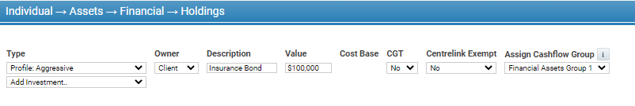
- Go to Input > Individual > Assts > Rates and Fees and update the ‘Growth (pa)’ rate by selecting the ‘Custom’ options from the drop-down list and set the ‘Income (pa)’ rate to zero. Please be aware that the growth rate is net of tax.

Withdrawing / Transferring the total amount of an investment bond after 10 years
- To close out or transfer the investment bond in the 10th year, navigate to Display > Individual > Assets > Client and add a withdrawal in year 11 using the value displayed in the ‘Closing Value’ row for year 10, and add same to ‘Start of Period’ row in year 11.
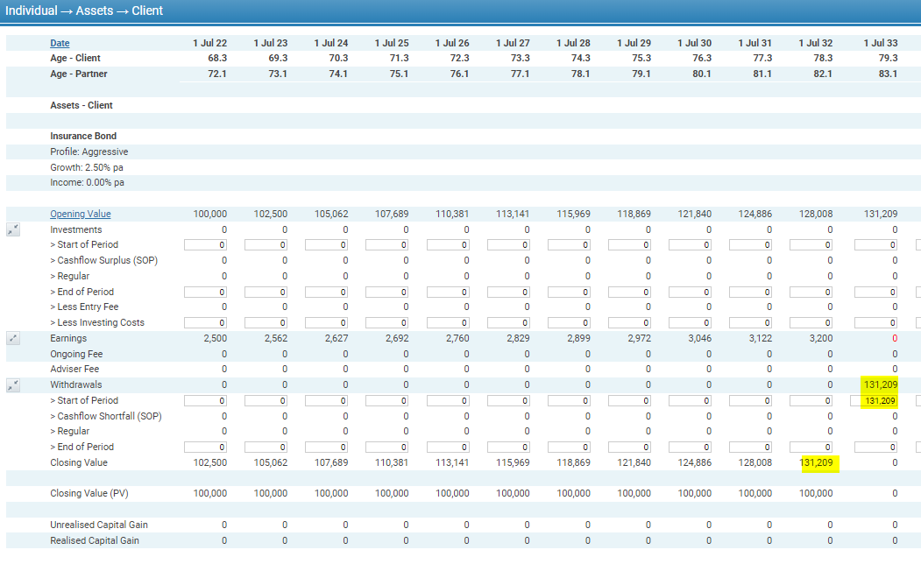
- If the fund value is being transferred to another entity, go to Cashflow > Consolidated and enter an ‘Other Expenditure (Post Tax)’ for the same amount, in the same year.
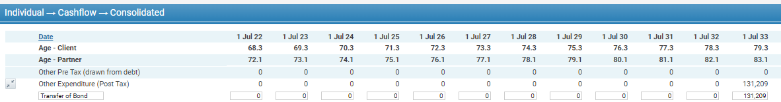

Withdrawing / Transferring the total amount of an investment bond before 10 years
If you need to do a withdrawal before 10 years, you need to work out the tax assessable amount first.

- Contact Generation Life who can work out the tax impact of a specific withdrawal amount, or alternatively,

- Go to the Investment Bonds Projection Calculator in the Adviser Portal at secure.genlife.com.au

- In ‘Step 3 – Withdrawals’ select Yes to either Regular Withdrawal Plan or Additional Withdrawals (whichever is relevant).

- Enter the withdrawal amounts. Note that you can add additional ad-hoc withdrawals by selecting the ‘+’ button.
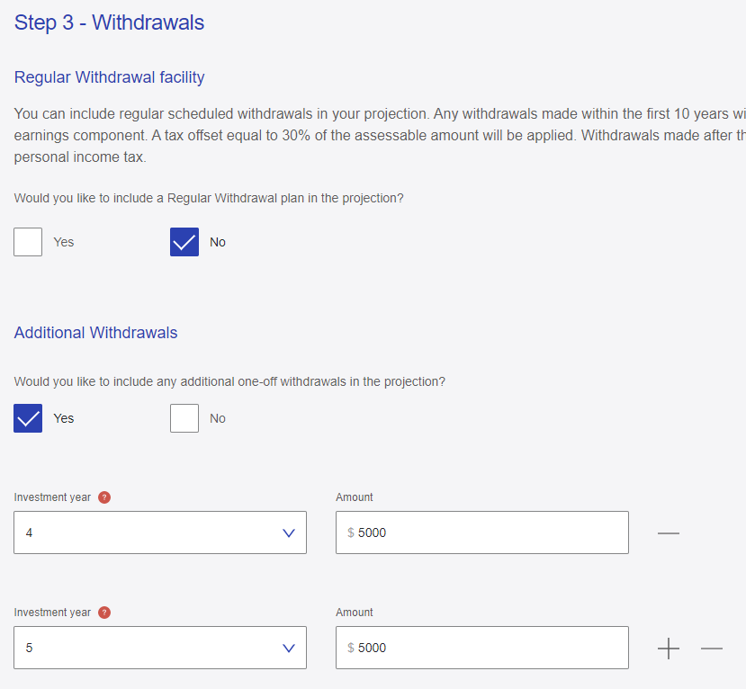

- On the results screen, use the ‘Tax Assessable Portion and ‘Tax Offset Available’ figures for your modelling. You can also download this report to Excel if easier.
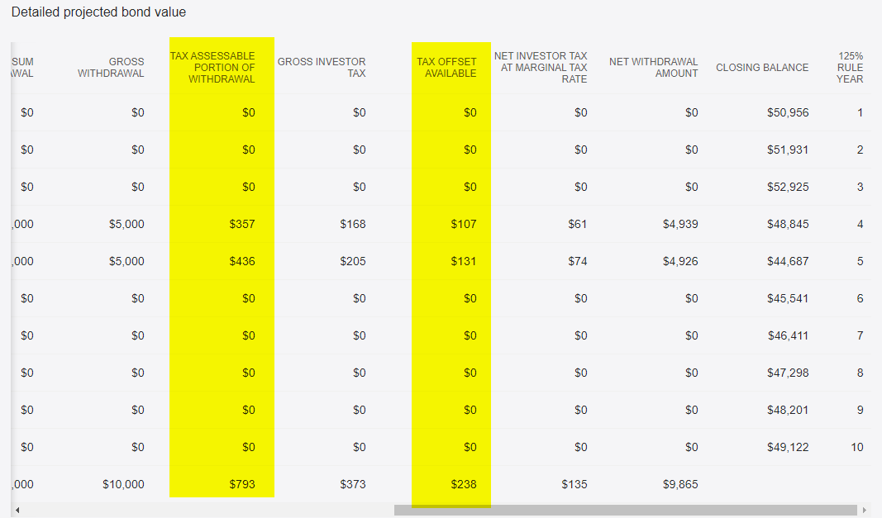

- Go to Xplan: Display > Assets > Client and enter the withdrawal(s) in the relevant year.
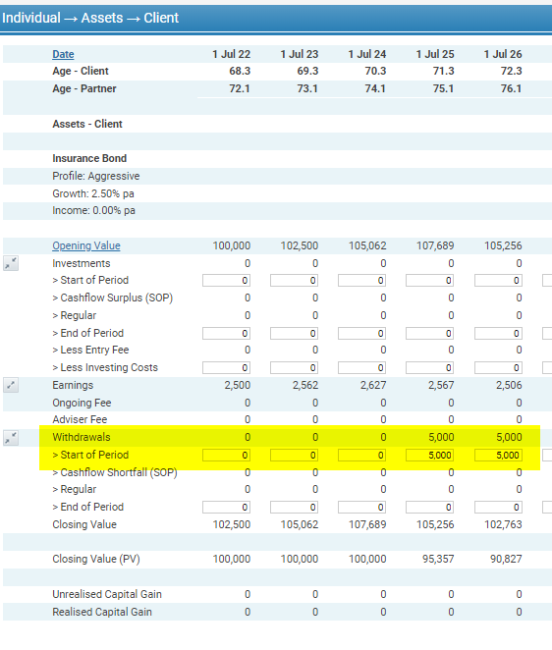
- Go to Display > Taxation > Client and add the taxable income as a ‘Capital Gain Adjustment’ and the tax offset as ‘Other Offset’ in the Non Refundable Tax Offsets area.
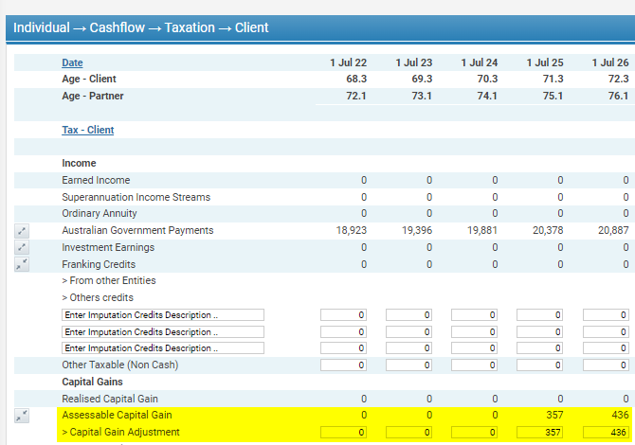

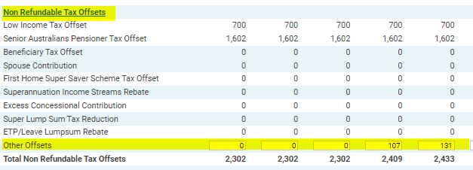

Adding a LifeBuilder investment bond within a Bonds Custodian Trust (BCT)
An investment bond within a BCT is assessable for the assets test, but not the income test. To do this, you need to implement some manual adjustments in the display screens.

- Go to Input > Individual > Assets > Holdings and create a new asset. Ensure that CGT option is ‘No’ and the ‘Centrelink Exempt’ is ‘Yes’.

- Follow the same process as entering a normal investment bond re: return assumptions.
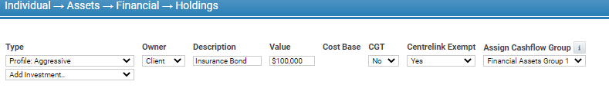

- Go to Display > Assets > Client and note the opening value of the bond each year.
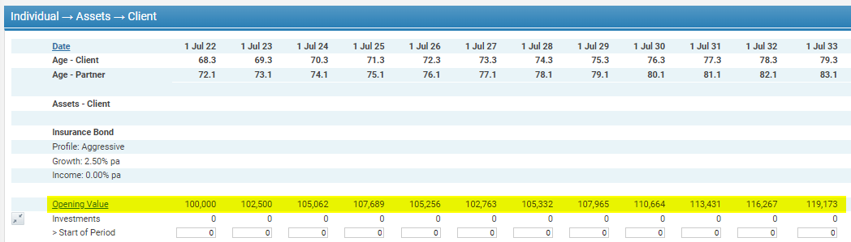

- Go to Display > Income Support > Pension Details and add the opening value as an Assessable Asset Adjustment.
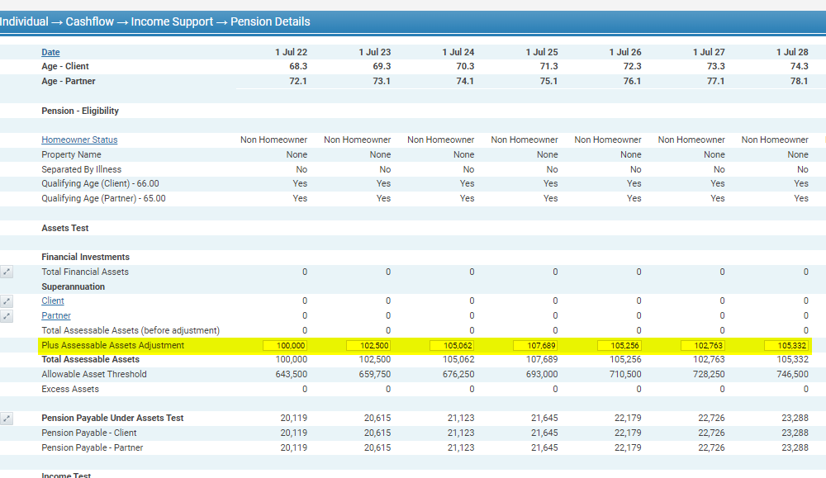

Adding a Funeral Bond
A funeral bond is not Centrelink assessable provided it is within limits.
It is assumed that the funeral bond is either under the funeral bond limit, or using a pre-paid service in this example.

- Go to Input > Assets > Financial Holdings and select ‘No’ to CGT and ‘Yes’ to Centrelink Exempt.

- Go to Input > Individual > Assts > Rates and Fees and update the ‘Growth (pa)’ rate by selecting the ‘Custom’ options from the drop-down list and set the ‘Income (pa)’ rate to zero. Please be aware that the growth rate is net of tax.
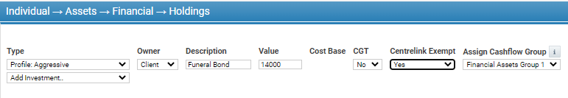

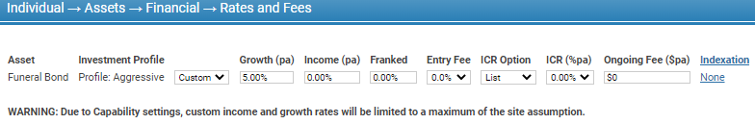

Aged Care Calculations
If you need assistance with Aged Care Fee Calculations, you can contact Generation Life for assistance who can perform these calculations for you.

Product Cost Tables
Generation Life products’ fees have been provided to Financial Software providers as follows:
- Xplan
- Adviser Logic
The products should therefore be available when conducting product research through these software providers.
Product Cost Tables
As a guide you should be including the following fees in your product cost tables. Please note that Generation Life offer an administration fee rebate, based on the underlying investments of the bond and how much is invested in total.

PROPOSED
PROPOSED | Generation Life LifeBuilder/ChildBuilder/FuneralBond Investment bond
Account Balance | $X
Upfront costs
Establishment fee | $0 / 0%
Contribution fee | $0 / 0%
Ongoing costs
Administration Fees | Based on each Underlying Investment Option  (See Investment Options Booklet)
Investment Management Costs | Based on each Underlying Investment Option  (See Investment Options Booklet)
Membership Fee | $0
Performance Fees | Based on Underlying Investments  (See Investment Options Booklet)
Gross Ongoing Costs | $X / X%
Rebates & Discounts
Administration Fee Discount/Portfolio Rebate | See PDS
Total Rebates | $X
Net Ongoing Cost | $X / X%

Fees & Costs Calculator
If you do not have access to Financial Planning Software, Generation Life can provide you with a calculator to help you calculate the relevant fees for the investment bond.
You will need access to the Generation Life portal to do this via your adviser login. The web address is secure.genlife.com.au. If you are a paraplanner, you will need to either have your adviser generate the report for you and provide it to you, or you will need to obtain access to the portal via your adviser.
- Go to Calculators:

- Select Fees and cost estimator:
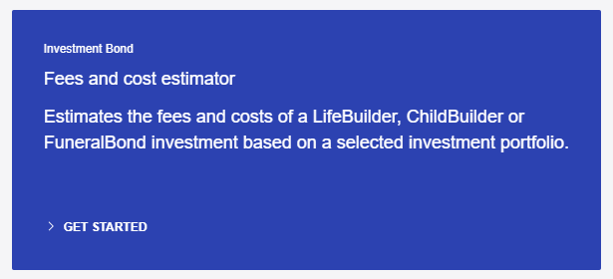
- Enter the client’s information:
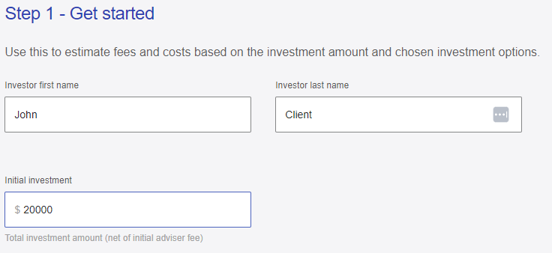
- Enter the investment options (% or $) and press calculate:
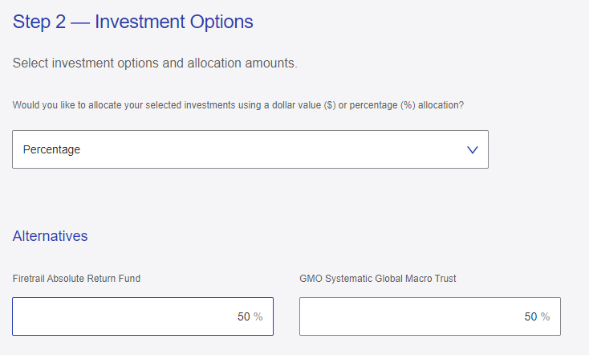
- The calculator will provide a total estimated fee breakdown you can use in your product cost tables.

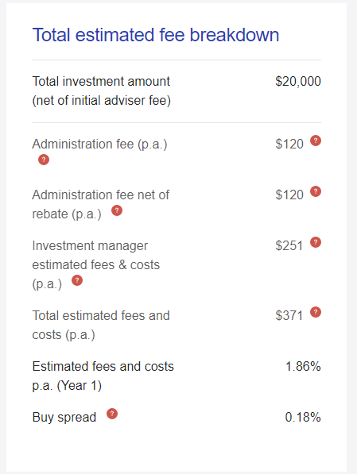

Alternative strategy and product types

Alternative strategy suggestions
- [Lower Tax Rate] We considered investing funds into an investment platform to meet your wealth creation goals, however we discounted this as you can invest into a similar portfolio within the recommended investment bond and have your earnings effective tax rate at 30% or lower depending on the investment option, rather than your marginal tax rate.
- [Do not want Assessable Income] We considered alternative investments for your wealth creation goals such as managed funds, however reducing your assessable income was a goal for you. The recommended investment bond will not distribute income to you directly, reducing your assessable income and allowing you to access [benefits].
- [Needs to Access Funds before retirement] We considered investing your funds into the superannuation environment, however we discounted this as having access to your funds prior to retirement was one of your goals. The recommended investment bond will allow you to access your funds at any time.
- [Used up Contribution Caps] We considered contributing funds into the superannuation environment however we discounted this as you have used up your contribution caps and can’t make contributions to super.
- [Adult Dependents] We considered leaving the funds in the superannuation environment and nominating your adult children as beneficiaries, however we discounted this as your adult children may pay tax on receiving the benefits from super, and they will not pay any tax when receiving the proceeds of an investment bond.
- [Non-Super Dependent] We considered leaving the funds in the superannuation environment, however you are unable to nominate [beneficiary] as a beneficiary to your super as they are not classified as a super-dependent, and funds would have to be passed through your estate, which you did not want to do.
- [Funeral Bond] We considered keeping funds in cash to help fund your funeral bond, however these funds would pass through your estate and could take time to be paid to fund funeral expenses. In addition, this asset would be assessable by Centrelink, whereas the funeral bond is not (assuming the investment is under the threshold).
- [Children Investing] We considered investing in your children’s name outside of a bond in a managed fund investment, however we discounted this given the high rates of tax for minors making it ineffective.

Appendix 1: References material
The following resources are available in the Generation Life Adviser Portal at secure.genlife.com.au.

Details
Projection calculator
Fees and costs calculator
Investment Bonds PDS
Investment Options Booklet
Additional information booklet
LifeBuilder Brochure
ChildBuilder Brochure
FuneralBond Brochure
Estate Planning Guide
Investment Bonds Strategy Booklet
A Technical Guide – Investment Bonds in Action
Comparing long-term investment solutions
How an investment bond is taxed
Transferring Wealth to Children
Bonds Custodian Trust Facility Flyer
Estate Planning Flexibility
Investment Menu APIR Codes
Forms
PDF and links to online application forms

Appendix 2: Suggested fact-finding questions
To help work out if a Generation Life investment bond is in your client’s best interests, it is important to understand how and what they will use the funds for, so that you can understand what product features may be useful to the client.
Some suggested fact-finding questions are listed below.
Could the client benefit from the tax concessions offered by LifeBuilder?
- What is your and your partner’s anticipated income in the next five years?
- Do you expect any bonuses paid in the next five years that may take you into the next marginal tax rate?
  - Will the bonuses be paid directly to you or via employee share schemes or other methods?
- Are you planning on selling any assets in the future which may generate a large capital gain?
- What was your tax bill last financial year? Is this typical?
- How much income did you generate from your assets?
- Is minimising the levels of income you earn or report a concern for you?
- What life stage are you at? Set and forget or are you planning on starting a family?
Could the client benefit from the reducing their income by using LifeBuilder?
- I can see that you currently earn significant investment income from your XX investments which you are accumulating in cash, do you require this additional income?
- Are you paying or receiving any Child Support?
- Are you receiving any Family Tax Benefits?
- Are you paying the Medicare Levy Surcharge?
- Are there any benefits (that you know of) that you’ve tried to get access to that you couldn’t due to your income level?
- Or, given your position, are you in receipt of [benefit] currently?
- Are your parents in Aged Care? Are they receiving any Aged Pension benefits?
Is the client interested in wealth creation outside of super? Do they have the means to invest in an investment bond?
- Do you need or want additional income in the next 5 – 10 years?
  - E.g. Will you or your partner be having a career break and need some savings to fund this?
- Do you have any surplus income you wish to direct to wealth accumulation or future expenses?
- Do you need access to savings within the next 5 – 10 years?
- If we look at investments that could save you tax, would that be of interest to you?
- As you have used up your contribution caps, do you have further funds to invest?
- When do you want to retire and do you have any plans on accessing retirement funds before preservation age?
Could a client (or other beneficiary) benefit from an investment bond?
- Draw a family tree:
  - Any adult children (SIS non-dependents)?
  - What do your children do for work – do any of your children own their own businesses that could pose a creditor risk?
  - Are your parents requiring aged care?
  - Have you got any future expenses for your children you would like to fund, such as a house deposit, car or education costs?
  - Do you think you would want to use funds set aside for your children for different purposes (not just education costs)?
  - Any divorces/broken relationships in your family?
  - Is there any family member or associated person that you do not want to receive your assets?
  - Are you caring for someone that is not related to you?
  - Would you imagine there would be any contest to your Will?
  - Have grandparents indicated any desire to provide benefits to your children?
  - Do you have children from another relationship?

- To whom are you thinking of leaving your assets to in your estate?
- Do you have a funeral plan or are you thinking of pre-paying for a funeral?
- Do you have any charitable causes you would like to provide funding to in the future or in your estate?
- Do you anticipate any inheritances soon?
- Do you intend on leaving your children benefits in your estate?
- Are you planning on transferring any of your assets to another person or entity in the future?
Does the client have a Family Trust?
- Do you have or plan to have a family trust?
  - How do you manage distributions
  - Who are funds distributed to – what are their marginal tax rates?
  - Is minimising distributable income something that would appeal to you and the beneficiaries?

Appendix 3: Flowcharts
Flowchart Example – Nominated Beneficiary - Single Beneficiary
Client Name
LifeBuilder Investment Bond
$X
Nominated Beneficiary
[Name]
On death/date
No tax payable when received.
Flowchart Example – Nominated Beneficiary - Joint Survivorship
Client Name
LifeBuilder Investment Bond
$X
Nominated Beneficiary 1
[Name] X%
On death
Nominated Beneficiary 2
[Name] X%
Nominated Beneficiary 2
[Name] X%
If a nominated beneficiary dies, the other beneficiaries receive the balance of funds proportionally.
No tax payable when received.

Flowchart Example – Nominated Beneficiary - Down the Line
Client Name
LifeBuilder Investment Bond
$X
Nominated Beneficiary 1
[Name] X%
On death
Nominated Beneficiary 2
[Name] X%
Nominated Beneficiary 3
[Name] X%
If a nominated beneficiary dies, you can nominate another person to receive their benefit.
Down the line Beneficiary 1
[Name]
Down the line Beneficiary 2
[Name]
Down the line Beneficiary 3
[Name]
No tax payable when received.

Flowchart Example – Future Event Transfer – Recipient nomination

Client Name
LifeBuilder Investment Bond
$X
Nominated Recipient
[Name]
Future Transfer On death/date
No tax payable when received.
Funds restricted from being accessed until age XX
Regular
INCOME PAYMENT
of $X pa
One-off withdrawal requests made while restrictions in place need to be Co-signed by X and X

Appendix 4: LifeBuilder or ChildBuilder?

Both LifeBuilder and ChildBuilder can be used for similar reasons – so we have put together this cheat sheet to help you work out which product may be best suited for your client.
We have set out the main differences between the products below.

What the client needs |  | ChildBuilder | LifeBuilder
Investment for child over 10 (with Guardian consent) |  |   can be set up for child under 16
Specify a purpose for the funds (non-binding)
 | More product features and flexibility within product
Change the nominated death benefit beneficiary at any time before death of owner
Future transfer to a nominated child at a certain age or date |  | after the child turns 10 and before the child turns 25
Multiple beneficiary nominations in one bond
May want to change the child nomination

