

Generation Life LifeIncome
Adviser and Paraplanner Handbook
March 2022
For financial adviser use only



Generation Life Limited
ABN 68 092 843 902
AFS Licence 225408
Important information 4
Instructions 5
1. About Generation Life 6
2. What is LifeIncome? 6
2.1 A new type of income stream 7
2.2 Paying an income for life 7
2.3 Benefits and features overview 8
2.4 How does LifeIncome work? 8
2.5 The power of LifeBooster 11
2.6 Improving your ongoing service proposition 13
3. Client Suitability 14
3.1 Target Market Determination (TMD) 14
3.2 Minimum requirements 14
3.3 How LifeIncome can meet client objectives 14
3.4 Financial situation 17
3.5 Who is not suitable for LifeIncome? 17
4. LifeIncome strategies 18
4.1 Overview of income stream options 18
4.2 Traditional lifetime annuity vs LifeIncome 18
4.3 Which LifeBooster to choose? 19
4.4 How LifeIncome complements other products 21
4.5 How to determine an appropriate investment into LifeIncome 24
4.6 Balancing liquidity requirements with future income needs 25
4.7 Social security considerations 26
4.8 Estate planning considerations 28
4.9 Taxation considerations 30
4.10 LifeIncome for those that can’t contribute to super 30
4.11 LifeIncome can reduce aged care means tested fees 30
4.12 Make contributions into super before investing in LifeIncome 31
5. Managing the Portfolio 31
5.1 Blended asset allocation approach 31
5.2 Switching 31
6. Statement of Advice (SoA) text 32
6.1 Example goals and objectives 32
6.2 Example strategy recommendations 32
6.3 Example recommendation table 37
6.4 Example recommended product text 37
Generation Life - LifeIncome 38
6.5 Underlying investments – product descriptions and asset allocation 40
6.6 Replacement of Product 40
6.7 Example of Alternative products considered 43
6.8 Example of Alternative strategies considered 44
6.9 Modelling LifeIncome for projections 44
6.10 Disclosure of Fees 48
7. Ongoing reviews and LifeIncome 50
7.1 Suggested agenda items for a LifeIncome annual retirement review 50
7.2 Reviewing your existing client base 50
7.3 Suggested Record of Advice text 51
8. Tools, calculators and resources 54
8.1 Adviser Online portal 54
8.2 Quoting tool 54
8.3 Retirement Income Optimiser 55
8.4 LifeIncome – The power of LifeBooster 55
Case Study 1: Lifestyle 56
Case Study 2: Confidence 58
Case Study 3: A Choice to make 60
Appendix 1: APIR Codes for Underlying Investments 62
References 64

Important information
The product description and sample wording below have been prepared by Generation Life Limited (‘Generation Life’) ABN 68 092 843 902 AFSL 225408 as a guide only to assist you in developing your own advice strategy and Statement of Advice (SoA) when offering Generation Life LifeIncome to your clients.
This information may not be considered complete as it does not consider your clients’ personal situation, needs or objectives – it is your responsibility to consider these aspects when formulating the SoA for your clients. Before making an investment decision or tendering of advice based on anything in this document, you need to consider, whether any general advice in this document is appropriate to the particular investment needs, objectives and financial situation of the person/s making the investment and/or receiving the advice.
This document may contain general advice in relation to financial products. Generation Life is not authorised to provide personal advice and accordingly has not considered any individual person’s financial situation, need or objectives. Generation Life is not responsible for any personal advice you provide, even if it is based on this document.
It is important to note that some product features may not be fully explained, some words or phrases have a specific meaning and rules may apply to the availability of certain features and options. For these reasons, this SoA should be used in conjunction with the terms and conditions set out in the Generation Life LifeIncome Product Disclosure Statement (“PDS”).
Should you choose to use all or part of this template to fit with your SoA, this is at your discretion. The law applying to SOAs is subject to amendment and reinterpretation at any time. This document is based on information from the Generation Life LifeIncome PDS and Target Market Determination (“TMD”) documents.
The document contains references to financial products issued by Generation Life in its capacity as a life insurance company under the Life Insurance Act 1995 and as the issuer of the interests in Generation Life LifeIncome. This document does not constitute an offer of interests in LifeIncome. Such offers will only be made in a copy of the PDS and anyone wishing to acquire interests in LifeIncome will need to complete the online application form.
Generation Life believes that any advice and information in this document is accurate and reliable, but no warranties of accuracy, reliability or completeness are given (except insofar as liability under any statute cannot be excluded). No responsibility for any errors or omissions or any negligence is accepted by Generation Life or any of its directors, employees, or agents.

Instructions
This document provides an example of wording that can be inserted into an SoA to explain the benefits of LifeIncome and why it has been recommended. Fees are included in this template as a guide only and should be included in the fee disclosure section of the SoA as per your licensee compliance guidelines.
The wording is provided as a guideline and advisers should seek guidance from their own compliance area to ensure all licensee and ASIC requirements have been met.
You should read carefully any text taken from these samples and ensure that the context in which it is used is appropriate for your client’s circumstances.
Individual client information/circumstances should be inserted where <indicated> and advisers should ensure non relevant insertion <indicators> are deleted.
In some sections, there are several options for wording to allow advisers to tailor the advice to the client’s circumstances. Instructions for tailoring are shown in blue text and in [brackets]. Advisers should insert their own details or delete any sections that do not apply to the advice given, as well as delete the instructions. In some cases, advisers may need to modify or provide additional wording to suit the client’s unique circumstances.
The samples are not exhaustive and other circumstances and strategies for Generation Life LifeIncome may not be covered by this document.

- About Generation Life
Generation Life, a wholly owned subsidiary of Generation Development Group Limited (ASX: GDG), is a life company registered under the Life Act. As the pioneer of Australia’s first truly flexible investment bond, Generation Life has been at the forefront of providing innovative tax-effective investment solutions since 2004. Over $2.5 billion has been invested with us to date.
Generation Life is proud to be shaping the retirement income landscape with our LifeIncome product, by applying our innovative approach to clients’ retirement income needs and enabling Australians to focus on enjoying retirement with the confidence of an income guaranteed for life.
Generation Life is regulated by the Australian Prudential Regulation Authority (‘APRA’) and as such, is required to hold a minimum amount of capital, determined by APRA, to ensure any payment obligations to clients can be met. APRA is the same independent statutory authority that supervises banks in Australia.
- What is LifeIncome?
One of the key challenges facing Australians in retirement is managing the risk of outliving their savings and suffering a reduction in lifestyle, known as longevity risk. Many Australians manage this risk by reducing their spending in retirement, living more frugally than they should and missing out on some of the good things in life. In their later years, many Australians look back with regret, and wish they had spent more in their earlier and more active years. This is called ‘regret risk’.
This behaviour is confirmed in a report by Milliman, Retirement Expectations and Spending Profiles (ESP) which studied 300,000+ retiree’s real-world annual expenditure. It suggested that running out of retirement savings is a key concern for many people and may be a driver for the substantial growing proportion of retirees with an account-based pension who drawdown the minimum legislated annual amount.
A common misconception is that retirees require higher income in later years than at the start of retirement, however a recent study by the Grattan Institute shows that Australians tend to spend less after they retire, slowing at 70 and decreasing rapidly after age 80. Milliman noted that retirees spend less in areas like entertainment, clothes and furniture and spend more on healthcare as they age, but Medicare largely shields them from the full healthcare costs. Furthermore, the study shows that not only do more retirees drawdown less from savings throughout retirement, many, add to savings.
So, if retirees tend to spend less and even save more in retirement in later years, why don’t we flip the spending trend and give retirees the confidence to spend more in the early phase of their retirement? If we consider a traditional lifetime annuity, it aims to deliver higher income in later years, which is contrary to evidence which shows that retirees need more income early in retirement, and less in later years.
LifeIncome has been developed on the belief that clients should have a level of certainty of income in retirement, so that they can spend more freely and enjoy their retirement in early years. Generation Life wanted to provide a product that had more flexibility in the way funds were invested while ensuring that clients had a guaranteed income stream to alleviate concerns with longevity risk.

2.1 A new type of income stream

Traditional vs modern lifetime annuities
Prior to 2017, for a lifetime annuity to receive concessional social security and tax treatment, it needed to guarantee income for life and the level of income from one year to the next. These are expensive products to offer, and the return on investment is generally low - particularly in sustained low interest-rate environments. To encourage innovation in lifetime annuities, the government changed the pension and annuity standards with the addition of ‘innovative income streams’ on 1 July 2017. This enabled a new cohort of lifetime annuities to be developed.
The biggest difference between an innovative income stream and a traditional annuity is whilst income needs to be guaranteed for life, the income that is paid from one year to the next can rise and fall. These products are cheaper to manufacture than traditional lifetime annuities, as the level of return is not guaranteed by the manufacturer and therefore have the potential to provide a far greater return on investment over the medium-to-long term.

LifeIncome is an innovative income stream
There are now essentially five different types of income streams:
- Account-based income streams
- Non-account based (RCV) income streams (e.g. Defined benefit income stream)
- Lifetime (nil RCV) income streams (e.g. Lifetime annuity)
- Fixed term (nil RCV) income streams (e.g. Fixed term annuity); and
- Innovative income streams.
LifeIncome is considered an innovative income stream. Innovative income streams are payable for a beneficiary’s remaining lifetime, or the reversionary if they choose, after they have met a condition of release and can access their preserved superannuation benefits. An innovative income stream is a lifetime annuity where income can be linked to investment performance.
LifeIncome is innovative retirement income stream compliant i.e. satisfies the requirements of an innovative retirement income product in Regulation 1.06A of the Superannuation Industry (Supervision) Regulations 1994, meaning LifeIncome receives concessional social security and tax treatment.

2.2 Paying an income for life
Generation Life guarantees to make income payments for life. To support this guarantee, Generation Life has reinsurance arrangements in place to address the possibility clients live longer than life expectancy assumptions used to calculate benefits. The reinsurer is Hannover Life Re of Australasia Ltd (‘Hannover’) a subsidiary of Hannover Rueck SE, a part of the Hannover Re Group worldwide. At the time of preparation of the PDS dated 22 March 2022, the rating agencies most relevant to the industry have awarded the Hannover Re Group very strong insurer financial strength ratings (Standard & Poor’s AA- ‘Very Strong’) and A.M. Best A+ (‘Superior’). As a subsidiary, Hannover currently enjoys a Standard & Poor’s financial strength of AA- (very strong capacity to meet financial commitments). Please note, that a client is not a party to the reinsurance arrangements between Generation Life and Hannover.

2.3 Benefits and features overview
LifeIncome is simple and provides these key benefits to enhance your client’s retirement:
- Generation Life guarantees income for life - LifeIncome guarantees a regular income for as long as the client (or their spouse in the case of reversionary beneficiaries) lives. The level of income is not guaranteed, but an income is.
- Investment choice - Income is investment-linked and there is flexibility to select and switch between 23 different investment options.
- Super or non-super investment - LifeIncome can accept investment from either personal monies or superannuation.
- Concessional Centrelink treatment – LifeIncome is treated like an annuity when assessing for Centrelink benefits. This could mean a reduction to the assets and income tests to help improve Centrelink entitlements.
- Tax-free income – Any earnings on LifeIncome are tax-free while they remain in LifeIncome, regardless of the client’s age. In addition, LifeIncome payments are tax-free in the client’s hands if super monies were invested, and the client is over 60 years of age. In all other cases, there are tax concessions on regular payments.
- Franking credit benefits – As LifeIncome is tax exempt, any franking benefits received can be paid into the fund to help improve the internal rate of the return for clients.
- Cooling off period - Generation Life offers a 6-month cooling-off period in addition to the 14-day statutory cooling-off period.
- Reversionary Beneficiary option – by selecting the Reversionary Beneficiary option LifeIncome automatically passes to the beneficiary with all the same benefits.
- LifeBooster – Allows the client to receive more of their income in the early years of retirement to allow for greater freedom at the start of retirement when expenses are statistically higher.
- Death Benefit – A lump sum Death Benefit is payable to the client’s nominated beneficiary of estate within a defined Death Benefit Period.
- Monthly or fortnightly income payments – Flexible payment schedules.
- 1 July Annual Income Reset – Aligning to annual income calculations with other income-generating assets such as account-based pensions, annual income is reset at the start of each Financial year, making reviewing the year ahead, easier.

2.4 How does LifeIncome work?
When investing in LifeIncome, a client exchanges a lump sum for a regular income stream payable for life. When Generation Life establishes LifeIncome, the first year’s income (“Annualised First Year Income”) is determined and then converted into Guaranteed Annual Income Units (“Income Units”). This is done by dividing the Annualised First Year Income by the unit price of the investment option(s) on the commencement date.
The number of these Income Units remain the same for the life of the product (except if investment options are switched) and are used to calculate the annual income at the start of each Financial year in the future. This means the income stream is linked to the underlying investment options and changes in line with the performance of those investments.
The amount of Annualised First Year Income is calculated using several factors including:
- Initial investment amount
- Age when LifeIncome starts, and spouse’s age if Reversionary Beneficiary nominated
- Gender
- LifeBooster rate
- Lifetime Income Protection Provision

If a client starts LifeIncome part-way through a Financial year, the amount of income received will be pro-rated based on the Annualised First Year Income.
This calculation is done using Generation Life’s quoting tool prior to investment. An example of the quotation is below:
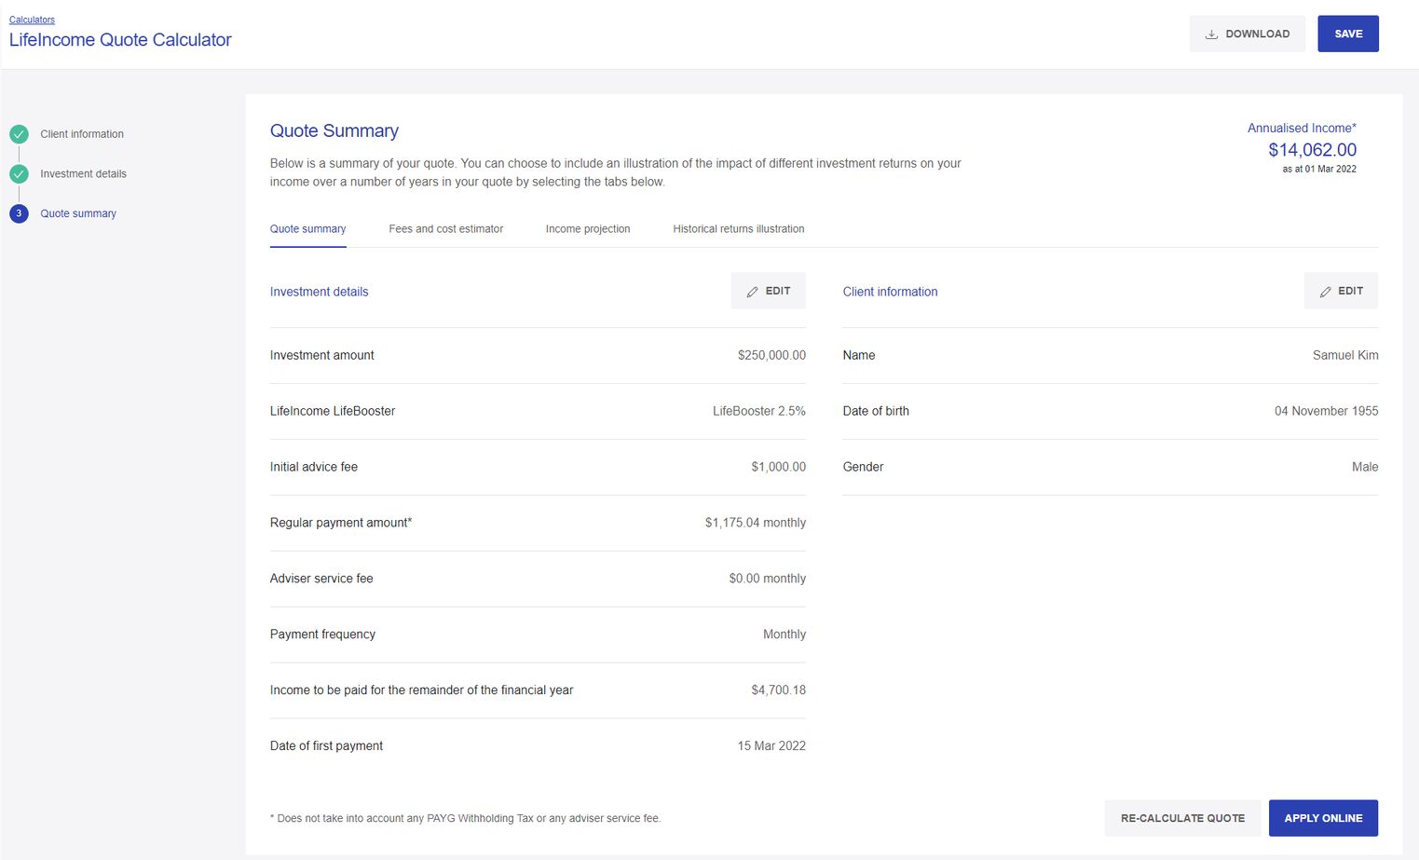

The quotation tool will generate a client-friendly quote with a summary of expected payments (Guaranteed Annual Income Units will be confirmed on investment):
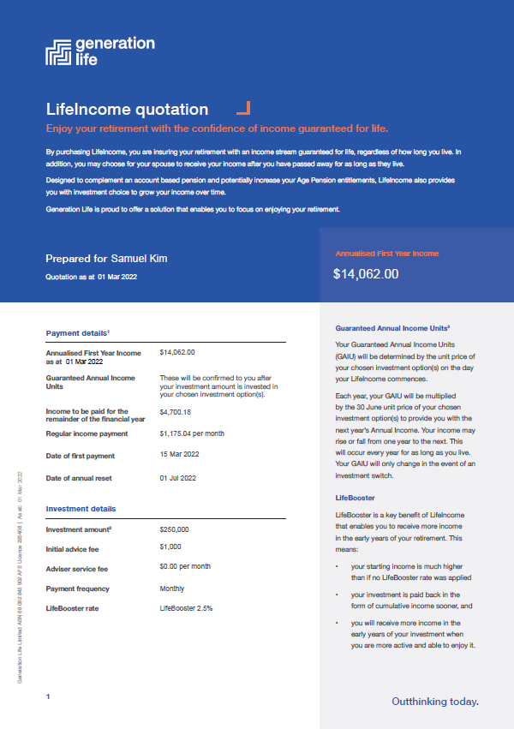

Annual income reset
At the start of each Financial year, a new annual income is determined by multiplying the number of Income Units by the unit price of the chosen investment option(s).
Where the performance of the investment options, after fees and charges and discounts for LifeBooster (below) is positive, the income increases. If the performance after fees and charges and discounts for LifeBooster (below) is negative, the income decreases.

LifeBooster 5% rate |  | First Year |  | Year 2 |  | Year 3 |  | Year 4 |  | Year 5
Return of previous Financial year |  | n/a |  | 10.20% |  | 9.70% |  | -3.00% |  | 12.00%
Return after fees |  | n/a |  | 9.28% |  | 8.78% |  | -3.92% |  | 11.08%
Return after the impact of discounting returns by the LifeBooster rate |  | n/a |  | 4.08% |  | 3.60% |  | -8.50% |  | 5.79%
Annual Income |  | $7,366 |  | $7,666 |  | $7,942 |  | $7,268 |  | $7,688
Monthly Income Payments |  | $614 |  | $639 |  | $662 |  | $606 |  | $641
Difference in monthly payment from one year to the next |  | n/a |  | $25 |  | $23 |  | -$56 |  | $35
* This is a general example for illustrative purposes only. The discounting effect of the LifeBooster rate is factored into the unit price daily. The Lifetime Income Protection Provision has not been taken into account in these estimates.
LifeBooster 2.5% rate | First Year |  | Year 2 |  | Year 3 |  | Year 4 |  | Year 5
Return of previous Financial year | n/a |  | 10.20% |  | 9.70% |  | -3.00% |  | 12.00%
Return after fees | n/a |  | 9.28% |  | 8.78% |  | -3.92% |  | 11.08%
Return after the impact of discounting returns by the LifeBooster rate | n/a |  | 6.61% |  | 6.13% |  | -6.26% |  | 8.37%
Annual Income | $5,770 |  | $6,152 |  | $6,529 |  | $6,120 |  | $6,632
Monthly Income Payments | $481 |  | $513 |  | $544 |  | $510 |  | $553
Difference in monthly payment from one year to the next | n/a |  | $32 |  | $31 |  | -$34 |  | $43
* This is a general example for illustrative purposes only. The discounting effect of the LifeBooster rate is factored into the unit price daily. The Lifetime Income Protection Provision has not been taken into account in these estimates.

2.5 The power of LifeBooster
LifeBooster is a key benefit of LifeIncome that should be highlighted early on to clients. Essentially, LifeBooster enables a client to receive more income in the early years of their retirement.
Depending on the client’s income needs, LifeIncome offers two LifeBooster rates of 2.5% and 5%, which optimise starting income while allowing the income to grow over the life of the investment.
For your client, this means:
- their starting income is much higher than if no LifeBooster was applied
- their investment is paid back to them in the form of cumulative income sooner, and
- they receive more income in the early years of their retirement when research tells us they are more active and able to enjoy it.
The concept of LifeBooster has been utilised in investment-linked lifetime annuity products across the world for many years.

How LifeBooster works
LifeBooster is a rate of return that is used to calculate the starting income and brings forward future income. The higher the LifeBooster rate used, the higher the starting income.
Instead of income growing each year in line with full investment returns, future investment returns are discounted by the LifeBooster rate. LifeIncome has a higher starting income, and future income growth is achieved when net investment returns, discounted by the LifeBooster rate, is positive.

Client considerations
- Will the client prefer higher income early in their retirement, and therefore are they also comfortable with more modest growth in income over time? If so, a LifeBooster 5% rate might be more appropriate.
- Is the client a more conservative investor but would still like a higher income early in retirement? In this case, to minimise the chance of income falling, a LifeBooster 2.5% rate may be more appropriate.
- Does your client have other income from their partner to support their retirement income until their partner retires? In this situation, the lower LifeBooster rate might be more appropriate to make sure that the client receives a higher income in later years when their partner retires.
- If your client is subject to a Centrelink benefit reduction due to the income test, a LifeBooster 2.5% rate may be more appropriate.
- If the client foresees a greater need for a higher income in later years, e.g. for medical or other expenses, a LifeBooster 2.5% rate may be more appropriate.

An example of an increase of starting income with a LifeBooster 5% rate
Assumptions: 67-year-old-male, $100,000 investment, LifeBooster 5% rate

An example of an increase of starting income with a LifeBooster 2.5% rate
Assumptions: 67-year-old-male, $100,000 investment, LifeBooster 2.5% rate

The graphs below demonstrate that cumulative income is higher in the earlier years of the investment, and that the client receives their investment back sooner in the form of income when LifeBooster is applied.
Assumptions: Male 67 years old, initial investment $100,000, gross return on LifeIncome investment option 7%, LifeBooster 5% rate, estimated total fees, expenses and costs of 1.22%. In this example LifeIncome without LifeBooster would pay more cumulative income only after the investor exceeds 87 years of age.

2.6 Improving your ongoing service proposition
Rather than a “set-and-forget” strategy, implementing a LifeIncome investment means that your client’s retirement income requirements, investment options and allocation strategy can be reviewed every year. Not only does this mean that you can regularly engage with your client and make sure that they can meet their income needs, but your clients will also benefit from a touchpoint to see how they are tracking in other areas of their lives. LifeIncome helps provide a viable reason to connect with your client and review their situation.
More information on reviewing your client’s needs with a LifeIncome product can be found in “Ongoing reviews and LifeIncome” on page 50.

- Client Suitability

3.1 Target Market Determination (TMD)
As a distributor of the LifeIncome product, it is important that you understand the suitability of the product for the client, that is, whether your client has the objectives, financial situation and needs that LifeIncome was intended for.
A detailed TMD document can be accessed on the Generation Life Website: Adviser resources | Generation Life (genlife.com.au).

3.2 Minimum requirements
At a minimum, the client must:
- be an individual.
- be at least 50 years of age (with access to their preserved superannuation benefits if commencing a superannuation LifeIncome) and under 86 years of age.
- have investable assets of at least $10,000 (either super or non-super assets).
- not require access to the capital invested.

3.3 How LifeIncome can meet client objectives
Ultimately, LifeIncome is designed to be part of a comprehensive, long-term retirement strategy. LifeIncome may be part of a retirement product suite that includes account-based pensions, non-super investments and/or government benefits to help boost the client’s income and let them enjoy their retirement without the concern that they will out-live their funds.
We have listed below some client objectives that may arise in your discussions, and how LifeIncome can help meet these objectives. We believe clients with these types of objectives would be suited to the LifeIncome product.

Those that require an income stream in retirement until their life expectancy, that keeps pace with the increases in the cost of living and out of pocket medical expenses.
LifeIncome will pay a regular income for as long as the client lives, which should keep pace with increases in the cost of living and out of pocket medical expenses given the product is investment linked and is designed to provide growth in line with risk profile objectives.

Those that are expected to live longer than their life expectancy and would like to ensure they can maintain an income past this date.
Annuity products are ideal to protect against longevity risk. LifeIncome will provide a regular income for as long as the client (or the reversionary annuitant) lives, providing comfort that they may live well past their life-expectancy and continue to receive an income.

Those that desire a guaranteed income stream.
When a client commences LifeIncome, they exchange a lump sum for a regular income that will be paid for the remainder of their life. LifeIncome guarantees a regular income, it does not guarantee the level of income. ‘Guaranteed Annual Income Units’ are determined at the start of LifeIncome. Each year’s income is determined by multiplying the Guaranteed Annual Income Units by the 30 June unit price of the chosen investment options.
Research shows that clients that have guaranteed income tend to be happier and live longer.

Client that would like a guaranteed income stream but would like to earn a return that is potentially greater than that of a typical market-linked or fixed-interest type annuity.
LifeIncome is investment-linked and has the potential for annual income to grow over time, while still providing a guaranteed income stream. LifeIncome provides access to leading Australian and International investment managers to help build a portfolio that aligns to the investment needs of the client.

Those that would like to improve their government social security benefits and may be currently subject to a reduction in income due to the assets or income test.
LifeIncome is defined as an ‘asset-tested income stream (lifetime)’ product for social security purposes. LifeIncome is treated as an annuity, that is under the assets test, only 60% of the investment amount is assessed. From age 84, or after a minimum of five years from the date of commencement, whichever is later, only 30% is assessed.
Only 60% of the LifeIncome annual income is assessed under the income test. For clients that would like to shelter some of their assets and/or income from means testing to improve their benefits, LifeIncome may be an ideal solution.
Clients that generally have assessable assets between $270,000 - $600,000 (singles) and $400,000 - $900,000 (couples) will benefit the most from LifeIncome.

A client who is comfortable to invest without access to capital in return for a guaranteed income stream for the rest of their lives.
A client will only be allowed to withdraw from the product within the first six months. After that, the funds will not be accessible until after death (if a Death Benefit is payable). Two cooling-off periods are available with LifeIncome, the regulatory 14-day cooling off period, and an extended cooling-off period of six months. It is critical that a client understands that they are exchanging liquidity for a guaranteed income stream for the rest of their lives.

The client has a spouse that they would like to provide an income for after they pass away.
Having LifeIncome is another way to guarantee income for a spouse, akin to an insurance policy.
Because LifeIncome is paid for the life of a reversionary partner, using LifeIncome to provide for a spouse means they will be able to access the increasing pension payments after the death of the initial annuitant, without worrying about whether their loved ones will be able to fund their retirement. Transitional caps do need to be considered if the Death Benefit balance exceeds this cap.

A client who wants to enjoy their retirement in the early years and does not want the fear of running out of funds later in retirement.
A key aspect of LifeIncome is the ability to provide the confidence of a guaranteed income until the end of a client’s life, allowing them to enjoy their retirement, rather than worry about outliving their funds. LifeIncome offers a unique feature, LifeBooster, which can pay clients a higher income in the initial years of their investment by reducing the returns over time by the LifeBooster rate (either 2.5% or 5%). This means clients can enjoy the freedom to spend early in their retirement while having confidence they will still receive a regular income guaranteed in later years, that can meet their expenses at that time.

A client who wants the ease of management of their retirement assets.
Unlike other retirement structures like a self-managed super fund (SMSF), LifeIncome provides an uncomplicated way to invest funds for retirement.
Once a LifeIncome has been established online, a client will be able to access their account via our Investor Online portal at secure.genlife.com.au. At all times, you and your client will have access to the latest information on the investment and be able to track the investment at any time, including the ability to view the annual income amount, Income Units, nominated beneficiaries and other investment information.
You and your client will also be able to access online resources via the Generation Life website, genlife.com.au, including forms to help manage the investment and initiate switching, change nominated beneficiaries, or remove a Reversionary Beneficiary.
After the end of each Financial year, Generation Life will issue an Annual Statement, made available via your client’s online account. The statement will include investment information, including payments made in the last year, annual income for the new Financial year, regular income payment amount and frequency for the new Financial year, Income Units and 30 June unit price(s), estimated Death Benefit payable as at 30 June and other investment information.
Clients can also easily access their Centrelink Schedule. If tax has been withheld from income payments, Generation Life will issue the client a PAYG payment summary.

Those who are comfortable with a changing income stream that is linked to the market value of their underlying funds.
One of the unique features of LifeIncome is the ability to receive an income, guaranteed, that is linked to the unit price of their chosen investment option(s). This can bring some favourable upside potential, in that the client’s annual income can grow over time. However, the volatility can also mean lower income in years where performance has been negative. It is important that the client is aware of the risks of investing in LifeIncome and that there is not a ‘minimum income’ level that is set, like a typical annuity or defined benefit scheme. A client should understand that they will be receiving a varying income stream.
Generation Life understands the importance of this conversation, so we have provided a section in the quoting tool which you can use in front of clients to demonstrate the effects of the market on LifeIncome payments, using historical returns of the underlying assets. More information on this tool is found on page 54 under Tools, Calculators and Resources.

Clients who want to invest in a range of investment strategies across a range of asset classes and investment managers (covering conservative through to higher risk investment strategies) based on their risk profile, and would like the ability to switch investment options as required.
The LifeIncome investment options menu allows a client to invest in different ways to meet their investment objectives. The menu offers:
- Diversified funds
- Sector funds, and
- Index funds.
LifeIncome allows clients to blend a portfolio to closely reflect their risk profile, which is unlike any other lifetime annuity in the Australian marketplace. LifeIncome’s flexible investment menu also means a client can decide to take on strategic investment approaches with the various retirement products they hold. For example, they may choose to take a more defensive approach with their account-based pension, which is being drawn upon regularly, with a higher allocation to cash, and invest in higher performing assets within their LifeIncome account to maximise returns, knowing that it will provide a guaranteed income for life which benefits from better performance.
Furthermore, LifeIncome provides the ability to switch unlimited times during the year. Switching can be done at any time, except for the period between midday on the third last business day of the Financial year and the end of the Financial year. This provides you and your client the flexibility to change the portfolio to meet client needs, market changes or fund rating changes in a timely manner.

If you or a Power of Attorney is concerned with the possibility of financial elder abuse, or the client themselves needs a product where they won’t be ‘tempted’ to withdraw more than required.
If you or a Power of Attorney is concerned with the possibility of a client being financially abused e.g. coaxed to withdraw funds from an account-based pension, setting up a LifeIncome investment will help minimise this risk, as withdrawals will not be allowed post the 6-month cooling-off period. This will mean the annuitant can receive a guaranteed income with investment-linked returns, and comfort that withdrawals cannot be made to deplete funds unwillingly.
LifeIncome will only pay income to the annuitant’s bank account (i.e. an account in their name or joint bank account) to further protect against financial abuse and fraud.

Clients who are comfortable that the product costs associated with LifeIncome, and its investments may be higher than other retirement income products, but the desire for a guaranteed income that has better upside returns with Centrelink concessions outweigh these costs.
When compared to other retirement products, LifeIncome may prove to be more expensive, however the additional costs can provide the features that may be otherwise unobtainable with other products, namely:
- An income guaranteed for life that is linked to the performance of the investment options chosen, providing opportunities for greater income over time.
- LifeBooster where guaranteed income can be increased at the start of retirement for more freedom in earlier years.
- Greater investment choice – with 23 researcher rated and flexible investment options to create a portfolio to match your client’s risk profile.

3.4 Financial situation
When considering the product, ideally the client should have one or more of the following financial situations:
- The client has a minimum of $10,000 to invest.
- If superannuation money is used, the client does not have total super of over $1,700,000.
- If non-superannuation money is used, the client does not have over $5,000,000 to invest.
- For superannuation money, the client must have met a condition of release and have access to preserved superannuation benefits.
- The client should not require access to the funds after it is invested, as after the 6-month cooling-off period, these funds cannot be withdrawn.
- Ideally, the client should have some assets outside of LifeIncome for emergencies and to supplement income if the income, in any year, is below expectations.
- The client may be in receipt of government benefits such as the Age Pension or DVA entitlements.
- The client has a medium to long-term investment timeframe.

3.5 Who is not suitable for LifeIncome?
Like any product, there are clients who will not be suited to LifeIncome. It is up to you as an adviser to make an assessment on their suitability based on the guidance above and the TMD; however, we have noted some situations where we consider this product unsuitable.
The client:
- is unsure on whether they will require access to the invested funds in the short, medium, or long term.
- is not comfortable with market volatility.
- is suffering from an illness that will severely curtail their life expectancy.
- is not comfortable that their income may not be constant and can rise and fall from one year to the next.
- will require changes to their income mid-way through a Financial year.
- wants to invest funds owned by a SMSF, company, or trust.
- requires the funds as collateral for a debt; and/or
- is not able to commit to a long-term ongoing client-adviser relationship. Although the product can be managed directly by a client, ideally this should be a product that is provided with the aim of ongoing advice and management from a professional adviser.

- LifeIncome strategies
Generation Life believes that retirement is something that clients should look forward to and not be afraid of. LifeIncome can form part of a well-developed retirement plan that meets your client’s objectives now and in the future, as well as manage some of the risks that come with funding retirement.

4.1 Overview of income stream options
Below is a comparison of standard types of retirement income products available and their features:
Type | Term | Investment  Choice | Payment rules | Commutable? | Concessional Social Security Treatment? | Taxable?
Account-based pensions | Until balance is exhausted. | Multiple options plus switching available. | Minimum payment per Financial year based on age. | Yes, but generally a pro-rata payment must be made to satisfy minimum payments. | None for assets test assessment.  Is subject to deeming for income test assessment. | Income is taxed if under age 60.
Traditional annuities | Could be fixed-term or lifetime. | Not usually. | Minimum guaranteed annual payment measured from commencement date that usually increases (cannot decrease). | Sometimes. | Yes. | Income is taxed if under age 60. *
LifeIncome | Life of annuitant/ reversionary. | Multiple options plus switching available. | Guaranteed income is linked to the returns of the investment options chosen by the client. | No. | Yes – 60% of investment assessed until age 84 (or min of 5 years from commencement), then 30% assessed  60% of income assessed. | Income is taxed if under age 60. *
*Non-super income will be taxable, but some concessions may apply.

4.2 Traditional lifetime annuity vs LifeIncome
Depending on a client’s circumstances, they may look to invest in an annuity to help meet their objectives such as mitigating longevity risk and/or improving social security benefits.
While both annuities and LifeIncome offer social security concessional treatment, there are some benefits LifeIncome has over a traditional lifetime annuity.

Flexible investment options
Most annuities are either invested in fixed-interest type products or can be market-linked, meaning that there is no active management, and are invested in products that track market indices. While there is a place for index funds and fixed interest investments, LifeIncome gives clients the option of investing in as many as 23 different investment options to create an optimally blended portfolio to align to a client’s risk profile.

Long cooling-off period
A traditional annuity typically offers a regular cooling-off period of 14 days. LifeIncome gives the client the opportunity to withdraw funds within six months, to alleviate any concerns that they may have when commencing LifeIncome.

Investment-linked income
Instead of offering a minimum income that can be indexed by a set figure like CPI, LifeIncome gives the client the opportunity to benefit from greater increases in their income by linking their payments to investment performance.
Of course, if a client prefers to have a minimum guaranteed income that does not have the possibility of decreasing, then a traditional annuity would be more appropriate to consider.

Higher income in early years – when a client needs it most
To give clients more freedom in their retirement, LifeIncome allows a client ‘boost’ their regular income in the early stages of their investment, to allow them to receive as much income as possible.
This concept, called ‘LifeBooster’, was based on research data which shows that retirees spend more in the early years of their retirement and less in the later years. LifeIncome was designed to support this behaviour and allow retirees to enjoy and use their retirement assets in the early years, by discounting future investment returns in return for additional income in the early years.

4.3 Which LifeBooster to choose?
To enable you to tailor a client’s income requirements over time, LifeIncome offers two LifeBooster rates of 5% and 2.5%, which optimise starting income while still allowing a client’s income to grow over the life of their investment.
Key principles
- Generally, LifeBooster will provide a higher income over time than other retirement income products.
- The chosen LifeBooster rate is deducted from the return of the underlying investments. This means, that a LifeBooster 5% rate will provide a higher starting income but more modest returns in the future.
- Conversely, a LifeBooster 2.5% rate will start with a lower income, but the potential for future growth is greater.
When considering which LifeBooster rate to apply, keep in mind that both options provide greater benefits than no LifeBooster at all. So which is better? Obviously, there is no right answer. It depends on many factors, none more than the preference and the income needs of the client. The table below aims to help you with the decision on which LifeBooster rate might be appropriate given the circumstances of your client and understanding trade-offs that may apply.
Consideration | LifeBooster 5% rate | LifeBooster 2.5% rate
Wants to generate as much income as possible early in retirement. | ü | Will generate a higher income early in retirement, but not as much as the LifeBooster 5% rate.
Needs less income at the start of retirement due to impacts of Centrelink income test or has other sources of income (such as a partner’s employment income). | Will provide a higher income stream with lower growth, which may impact benefits. | ü
Wants to have more growth in income as they will need  to rely on these income sources later in life. | Will provide growth in income, but not as much as LifeBooster 5% rate, as LifeBooster discounts future returns. | ü
Has annual expenses like holidays in the early years of retirement. | ü | Will provide higher income but not as high as LifeBooster 5% rate.
Is a more conservative investor. | As the LifeBooster rate is deducted from the returns, a lower expected investment return may result in lower or negative income returns. | ü
Is a more aggressive investor. | ü | As a client can accept greater risks for a higher return, they may benefit from a higher LifeBooster rate.
Has other assets (such as home equity or an investment property) and requires a higher income early in retirement until other assets are realised later in retirement. | ü | The client may benefit from a higher income early in retirement as they have other assets to fall back on in later years.
Has a short timeframe or has commenced LifeIncome at a later age. | ü | The client should take advantage of a higher LifeBooster rate to receive as much capital back as possible while they can.
Too much income will realise unnecessary surplus income. | If the client doesn’t need the additional income, reducing the LifeBooster rate will mean greater growth over time. | ü
Is more concerned about leaving a reasonable payment for a reversionary partner than receiving a high payment initially. | If the client doesn’t need the additional income, reducing the LifeBooster rate will mean greater growth over time for the reversionary partner. | ü

4.4 How LifeIncome complements other products

Other investments
While LifeIncome can provide a guaranteed income that is investment-linked for future growth opportunities, LifeIncome is inaccessible after six months. Therefore, investments that can provide liquidity and can meet bequeath objectives may be an ideal complement to LifeIncome.
Examples when other investments might be suitable to complement LifeIncome:
- Requires access to capital for any planned or unplanned large expenses during retirement.
- Meeting specific estate planning needs that require investment assets that are easily accessible. E.g. an bequeath of shares to a grandchild.
- Meeting a client’s specific investment objectives, e.g. desire for a direct share portfolio.
- Joint assets that cannot be separated.
As personal investment earnings and capital gains are taxable, using LifeIncome as an alternative where possible may reduce tax as LifeIncome earnings and growth are tax exempt. LifeIncome can be commenced with super and non-super monies.
In addition, as investment assets are generally fully assessed for Centrelink’s asset test and deemed for the income test, investing a portion of investment funds in LifeIncome may improve social security benefits for the client.

Account-based pensions
Account-based pensions are effective retirement income products, and we consider them an ideal complement to LifeIncome.
By combining an account-based pension and LifeIncome, a client can benefit from the features of both products:

Consideration | Account-based pension | LifeIncome | A combination of an account-based pension and LifeIncome
Guaranteed Income for life | û | ü | ü
Concessional social security treatment | û | ü | ü
Flexibility in drawdowns / access to savings | ü | Annual income is linked to the returns of the investment options chosen by you and your client. | ü
Lump sum withdrawals | ü | û | ü
Income that has the potential to grow over time | ü | ü | ü
Investment choice | ü | ü | ü
Money available to support beneficiaries | Account balance paid on death plus Reversionary option. | A Death Benefit is available within a Death Benefit Period, plus Reversionary option available to provide the spouse with an income for life if they choose. | ü
Account-based pensions are not guaranteed for life, but are accessible, and depending on performance, can be exhausted before the client passes away leaving them dependent on government benefits or selling down other assets. They are also fully assessable for Centrelink so they can impact social security benefits.
Conversely, LifeIncome does provide a guaranteed income stream, but cannot be used for lump sum withdrawals and therefore can leave a client in a difficult situation if all their money is tied up in LifeIncome and an unexpected expense arises.
To mitigate against the drawback risks of each, we suggest a blend of an account-based pension and LifeIncome to give the client the benefits of both products and a flexible yet secure retirement.
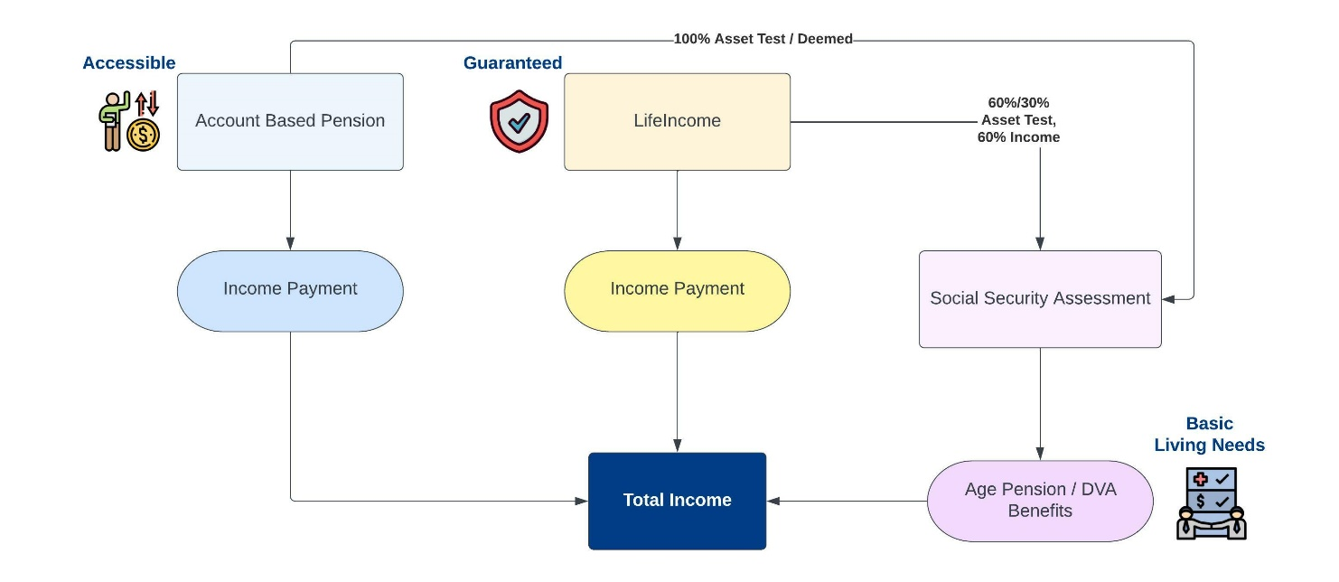
Blending an account-based pension and LifeIncome will mean the client will get the best of both retirement income streams:
- An account-based pension that can generate returns in line with their risk profile, a tax-free income stream, and access to capital when required.
- LifeIncome that performs in line with their risk profile, a guaranteed income stream, tax-free income, and concessional social security treatment.
Clients can have the freedom to spend as much as they want early in their retirement, with the comfort and security that they have LifeIncome and Centrelink/DVA benefits to rely on later in life, which will cover their reduced income needs.
Future-proofing a client’s situation by implementing LifeIncome now, means that you could put them in the best position to receive maximum social security benefits (combined with a guaranteed income for life) to assist with living and home-care expenses later in retirement.

Sources of income in retirement
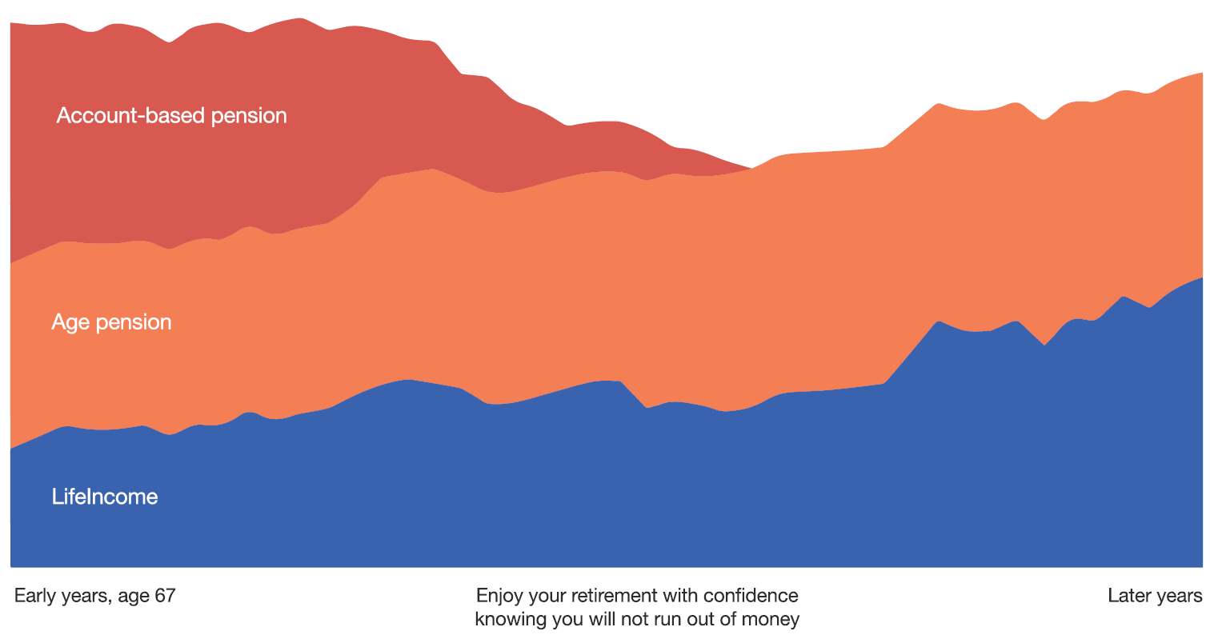

Defined benefit income streams
Defined benefit income streams are paid from a public sector or corporate defined benefit superannuation funds. Most of these schemes are closed to new members.
Like LifeIncome, defined benefits must be paid for the lifetime of the recipient, and most are capped, which means they have modified rules for the transfer balance cap, total superannuation balance and taxation. If a defined benefit pension has an untaxed element, those under age 60 would be subject to tax at their marginal tax rate on this portion, and those above age 60 would receive a 10% tax offset.
Most defined benefit income streams would not offer investment linked returns and are usually a fixed or indexed pension.
Be cautious blending a defined benefit scheme solely with LifeIncome, as the client could be left without access to capital. Also, we caution against cashing out a defined benefit scheme to invest into LifeIncome without doing careful analysis on the product, features and benefits lost. Most government-backed schemes are very generous.
Alternative approaches include:
- Providing LifeIncome to those clients who have inadvertently cashed out a defined benefit scheme and desire a similar guaranteed income stream.
- Using the lump-sum portion of a defined benefit scheme and investing in LifeIncome to provide a guaranteed income stream that is tax-free with more favourable and flexible investment options. Defined benefit pensions are usually asset-test exempt, so be aware that cashing in a defined benefit could result in a detrimental impact to the client’s social security benefits.
- Combining LifeIncome with an account-based pension and a defined benefit pension to give the client access to capital, a minimum lifetime pension, and a guaranteed pension that can grow with investment performance over time.
Transfer balance cap rules apply differently to capped defined benefit income streams, as generally any excess transfer balance is unable to be commuted from these income streams.
The Australian Taxation Office (ATO) will generally assign a ‘special value’ of the defined benefit for the credit to a client’s transfer balance account. As a guide, the special value will be the annualised income multiplied by the remaining term. In some cases, the income received from a defined benefit may be lower than that of LifeIncome, with the same amount being added to the transfer balance account. If a client has transfer balance cap concerns, we recommend you investigate options to see whether a LifeIncome product may provide a higher income, with less being assigned to the transfer balance account, possibly reducing tax. The Generation Life Adviser Services team can assist with any technical support regarding transfer balance caps.

Cash reserves
Maintaining liquidity in a comprehensive retirement strategy is necessary. There’s two ways to have cash on hand – within a cash account, and within investments clients hold – especially if investments are being drawn upon on a regular basis e.g. from an account-based pension.
A separate cash account can help a client feel secure if an emergency occurs or something unexpected happens. Cash inside an account-based pension will mean income can be drawn down without having to sell down growth assets in a down market.
LifeIncome does not require a cash reserve. Therefore, the entire portfolio can be invested to earn returns in line with the risk profile of the investor, or better. The better the unit price of the underlying funds, the higher the income for the client.
Market downturns are bound to happen though, and if the client needs to top up their LifeIncome payments when markets are low, cash reserves can help.

Funeral bonds
Funeral bonds and pre-paid funeral services allow a client to set aside money for funeral costs. It provides immediate benefits upon death to a nominated person and can’t be accessed earlier.
The funeral bond threshold is currently $13,500, and the amount is usually exempt from Centrelink’s asset and income tests.
A funeral bond, with a reversionary LifeIncome could provide the peace of mind a spouse may need following the death of the initial annuitant. They would be able to immediately fund any funeral costs and have the comfort of an immediate income while they are dealing with complex matters.

4.5 How to determine an appropriate investment into LifeIncome
There are two ways you can use the LifeIncome quoting tool:
- Using the income needs of the client in the first year to determine the lump sum investment required; or
- Using a specific lump sum invested into LifeIncome to determine the first year’s payment.
Using an income amount
This method will help you determine the amount a client should invest into LifeIncome to generate an income required to supplement other sources, such as an account-based pension.
This strategy is best for clients who have a clear idea of how much income they require over time, noting the income is variable.
When employing this strategy, points to consider are:
- How much capital is the client willing to set aside to achieve guaranteed income for life at a level they require?
- Is there enough additional liquidity to support their future additional expenses?
- How much can this income fluctuate before it impacts their expenditure?
- How is this impacting their Centrelink benefits, now and in the future?
- What are the expectations on how the income will grow based on the investment options chosen?
Ideally, when blending an account-based pension with LifeIncome, the account-based pension should act as a buffer to smooth out the income and lump sum expenditure needs of the client while the pension is available.
Remember the quote is only providing income estimates for the first year – this income will change year-on-year, so it is essential that you provide a buffer on the income amount to allow for any negative performing years. Furthermore, the chosen LifeBooster rate will impact the starting income and how the income will grow over time.

Using a lump sum amount
A lump sum approach is where you determine what investment total should be placed into LifeIncome. The resulting payment combined with other income sources form the retirement income received.
This approach may be appropriate for those clients who require a reduction in their assets to qualify for Centrelink/DVA benefits. The investment into LifeIncome may be determined by how much assets they need to reduce to qualify or improve their situation.
For every $50,000 of investment into LifeIncome, the client’s assessable assets will reduce by $20,000. This equates to an increase in Age Pension benefits of $60 per fortnight or $1,560 per year for every $50,000 invested, assuming they are subject to the assets test reduction. That’s a return of 3.12% per $50,000 when investing in LifeIncome to reduce assessable assets. Together with investment returns from a well-constructed LifeIncome portfolio, this becomes an effective strategy to improve the client’s situation.
The amount should also reflect how much retirement assets a client is prepared to set aside to receive a guaranteed income for life. For example, if a client has other income sources or is expecting a lump sum in the future (e.g. an inheritance) they may be more comfortable to allocate more of their funds towards LifeIncome, for a more favourable Centrelink result.
When employing this strategy, points to consider are:
- Does the client understand the trade-off of receiving additional Centrelink benefits when the money they invest in LifeIncome can’t be accessed as a lump sum?
- Have you conducted an analysis to see if the Centrelink benefits achieved are for the long-term? It would not be prudent to secure significant funds in LifeIncome for a Centrelink benefit of one or two years.
- Is there enough liquidity to support the client and dependant’s future requirements?

4.6 Balancing liquidity requirements with future income needs
The biggest trade off with having a guaranteed income, is that funds are inaccessible after six months, for the client’s life. They will only be able to access their investment within six-months of commencement of LifeIncome, or after they pass away (via their beneficiaries) if there is still a Death Benefit payable.
Prior to investing in LifeIncome, you should have a clear understanding of your client’s liquidity requirements, in particular:
- What planned expenses does the client have now and in the future?
- Can these planned expenses be funded with their annual income?
- Has the client conducted a detailed budget on their expenses now and in the future, taking into account any debt that might be repaid or additional expenses that need to be accounted for such as holidays?
- Do they require a higher income in the early years, and how much will they require?
- Will they be in receipt of any large sums of money which may impact Centrelink benefits and therefore cashflow projections?
- Do they anticipate they will need to move into aged care residence in the future?
- Do they have other income to meet excess spending needs?
- Acknowledging that income from LifeIncome is fixed during the year – do they have other variable income to meet total spending needs?
- How much liquidity can you set aside for the client in an account-based pension to assist with income payments?
- Consider allocating a portion of surplus income back into cash to top up cash reserves for future expenditure needs or cashflow smoothing.

An example of liquidity analysis:
Liquidity requirements | Amount | Details
Cash buffer for emergencies | $15,000 | For unexpected emergencies
Smooth out income in any year | $15,000 | Assume need $3,000 every 1 in 5 years for 25 yrs. (as per risk profile)
Short term expenses | $25,000 | Holiday to Europe 2023
Car changeover | $10,000 | Early 2024
Total | $65,000 | Bank Account

4.7 Social security considerations
LifeIncome is concessionally treated for Centrelink purposes, making it an ideal investment for those clients that need to legally reduce their assessable income or assets for means testing purposes.

Assets test
Lifetime income streams purchased after 1 July 2019 are entitled to a partial assets test exemption.
There are two dates which are critical in the assessment:
- The “assessment day” – the day income stream commenced; and
- The “threshold day” – age 85 or the fifth anniversary (whichever is later).
The assessable value is 60 per cent of the purchase value from assessment day up until threshold day, and then 30 per cent of the purchase value thereafter.
LifeIncome is therefore an effective way to reduce assessable assets while still generating competitive investment returns in a concessional taxed environment.
The graph below compares an account-based pension valued at $350,000, drawing the minimum pension earning 5.75% after fees, and a $350,000 investment into LifeIncome.
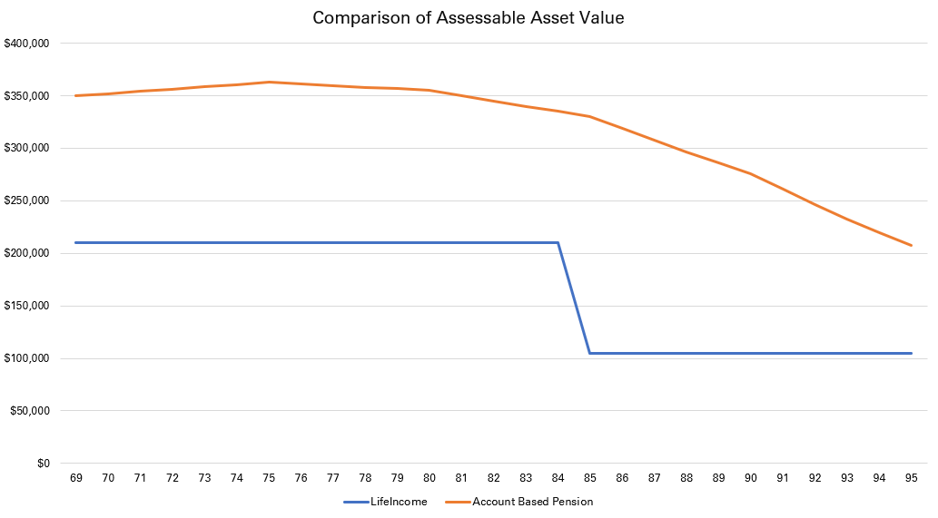
Illustration example based on a 69-year-old male.
The graph above demonstrates the long-term benefits of holding LifeIncome for those clients who have excess assessable assets. In this example, LifeIncome will, for most of the pensioner’s life, prove to be more effective for Centrelink assets test purposes than an account-based pension.

Income test
Lifetime income streams that commence after 1 July 2019 are also concessionally assessed for Centrelink’s income test. Only 60 per cent of LifeIncome payments will be assessable.
You should note that LifeIncome may not be as favourable for reducing assessable income as account-based pensions, as deeming rates in the current low interest rate environment are very favourable.
In this example, we are comparing a single, 67-year-old male who is investing $250,000. We have assumed a deeming rate of 0.25% for the first $53,600, and 2.25% for the balance.
Details | Account-based pension | LifeIncome (LifeBooster 2.5% rate)
Investment amount | $250,000 | $250,000
First Year’s Payment | $10,000 | $14,062
Assessable income | $4,553 | $8,437
The above table shows that the assessable income for the account-based pension is almost half of that of LifeIncome’s, making the account-based pension a more effective option to reduce assessable income in this situation.
Although LifeIncome provides some income test concessions, it is probably not enough to warrant restricting access to capital to achieve a reduction in income, when an account-based pension will achieve better results.
In the above example, the account-based pension is 100% assets test assessed which will reduce the Age Pension, yet the assessable income for LifeIncome is far greater, which will mean that LifeIncome is income test assessed, resulting in a higher reduction in Age Pension. In summary, the client would be receiving $1,150 a year less in Age Pension benefits if they were to invest in LifeIncome rather than an account-based pension.
However, when looking at the whole situation, the client is receiving $2,912 p.a. more in total income when investing 100% in LifeIncome than if they were to invest the total amount in an account-based pension. This is due to the power of LifeBooster, and the 40% reduction in assessable income. The LifeIncome position will become even stronger when the deemed income rates start to move closer to 3.50%.
Furthermore, the income received from LifeIncome is guaranteed (albeit variable), where the account-based pension income will eventually deplete the capital as the client nears life expectancy, depending on returns.
Details | Account-based pension | LifeIncome (LifeBooster 2.5% rate)
Investment amount | $250,000 | $250,000
Other financial assets | $10,000 | $10,000
Household contents | $20,000 | $20,000
Assessable assets | $280,000 | $180,000
Excess assets | $9,500 | $0
Pension payable assets test | $24,414 | $25,155
Assessable income^ | $4,778 | $8,462
Pension payable income test | $25,106 | $23,264
Pension payable incl. supplement | $24,414 | $23,264
Plus Inc Stream Income | $10,000 | $14,062
Total income received | $34,414 | $37,326
^Includes deemed income.
As you can see above, it is crucial to balance LifeIncome with an account-based pension (and other assets) to achieve an optimal mix of retirement assets to maximise Centrelink benefits and the need for a guaranteed income stream, and access to capital. You can experiment with different scenarios to find that optimal mix using the Generation Life Retirement Income Optimiser, available on our Adviser Online portal.

4.8 Estate planning considerations

Death Benefit options
When a client applies for LifeIncome, they have two options for how the benefits are treated when they pass away:
- Nominate beneficiaries or the estate to receive a lump sum payment, if the client dies within their Death Benefit Period; or
- Nominate a Reversionary Beneficiary to receive the income for as long as they live.
The main consideration is who the client wants to leave their benefit to. LifeIncome will only allow a spouse for a reversionary, so if other persons are required to be beneficiaries, these need to be nominated instead.
If more certainty of income across a couple’s life is required, and the client is sure that their spouse is their preferred beneficiary, then a Reversionary Beneficiary may be the most advantageous option to choose.

Death Benefit Period
A lump sum benefit is payable if the last life passes away within the Death Benefit Period. The Death Benefit Period is determined at commencement and calculated based on the initial annuitant’s age. If there is a Reversionary Beneficiary, the Death Benefit Period does not consider the Reversionary Beneficiary’s age. This means, if a Reversionary Beneficiary receives a benefit, and dies after the initial Death Benefit Period, then no Death Benefit is payable. If they pass away during the Death Benefit Period, the lump sum would be paid to their estate or nominated beneficiaries, as expected.
The Death Benefit amount is based on the unit price of the chosen investment options on the day that Generation Life receives evidence of death. The estimated annual Death Benefit amount can be retrieved from the client’s statement or from the Online Portal.

Reducing Death Benefit Tax
The tax payable on a lump sum Death Benefit depends on whether LifeIncome was started with super or non-super monies.
Any repayment of capital for non-super monies is considered tax-free, however any growth or excess may be taxable to the beneficiary and may need to be included as assessable income in their tax return.
Like most super Death Benefits, if a LifeIncome Death Benefit is paid to a tax dependant, then the benefit is tax-free. If paid to a non-dependant, then the taxable component may be subject to tax at the beneficiary’s marginal tax rate (including the Medicare levy) up to 17%.
- Cash out and recontribution strategy is useful to reduce the taxable component and increase the tax-free component of superannuation funds by withdrawing the taxable portion and making a non-concessional contribution back into super. If the client is under age 60, there may be some tax payable on the taxable component of the withdrawal, but if the client is over age 60 the withdrawal is tax-free making it even more effective. This should be done before rolling over funds into LifeIncome.
- Quarantining benefits is another strategy which involves contributing funds to a separate superannuation account and beginning LifeIncome with the 100% tax-free super account. Non-dependant beneficiaries can then be nominated in LifeIncome, and other superannuation funds with taxable components can be directed to tax dependants.

Who can be a Reversionary Beneficiary in LifeIncome?
LifeIncome will only allow a spouse to be a Reversionary Beneficiary, which may be more limited than other products, which may allow dependent children to be reversionary beneficiaries.
The definition of spouse for LifeIncome includes same-sex couples and interdependency relationships.
You cannot change a Reversionary Beneficiary after LifeIncome has commenced. You can remove a Reversionary Beneficiary, but this will not change the Income Units, therefore the client may be receiving a lower income than they could. Therefore, it is critical to make sure that the Reversionary Beneficiary selected will remain for the term of the client’s life, so a reversionary LifeIncome is effective and appropriate.

Benefits of a reversionary pension
- Estate protection: Certainty that the chosen beneficiary will receive the income, and it is likely that the person made the decision while they had the mental capacity to do so. The annuity does not form part of the deceased’s estate so therefore is rarely challenged as the Reversionary Beneficiary was fixed at the start of the annuity. Nominated beneficiaries are more complex and can be poorly executed which means they are more open to challenges.
- Simplicity: By using a Reversionary Beneficiary, the receiving pensioner can tend to other complex matters and grieve knowing that the income stream will be automatically paid to them.
- Retaining funds in a tax effective environment: If a Death Benefit is paid out as a lump sum, the beneficiary may be too old to recontribute to their own super or have other cap restrictions. With a reversionary pension, the funds will remain in the tax-concessional super environment.
- Centrelink benefits: The reversionary annuitant will retain the Centrelink treatment for means testing purposes. If a Death Benefit was paid out, this amount could be fully assessed, possibly impacting Centrelink benefits.

Drawbacks of a reversionary pension
- Spouse only: A Reversionary Beneficiary can only be a spouse. If the client wants to consider multiple beneficiaries, then setting up multiple LifeIncome accounts with a Reversionary Beneficiary to the spouse in one, and the other with a nomination to an adult child (for example), may be appropriate.
- Transfer balance caps: For superannuation annuities, the value of a reversionary LifeIncome will count towards the beneficiary’s transfer balance cap. See below for more information.
- Less flexibility: Under a reversionary arrangement, there is less flexibility for the estate to manage and distribute a person’s overall wealth equally among their beneficiaries, if this is what was stated in the Will. In addition, once the Reversionary Beneficiary is set, it cannot be changed, only removed.
- Lower Income: LifeIncome will calculate the income paid considering the Reversionary Beneficiary’s gender, age, and life expectancy. This means that the income received by the primary annuitant may be lower than they would receive if they did not have a Reversionary Annuitant selected.

Reversionary pensions and transfer balance caps
The value of a reversionary pension will count towards a reversionary beneficiary’s transfer balance cap – the limit which restricts how much money a person can have in tax-free superannuation pensions – based on the value of the pension at the date of death. This means, if the reversionary pensioner has already used a lot of their own transfer balance cap, then they may not be able to receive the reversionary pension without first withdrawing some of their own pension to an accumulation account or as a lump sum to their personal name.
This could mean more tax payable for the reversionary annuitant. As an adviser, you should conduct an analysis on both the client and spouse to see if this could be an issue in the future, and if so, consider whether a reversionary beneficiary is appropriate.
Note that with a reversionary pension, there is a 12-month delay before the receipt of a reversionary pension affects the receiving beneficiary’s own transfer balance account report. This gives the beneficiary more time to get their own affairs in order if they are near the transfer balance cap. During this 12-month period, the reversionary income stream will continue. For a pension that is not reversionary, the credit arises immediately once the Death Benefit is converted to a pension.
The transfer balance cap is not impacted with LifeIncome commenced with non-superannuation monies.

Speak with a legal professional first
There are many factors impacting the choice of whether to establish a Reversionary Beneficiary and once established it is hard to change. Therefore, it is prudent to speak with the client’s lawyer prior to setting up LifeIncome to determine which strategy is best, especially if broader tax planning and estate strategies should be considered.

4.9 Taxation considerations

Initial investment
Being a rollover into LifeIncome, there is no tax deducted from the investment if started with taxed superannuation funds. If there is an untaxed element, tax will be deducted at a maximum rate of 15% by Generation Life.
Non-superannuation monies are not taxed on investment.

Superannuation money - Regular income payments
If the client is age 60 and over, regular payments are treated like any other retirement income and are tax-free.
If the client is under age 60, tax may be withheld on the taxable amount, but the client may be entitled to a 15% tax offset.

Non-super money – Regular income payments
If the client starts LifeIncome with non-super money, part of the regular payments may be included in assessable income, reduced by a ‘deductible amount’. The deductible amount is considered the return of the initial investment and is set at commencement of LifeIncome.
The formula is:
$$Deductible amount=\frac{Initial investment}{Life expectancy}$$

For example, if the initial investment is $100,000 and the client is age 59 (male). The life expectancy based on the Australian Life Tables 2015-2017 is 24.87. The client’s annual deductible amount is therefore $4,020.91.
If a Reversionary Beneficiary is selected, the longer life expectancy of the client or the reversioner’s life expectancy is used for the calculation.

4.10 LifeIncome for those that can’t contribute to super
While superannuation provides favourable tax concessions, there are conditions and caps associated that can make using superannuation as an investment vehicle hard to use.
For instance, if a client is over 67 years of age, they may need to meet a work test to contribute to super. Contribution limits also restrict the amount that can be contributed to super and any excess contributions may be subject to additional tax.
If a client cannot contribute to super, LifeIncome can provide a similar tax-exempt retirement environment, like an account-based pension, but with non-super monies. This means that clients are not restricted by superannuation rules and can invest up to $5 million into LifeIncome to obtain similar benefits such as tax-free earnings and growth. Keep in mind, unlike income streams, non-super LifeIncome payments are taxable in the hands of the recipient, although a portion of the income payments are not taxed.

4.11 LifeIncome can reduce aged care means tested fees
LifeIncome is useful for those entering aged care as it provides a guaranteed income stream to assist with aged care costs and receives favourable means test treatment for Centrelink/DVA and aged care fee purposes. This treatment applies if it is purchased with super or non-super monies.
The means tested amount determines both the accommodation payments and ongoing care fees. The means tested amount is calculated by Centrelink/DVA by adding the resident’s income tested amount and assets tested amount. LifeIncome will reduce the assessable assets for this purpose.
Like Centrelink/DVA tests, 60 per cent of the purchase price is assessable until age 84 (or for a minimum of five years), then 30 per cent of the purchase price is assessable for the remainder of the client’s life. For income test purposes, 60 per cent of the annual payment is assessable.
Using LifeIncome could result in an increase of Age Pension benefits, as well as a reduction in the means tested aged care fee.

4.12 Make contributions into super before investing in LifeIncome
LifeIncome cannot accept super contributions prior to investment, therefore you will need to work with your client to implement a contribution strategy into to an accumulation fund prior to rolling over their super to LifeIncome.
LifeIncome can accept rollovers from different superannuation accounts to commence LifeIncome – these accounts will need to be specified on the online application form. Please note that the funds will be combined and therefore the tax components will be recalculated on commencement. If your client wishes to preserve the tax components in any of the super accounts for Death Benefit reasons, they may need to commence separate LifeIncome annuities.
- Managing the Portfolio
LifeIncome has a menu of 23 professionally managed fund options to choose from. This is unique to LifeIncome, and therefore LifeIncome is the most flexible product in the Australian marketplace in relation to investment choice for innovative income streams.
The greatest benefit for the client is that advisers will be able to create a portfolio that can align to the portfolios of other retirement assets, such as account-based pensions. As an adviser, you will have more flexibility to decide the risk level in the portfolio and can more accurately match the client’s risk profile.
More information on the different investment options can be found in the PDS.

5.1 Blended asset allocation approach
As both an account-based pension and LifeIncome are investment-linked, when considering the client’s whole portfolio you could take different asset allocation positions to construct an ideal portfolio mix that considers how funds are drawn down from each income stream.
For example, because the account-based pension is subject to regular withdrawals, you may decide to take a more conservative investment approach with a higher allocation to cash. As the Income Units in Life Income do not decrease and performance returns are likely to improve annual payments, you may take a more aggressive risk position to bring the total portfolio to a ‘balanced’ risk profile overall.

5.2 Switching
Your client can switch between investment options at any time, except for the period between midday on the third last business day of the Financial year and the end of the Financial year. Switches can be made provided that the minimum held in any investment option, determined at the time of the switch, is not less than 1% of the value of your client’s Income Units.
Unlike other guaranteed income products that restrict the amount of switches that can be made, there is no limit to the number of switches you can make. This means that you can be proactive with any changes that need to be made to manage your client’s portfolio effectively.
Please note that switches will not impact the current Financial year’s income. When a portfolio is switched the number of Income Units will change because each investment option will be different. At the start of each Financial year, the new annual income is determined by multiplying the number of the Income Units by the unit price of your client’s chosen investment option(s).
With your support, your client can complete switches using the ‘Switch form’ available on Adviser Online.
- Statement of Advice (SoA) text

6.1 Example goals and objectives
- You require a retirement income of $<Amount> per annum until at least your life-expectancy.
- You would like to maximise your retirement income over your lifetime.
- You would like to invest your available funds to allow you to spend as much as you can in retirement.
- You would like your income to keep pace with the increases in the cost of living and any future additional expenses such as medical or health expenses.
- You are concerned that you will outlive your retirement funds and would like to protect against this risk.
- You would like to receive an income for the rest of your life and do not want the worry of running out of money.
- We have discussed your retirement expenses and you have advised that you wish to make the most of your retirement in the first few years, and therefore intend to draw an income of $<X> p.a. in the first 5 years, and $<X> p.a. thereafter.
- You have an existing <account-based income> in place which provides you with income of $<X> per year. You would like to complement this income with an investment that can guarantee an income for the rest of your life to provide security in your retirement.
- You have investigated annuities and like the idea of a guaranteed income stream for the rest of your life. However, you are concerned that the low-interest rate environment would mean that you are locking away your funds at a low rate, missing out on potentially higher rates in the future.
- You are currently receiving a reduced Age Pension due to the <income/assets> test. You would like to see if you can improve your situation and increase your benefits to help fund your retirement while having access to growth assets.
- You are unable to contribute to super and therefore would like to invest your available funds of $<X> into an income stream investment to help fund your retirement in a tax-effective way.
- You would like to make sure your spouse is taken care of in the event of your death, and you would therefore like to ensure your assets can help fund their retirement until at least their life expectancy.
- You prefer uncomplicated investments that are easy to manage, have online access, and the ability to easily switch funds and generate reports such as statements and Centrelink Schedules as required.
- Although you would like a guaranteed income stream, you are concerned that your expenses and your cost of living will exceed these repayments. You therefore would like an investment that has a guaranteed income with the potential of increased income over the long-term.
- You want to invest into a range of investments across a range of asset classes and investment managers to align to your risk profile. You would like the ability to switch investments should the need arise.
- You would like a long-term advice relationship with a financial adviser to help manage your retirement income needs.
- As Power of Attorney of <Client Name>, you are concerned with the possibility of financial abuse and therefore would like to consider products that can mitigate the risk of unwanted persons accessing the client’s funds.
- You have mentioned that you would like to invest in a retirement product that will help protect your capital from the temptation of unnecessary withdrawals.

6.2 Example strategy recommendations

Commence a Generation Life LifeIncome investment with $<lump sum>
<Client Name>, you have advised that you require an income of $X p.a. in retirement to fund your living expenses and would like some certainty of income throughout retirement.
Our analysis shows that based on your current assets and income; your Age Pension benefits will be reduced by $X per fortnight due to the assets/income test. You have asked us to provide recommendations on ways to improve your position, if possible.
We therefore recommend that you commence a lifetime annuity income stream with Generation Life – Generation Life LifeIncome, with a lump sum of $X from your <superannuation fund/cash/investment>. LifeIncome is an investment-linked income stream that pays you for life.
To help boost your retirement income in the early years of your retirement, we recommend that you implement a LifeBooster <2.5/5.0>% rate. This will provide a first year’s payment of $X per <month/fortnight>.
[Reversionary] We recommend you nominate <Spouse> as a reversionary annuitant. This means that upon your passing, <Spouse> will continue to receive an income for the rest of their life.
We recommend that you invest into a portfolio of professional managed funds in line with your <Risk Profile> risk profile. More information on the recommended portfolio is detailed in the ‘Investment recommendation’ section of this SoA.

Generation Life LifeIncome (Superannuation)
Annuitant | <Client name>
Reversionary | Yes / No
Investment amount | $X
LifeIncome LifeBooster rate | 2.5% / 5.0%
Estimated Annual Income | $X
Regular Payment Amount | $X monthly/fortnightly
Income to be paid for the remainder of the Financial year | $X
Date of first payment | XX

Benefits
- You will receive an income stream guaranteed for your life, and then for the duration of <spouse/s> life after your death.
- Your LifeIncome payment of $X combined with your account-based pension/investment/Age Pension, will provide an income of $X in the first year, meeting your income needs.
- Your payments will be calculated each year based on the performance of your underlying assets. This means you will have the opportunity to increase your income payments if your underlying assets perform well.
- [Social security benefits ] Centrelink provides assets and income test concessions on your LifeIncome investment. This means only 60% of your investment value and income payments are counted. As a result, we estimate your Centrelink Age Pension payment will increase by $X per fortnight ($X p.a.). The assets test exemption increases to only 30% of the purchase price counting, [at age 84] [after five years from the date of commencement], making it even more advantageous in later years.
- [If combined with account-based pension] You can consider spending more than the minimum income provided by your account-based pension as you will have guaranteed income with LifeIncome.
- Generation Life guarantees to pay an income for life. Generation Life has reinsurance arrangements in place to enable it to provide this guarantee. The reinsurer is one of the world’s leading reinsurers, Hannover Life Re of Australasia Ltd (‘Hannover’) a subsidiary of Hannover Rueck SE, a part of the Hannover Re Group worldwide. Hannover Re Group has very strong insurer financial strength ratings which means they have a very strong capacity to meet financial commitments. You are not a party to the arrangements between Generation Life and Hannover.
- You will have a retirement income that generally keeps pace with increases in the cost of living and out of pocket medical expenses, depending on your investment choices.
- Any earnings on LifeIncome are tax-free while they remain in your account, regardless of your age. This is an advantage LifeIncome has over non-retirement phase superannuation accounts and investments outside superannuation. You also receive the benefits of any franking credits that may arise.
- LifeIncome income payments are tax-free in your hands if you are using your superannuation and are at least 60 years of age. In all other cases there are tax concessions on your regular payments.
- You will have access to 23 different investment options to which you can allocate your LifeIncome. You can combine any number of investment options within one LifeIncome. If Generation Life adds additional investment options to the menu, these options will be available to existing investors providing even more flexibility in investment choice in the future.
- You can switch your investments at any time during the year, except for a short blackout period before Financial Year end. Your Income Units will change depending on your new investment portfolio; however, your income will not be recalculated until the start of the next Financial year.
- LifeBooster is a rate used to calculate your starting income and enables you to receive more income in the early years of your investment. The effect of using LifeBooster is that your starting income is higher than what it otherwise would have been.
- If you change your mind within the first six months of the commencement of your LifeIncome, you can withdraw your investment.
- A lump sum Death Benefit is payable to your nominated beneficiaries or estate if you pass away during your Death Benefit Period. When you commence your LifeIncome, your Investment Confirmation Statement will show the Death Benefit Period and the amount payable on 30 June each year on your Annual Statement.

Risk and considerations
- LifeIncome will guarantee an income payment each year for the rest of your life, however this income may change from year to year and will be recalculated at the start of each Financial year based on your investments. You should ensure you have cash available to meet your income needs in the event your income payments reduce.
- LifeIncome is investment-linked, that means that your underlying investments will carry different levels of risk depending on the assets that make up your portfolio. Returns are not guaranteed, and past returns do not determine future performance. Please refer to the PDS for other specific risks of investing in LifeIncome.
- You select your LifeBooster rate when you commence LifeIncome. Your LifeBooster rate cannot be changed after commencement.
- After the 6-month cooling-off period expires you can no longer withdraw your investment from LifeIncome. If you withdraw your money in the first six months, you may receive less than you invested, this is because LifeIncome is investment-linked, and unit prices may fall after you invest. Refer to the PDS for information on how your withdrawal upon exercising your cooling-off rights will be calculated.
- If you, or your Reversionary Beneficiary pass away after the Death Benefit Period has expired, then no Death Benefit is payable.
- As your Income Payments are linked to the performance of your underlying investments, you may experience volatility in your annual payments. Based on your risk profile statistical return expectations, we expect that your annual income could drop up to X% in any year and you could experience a decrease in payments once every X years.
- You cannot choose to add or change a spouse as your Reversionary Beneficiary once your LifeIncome has commenced. You can choose to remove your spouse as a Reversionary Beneficiary at any time, but this will not change your Income Units.
- Nominating a Reversionary Beneficiary may affect your Annualised First Year Income as your spouse’s date of birth and gender is considered. As such, adding a spouse may reduce your Income Units.
- You cannot add more money into your LifeIncome after it has commenced. You can, however, commence a new LifeIncome.
- Buy/Sell spreads may apply.
- [Under age 60] As you are using superannuation to start LifeIncome and you are under age 60, the taxable component of your LifeIncome payment will be taxed at your marginal tax rate of X% with a tax offset of 15%.
- A Lifetime Income Protection Provision supports the LifeIncome lifetime income guarantee. This ensures the income is payable for life regardless of the mortality experience of the investors and the general Australian population. This Provision will mean a small discount of $3.50 per $1,000 of income received per year, or 0.35% p.a. for the next two years and will be reassessed in subsequent financial years. More information on this Provision can be found in the PDS. The Provision may be set to 0% if mortality assumptions were found to be set too conservatively after the first two years.
- [Non-Super] Your beneficiaries may be subject to income tax on any death benefits in excess of a tax-free amount.
- [Non-Super] As you are starting LifeIncome with non-super monies, some tax may be payable on income payments.
- [Super] The Death Benefit is generally tax-free if paid to a nominated beneficiary that is tax dependant such as your spouse or child under 18 years of age. If paid to a non-dependant, the taxable component may be taxable at the beneficiary’s marginal tax rate, if paid to the beneficiary’s super fund via a rollover to commence an income stream – no tax is payable at the time of rollover.
- The initial advice fee of $X will reduce the starting balance of your LifeIncome investment by the same amount.
- The ongoing advice fee of $X will reduce your income payments by the same amount.
- [If losing insurance from previous super] You will lose your insurance cover within <superfund> when rolling over to LifeIncome. You have advised that you do not require this cover.
- [If personal contribution made prior to rolling over] If you have made personal super contributions to your existing super fund and you intend to claim a tax deduction for any of those contributions, you must give your existing fund a “notice of intention to claim a tax deduction” and they must acknowledge receipt of the notice. This must occur before you roll your super over to LifeIncome or you will be unable to claim a tax deduction.
- Amounts held in the retirement phase of superannuation are counted towards your ‘transfer balance cap’. The transfer balance cap is currently $1.7 million. When your account is valued at more than the transfer balance cap, the excess will need to be rolled back into a super accumulation account or withdrawn from the super environment. Additional tax may also apply. This rule will also apply to your Reversionary Beneficiary upon your death on the account balance at that time.

Meeting your retirement living expenses of $X p.a.
You would like to ensure you have enough income to meet your living expenses of $X per annum or $X per month in retirement.
[Planned expenses] You would also like to set aside $X to fund your upcoming planned expenditure in the next X years.
We have assessed that you will be able to meet your income needs from the following sources in the first year:
Income source | Owner | Annual Amount ($)
Centrelink Age Pension | X | $X
Employment income | X | $X
Account-based pension income | X | $X
Generation Life LifeIncome | X | $X
Investment income | X | $X
Other income | X | $X
Total income |  | $X
Less income tax payable | X | ($X)
Less salary sacrifice | X | ($X)
Less living expenses | X | ($X)
Less debt repayments | X | ($X
Other expense | X | ($X)
Total expenses |  | ($X)
Net income received |  | $X
As income from your account-based pension and LifeIncome is variable, we will continue to review your income needs each year to ensure you continue to meet your income requirements.

To fund your planned expenses and provide cash reserves for emergencies and unplanned expenses, we recommend retaining the following cash accounts:
Account details | Owner | Amount ($)
Cash Account X | X | $X
Cash Account X | X | $X
Cash Account X | X | $X
Cash Account X | X | $X
Total cash reserves |  | $X
Less planned expenses |  | ($X)
Cash available for liquidity |  | $X

Benefits
- You require regular income to provide for your retirement living expenses of $X p.a. which can be readily met as shown above.
- [Account-based pension] Your account-based pension will provide a regular income stream that can be altered to meet any fluctuating income needs. You will also be able to drawdown on the capital if required.
- Your LifeIncome will provide a guaranteed income stream to give you the freedom to enjoy your retirement without worrying about running out of funds.
- LifeBooster will provide you with more income in the early years of your investment to support your desire to travel/<other goal>.
- Even though a portion of your funds will be inaccessible after six months in LifeIncome, you will maintain access to capital for any unforeseen contingencies in your cash accounts and account-based pension.
- You will minimise the reliance on selling down assets to cover your cost of living.

Risk and considerations
- Your LifeIncome payment is variable and depends on the value of your assets at the start of the Financial year. We will contact you at this time to plan the next 12-months and how your expenses will be met.
- Drawing down more than the minimum from your account-based pension funds may deplete your funds sooner than expected, however as you have a lifetime annuity with LifeIncome you will always be in receipt of an additional payment to help support your living expenses together with the Age Pension.
- You won’t be able to change your LifeIncome payment throughout the year. This is why it is important to have access to liquid assets to fund any expenses that are not accounted for.

6.3 Example recommendation table
<Remove underlying investments that are not required>
Investment | Amount  allocated | Amount allocated %
Generation Life LifeIncome
iShares Wholesale Australian Bond Index Fund | $X | X%
iShares Wholesale Australian Equity Index Fund | $X | X%
iShares Wholesale International Equity Index Fund | $X | X%
iShares Hedged International Equity Index Fund | $X | X%
iShares Wholesale Australian Listed Property Index Fund | $X | X%
Dimensional World 30/70 Portfolio | $X | X%
Dimensional World 50/50 Portfolio | $X | X%
Dimensional World 70/30 Portfolio | $X | X%
Schroder Real Return Fund | $X | X%
Vanguard Conservative Portfolio | $X | X%
Vanguard Balanced Portfolio | $X | X%
Vanguard Growth Portfolio | $X | X%
Vanguard High Growth Portfolio | $X | X%
Ardea Real Outcome Fund | $X | X%
PIMCO Wholesale Global Bond Fund | $X | X%
AB Managed Volatility Equities Fund | $X | X%
Bennelong Concentrated Australian Equities Fund | $X | X%
Dimensional World Equity Portfolio | $X | X%
Hyperion Global Growth Companies Fund | $X | X%
Magellan Infrastructure Fund | $X | X%
Dimensional Global Bond Sustainability Trust | $X | X%
Pendal Sustainable Balanced Fund | $X | X%
Stewart Investors Worldwide Sustainability Fund | $X | X%
Total | $X | 100%
This portfolio will determine your Income Units. You can switch your investment options throughout the year; however your income will only be calculated at the start of the next Financial year based on the investments you hold at that time.
Your Income Units will be confirmed on the commencement of your LifeIncome.

6.4 Example recommended product text

PDS Link: Adviser resources | Generation Life (genlife.com.au)
Dated: 22 March 2022



Generation Life - LifeIncome
Generation Life is regulated life insurance company and is a wholly owned subsidiary of Generation Development Group Limited (ASX: GDG).
Generation Life LifeIncome is an innovative lifetime annuity that provides five key benefits to enhance your retirement:
- Guarantees income for life.
- Income is investment-linked and provides the flexibility to switch between a range of investments options at any time throughout the year.
- Is concessionally treated for social security.
- Has a long six-month cooling-off period.
- Allows for a Reversionary Beneficiary option to automatically pass LifeIncome to a spouse with the same benefits.
Generation Life gives you access to your account via their Investor Online portal with the latest information on your investments and how they are tracking. You can also view your annual income amount, Income Units, your nominated beneficiaries, and other investment information.
You will also be able to access online resources via genlife.com.au to change your details and update your nominated beneficiaries.
Generation Life LifeIncome pays regular income payments fortnightly or monthly, providing regular income to help you manage your budget and expenses, easily.

Why is this product appropriate for you?
[Link product benefits to specific client goals, examples below]
- <Client>, Generation Life LifeIncome will achieve your goal of providing regular, guaranteed income for the rest of your (and your spouse’s) life.
- Unlike other similar products in the market, LifeIncome allows you to select a blended portfolio that aligns closely to your risk profile, whilst giving you the flexibility to change these options at any time.
- Generation Life LifeIncome offers 23 different investment options, professionally managed, to choose from, where others offer 1 – 5 options. This means your money is being managed by experienced and qualified professionals who specialise in the selection of investments to meet the investment objectives. Having flexibility in investment choice and the ability to keep pace with (or perform better than) inflation is important to you.
- This product will provide you with regular income, as well as increase your social security benefits, therefore improving your retirement income position.

Product benefits
- Income guaranteed for life: Generation Life provides a guarantee that you will receive an income each year. Other providers who provide similar market-linked annuities and are not life insurance companies cannot guarantee an income.
- LifeBooster: LifeIncome offers LifeBooster which ‘boosts’ your income at the start of your investment so you can enjoy your retirement in the early years instead of having possibly unnecessary higher income in later years which is the case with traditional life annuities. LifeBooster is unique in that it offers two levels – a 2.5% or 5% rate from which you can choose, where other products offer only one or none.
- Simplicity: Easy online access, and less paperwork to review. LifeIncome is easy to administer and get up to date information to assist you in managing your retirement situation.
- Cost-effectiveness: Transparent fee structure that is competitive against other similar products in the marketplace. While investment fees may vary, you have flexibility in the products you select to create a portfolio that aligns to your needs.
- Switching: Switch investments at in your portfolio at any time (except for a short blackout period before Financial year end) so you can manage your portfolio when your circumstances change or there are prevailing market conditions that demand your attention. With other similar products, if investment choice is offered at all, you can only switch at the anniversary or once per year, and only allow switching from one option to another option.
- Tax benefits: Earnings and growth within LifeIncome are tax exempt. You will also benefit from franking credits to help improve the overall investment returns.

Risks and considerations
- Product costs: There are costs involved in investing, including administration and management fees. There may also be transactional costs such as buy/sell spreads, and performance fees on some investment options. Please refer to the ‘Product Costs’ section of this SoA for more details.
- Returns are not guaranteed: The value of your Income Units can increase and decrease, and returns are not guaranteed.
- Operational and counterparty risks: Like other products, there is a risk that Generation Life doesn’t properly manage its operations or meet its contractual commitments to you. To help mitigate this risk, Generation Life is supervised by APRA and is required to provide regular reporting to meet APRA’s prudential standards. Please note that while it is APRA regulated, this does not provide a financial guarantee.
- Regulatory risk: The Government may change laws and policies in relation to tax and social security, which may impact the appropriateness of LifeIncome for you.

6.5 Underlying investments – product descriptions and asset allocation
For specific text on the underlying investments within LifeIncome please refer to the PDS which has each underlying investments sector, objective, investment timeframe and investment approach, as well as the asset allocation guidelines.
When entering these products in software (such as Xplan WealthSolver) the underlying investment options will have their own Generation Life LifeIncome APIR codes. We have attached a table in Appendix 1 with a list of LifeIncome funds and their APIR codes. We have also included the Underlying fund APIR codes that you can reference to assist with your asset allocation tables, as the LifeIncome funds may not be available in financial planning software initially. Please note, that you will need to use the LifeIncome product fees in your product cost tables, do not rely on the fees for the underlying funds in financial planning software.
To create the asset allocation graph to compare against the client’s risk profile, you will need to use the SAA of the underlying funds. We recommend you use the purchase price to create the portfolio.

6.6 Replacement of Product
LifeIncome is currently not available in most financial planning product research software, so you will need to include LifeIncome as a ‘custom product’ until the product is available.
We have provided an example of how you may compare products for your Replacement of Product Section. We have assumed the client is investing $50,000 into LifeIncome, with a 100% investment into Vanguard Balanced Fund. The annual income in the first year is $3,000.
The important thing to remember is that the fees are calculated on the Annual Income and impacts the income the client receives via the net unit price (e.g. unit price after fees).

Client name | Generation Life LifeIncome
Client name | $3,000 p.a.
Ongoing costs | % | $
Management and admin fees | 0.75% | $22.50
Investment management fees & costs | 0.29% | $8.70
Transactional and operational costs | 0.22% | $6.60
Total | 1.26% | $37.80

Notes:
- The Management and Administration fee is calculated daily and based on the net asset value of each investment option and is reflected in the unit price, which then impacts the Annual Income Units. It is not a transaction debited from your account.
- Investment Management fees and costs are deducted by the underlying investment manager or by Generation Life and incorporated into the unit price.
- The fees and costs impact the annual income that you receive. Your first year’s income has no fees and costs. In the next Financial year, the fees and costs are included in your Annual Income amount.
- Transaction fees can vary depending on the transactions that have occurred. The above figure represents the lower range limit of transaction fees. Please refer to the PDS for details on the range of transaction fees applicable for each underlying fund.
- When you invest, switch or withdraw your investment in an investment option, Generation Life uses the buy/sell spread to pay for the transaction costs incurred as a result of the transaction. Generation Life uses the buy/sell spread to allocate transaction costs to the transacting investor rather than other investors in the investment option. Refer to the PDS for details on the range of buy/sell costs that may apply.

Sample features and benefits table
Product overview | Generation Life LifeIncome
Product APIR | ALL4731AU
USI | LifeBooster 2.5%  68092843902025  LifeBooster 5.0%  68092843902050
Plan subtype | Lifetime Income Stream
Open for new business | Yes
General description | Generation Life Limited is a regulated life insurance company. Generation Life LifeIncome is a lifetime annuity offered through the Generation Life Benefit Funds and offers an investment-linked, income stream guaranteed for life.
Commencement Year | 2022
Number of members (approx) | N/A
Funds Under Management | N/A
ABN | 68 092 843 902
Contact information | Postal Address  GPO Box 263  Collins Street West  Melbourne VIC 8007  Telephone  Investor services 1800 806 362  Adviser services 1800 333 657  Email  enquiry@genlife.com.au  genlife.com.au
Last PDS update on | 22 March 2022
Investments update on | Daily unit pricing
Payment facilities – money in
B-Pay | Yes – for non-superannuation
Superannuation contributions | No
Superannuation rollovers via SuperStream | Yes
POST Billpay | No
Cheque | No
Direct Debit | No
Direct Credit / EFT | No
Payment facilities – money out
Direct Credit / EFT | Yes
Cheque | No
Investment Rules
Minimum initial investment | $10,000
Minimum ongoing investment | N/A
Minimum one-off withdrawal | N/A
Minimum regular withdrawal | N/A
Minimum annual income amount | N/A
Minimum account balance | N/A
Investment minimums
Investment option minimum | 1% of Income Units  Must be held in an investment option at all times
Switch minimum | 0.00%
Estate planning
Binding Nomination - Lapsing | No
Binding Nomination - Non-Lapsing | Yes
Binding Nomination - Non-Binding | No
Reversionary Pension | Yes
Anti-detriment payments | No
Associated costs | No
Ongoing reporting and transactions
Annual Report | Yes
Half Yearly Statement | No
Online Income Units | Yes
Update details online | Yes
Switch investments online | Yes
Adviser Authorised to Transact | Yes
Education and advice
Regular newsletter | No
Seminars | No
Website tools & education | No
In-house related financial planners available | No
External financial planning allowable | Yes
Advice at no cost | No
Ancillary services
Home loans | No
Personal loans | No
Credit cards | No
General insurance | No
Health Insurance | No
Acceptance of UK Pension Transfers | No
Discounts available | No
Other complimentary services | No
Pensions
Fortnightly Payment | Yes
Monthly Payment | Yes
Quarterly Payment | No
Yearly Payment | No
Reversionary Nominations | Yes
Capital Gains Transfer | No
Online Pension Calculator | Yes (Adviser only)
Transition To Retirement | No
Drawdown ProRata | Yes
Drawdown Proportional | Yes
Drawdown Priority | No
Minimum Initial Investment | $10,000.00
Product costs
Ongoing costs
Administration Fees | 0.75%
Expense Recovery Fee | $0.00
Membership Fee | $0.00
SMA Administration Access Fee | $0.00
Trustee Fees | 0.00%
Transactional Costs
Operational costs | 0.17% - 0.60%
Buy/Sell spreads | Yes
Exit Fees | $0.00
External Brokerage Fee | 0.00%
Initial Contribution Fee | 0.00%
Less Initial Contribution Commission Rebate | 0.00%
Listed Securities Fees | $0.00
Managed Funds Fee | $0.00
Portfolio Construction Fee | $0.00
Supplementary Brokerage fee | $0.00
Withdrawal Fees | $0.00
Commission Details
Contribution Commission | 0.00%
Initial Commission | 0.00%
Insurance Commission | 0.00%
Trail Commission | 0.00%
Switching Fees
Number Of Free Switches | Unlimited
Switching Fees | Nil
Fee Aggregation | No
Investment Details
Number of Investment Options (excl Direct Shares/Listed Investments) | 23
Index Options | 5
Diversified Options | 8
Sector Options | 7
Multi-manager Options | 0
No of Avail Direct Shares/Listed Investments | 0
Ethical Investments | 3
SMA Investments | 0
Re-directions of Contributions | No
Investment Reserving | No
Automatic Re-Balancing | No
Direct Shares/Listed Investments | No
Unit Pricing Frequency | Daily
Default option | No
Important investment details notes | Investment Switching will recalculate the Income Units used for annual payments.
Cash Holding Details | No
Ability to Transfer Existing Assets (in-specie) | No

6.7 Example of Alternative products considered
Below are examples of why LifeIncome may be more appropriate for your client. The reasons why LifeIncome has been selected over other products need to align to the client’s needs and objectives, so please add, delete, and edit accordingly.
When preparing our recommendations we considered the following alternative options:

Challenger’s Market-Linked Lifetime Annuity
We considered using a Challenger Lifetime Annuity to provide the guaranteed income you require, however we discounted this because:
- Challenger only offers five investment options which are composite indices, and you can only hold one investment option at one time.
- Challenger does not offer a LifeBooster option.
- Challenger only pays monthly, and you have indicated that you prefer fortnightly payments.
- You can only switch underlying investments at the product’s anniversary date, limiting control of your investment selection.

QSuper’s Lifetime Pension
We considered using QSuper’s Lifetime Pension to provide the guaranteed income you require, however we discounted this because:
- As QSuper is a super product, you can only start the pension when you have reached preservation age, whereas you can start LifeIncome from age 50 with non-super monies.
- QSuper only offers one investment option – QSuper’s Balanced option for Income accounts. This means we are unable to select a portfolio that aligns to your risk profile.
- QSuper offer an equivalent of LifeBooster at a rate of 5%, however LifeIncome offers you the choice of a LifeBooster 2.5% rate or a LifeBooster 5% rate providing greater flexibility.
- Adviser fees cannot be paid from this account; therefore you will be paying for advice fees from other sources which is not viable for you.
- QSuper only pays income fortnightly, and you have indicated you wish to receive monthly payments.
- [Non-super] QSuper only accepts superannuation monies, and you wish to invest non-super monies into LifeIncome.
- QSuper cannot guarantee income for life because they are not a life insurance company.

6.8 Example of Alternative strategies considered
- We considered investing 100% of your funds into an account-based pension however this meant that all of your pension balance is assessed for Centrelink’s assets test, as well as the entire amount being deemed for income purposes. This would have meant a reduction in your Age Pension entitlements of $X per annum.
- We considered investing into a fixed term annuity; however this would not provide the same Centrelink concessions and you would not be provided an income for life.
- We considered investing outside of superannuation and drawing down amounts to fund your retirement. We discounted this strategy as this is not a tax-effective way to invest your funds as all earnings and growth would be taxable, and you would not benefit from the Centrelink concessions that LifeIncome provides.
- We considered investing 100% into an account-based pension but this would not guarantee you an income for life. Depending upon drawdown rates and investment returns an account-based pension can run out of money, leaving you entirely dependent on the Age Pension.

6.9 Modelling LifeIncome for projections
Generation Life can be modelled like lifetime annuities. The only difference is the indexation figure.
Instead of an indexation figure of CPI or AWOTE used for traditional lifetime annuities, you need to use the rate of return less fees discounted by the chosen LifeBooster rate (2.5% or 5%).
Guidance on how to enter this figure in Xtools+ is shown below.
Scenario:

Georges (Male) - LifeIncome
DOB 4/11/1955
Investment Amount $250,000
LifeBooster 2.5%
Annual Income: $14,062
Assumed rate of return: 7%
Fees: 1.22%
Advice Fees: $0
Indexation Figure: : ((1+(7%-1.22%))÷(1+2.5%))-1)=3.2%
Xplan – Xtools+ Input
- To enter Generation Life LifeIncome, treat it as a lifetime annuity. You can enter it under “Pensions” in Xtools+, as an existing or new annuity which can be rolled over from super or non-super assets in the future.
- Remember to select ‘Lifetime’ and the correct purchase date and investment amount.
- If Reversionary – enter 100% as the Reversionary amount.
- You can enter a tax-free amount, however this will only be relevant for Death Benefit calculations for a superannuation LifeIncome.
- The Annual Income Amount is the First Year’s income, and the Annual Indexation is:
  - Annual Indexation = (1+ Expected return – (estimated fees, expenses and costs))/(1LifeBooster rate) – 1.
  - You can get these figures from the quote generated from the Generation Life quoting tool on page 9, otherwise use licensee assumptions for after-fee returns less the LifeBooster rate.
- Entry fees is the adviser fee – if required.
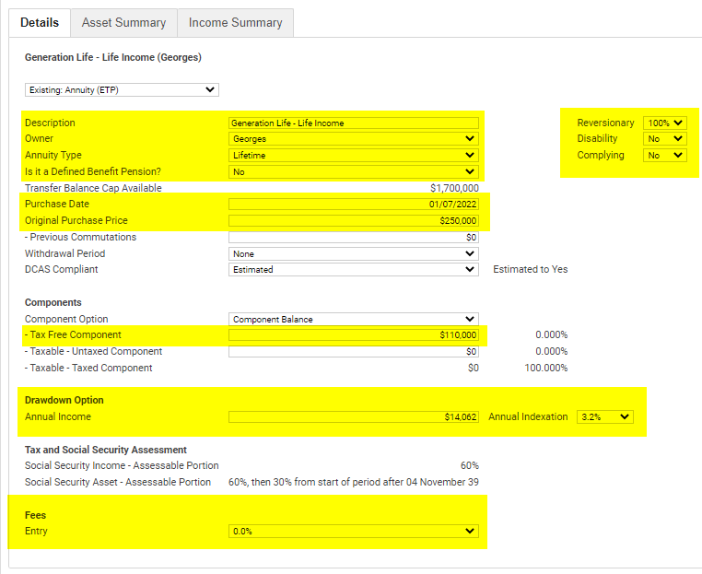
- Once you have entered the main details, click over to the ‘Asset Summary’ tab and check the Social Security Assessable Asset value is correct.
- It should reflect a value of 60% until the client’s 85th year, then 30% thereafter.
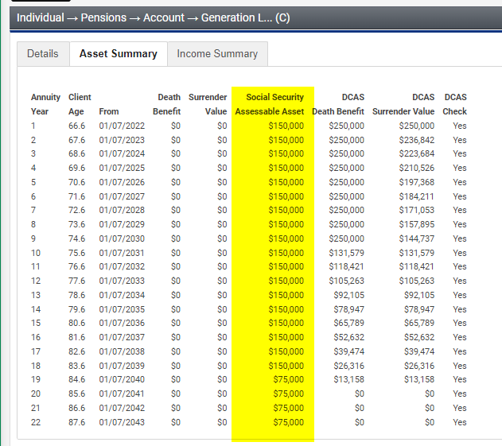
- Finally, click over to the ‘Income Summary’ tab, there you can compare the payments with the generated quote. It should be fairly close noting that Xplan will only allow an annual indexation of 1 decimal place.
- Confirm the Social Security Exempt Income reflects 40% of the payment amount.
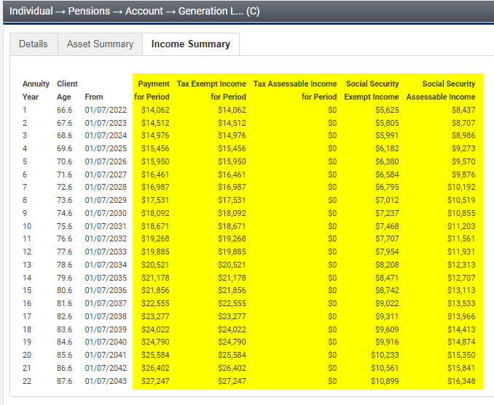

If the LifeIncome indexation rate is negative
You may have the situation where the indexation of LifeIncome is negative, and this is usually because of the higher LifeBooster 5% rate, and lower return expectation.
For example, if Gross return expectations are 6% p.a., LifeIncome fees and costs are 1.22% p.a., and a LifeBooster 5% rate is used, the indexation on LifeBooster is -0.21% p.a.
To enter this in Xplan Xtools+, you need to use a custom indexation figure for AWOTE. Please ensure that AWOTE is not being used for any other indexation purposes when applying this workaround.

Go to Input > Options > Economic tab
Adjust AWOTE to the LifeIncome indexation figure required.
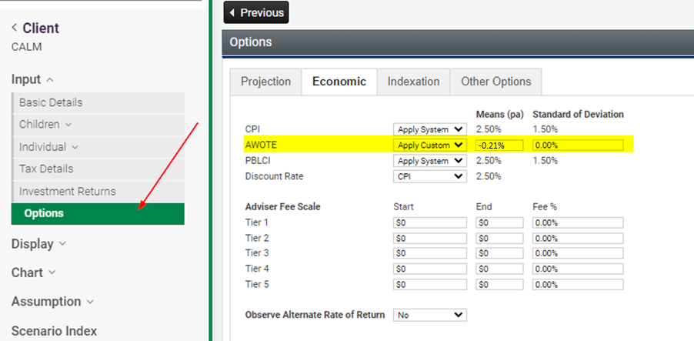
Make sure salary is not being indexed by AWOTE, go to ‘Indexation’ Tab
And say ‘no’ to Link Salary to AWOTE and enter your preferred indexation amount in “Salary Indexation”.
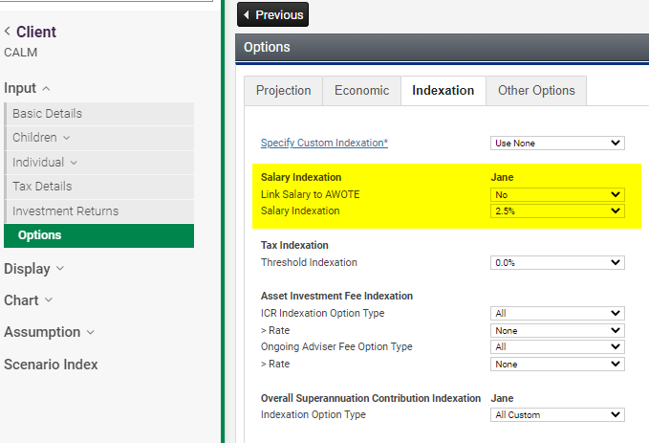

Finally, when applying the indexation rate for your LifeIncome annuity, select AWOTE.
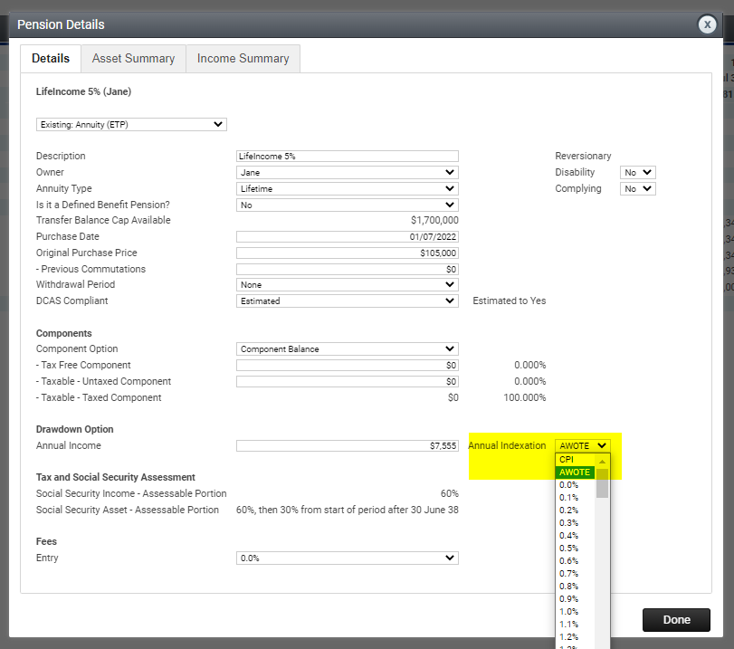

6.10 Disclosure of Fees
Ensure it is clear in your Disclosure of Fees, that the initial advice fee is deducted from the initial investment, and the Annualised First Year Income is therefore calculated on the net figure.
Any ongoing advice fee is deducted from the regular payments to the client, and the client receives a net payment figure. For example, if the client’s annual income is $5,000 p.a., and the adviser fee is 1.0%, the client will receive $4,950 p.a., and the adviser $50 p.a., assuming no tax applies.
Where required by law, a copy of the client’s annual consent must be provided to Generation Life to continue to receive ongoing fees, otherwise they must be discontinued. You can find the Annual Fee Consent Form on Generation Life’s Adviser Online portal.

SOA wording
Upfront advice fees payable
Fee | Deducted from | Total cost to you | Adviser |  | Licensee
 |  | $ | $ | % | $ | %
Initial SOA Fee | Generation Life initial investment | $1,000 | $800 | 80% | $20 | 20%
Grand total |  | $1,000 | $800 |  | $20

Ongoing advice fees payable
Fee | Deducted from | Total cost to you | Adviser |  | Licensee
 |  | $ | $ | % | $ | %
Annual Advice Fee | LifeIncome Annual Payment | $50 | $40 | 80% | $10 | 20%
Grand total |  | $50 | $40 |  | $10

- Ongoing reviews and LifeIncome
LifeIncome is an investment that should be managed and supported by a financial adviser initially and ongoing.
We believe LifeIncome will help offer a viable reason to reconnect with your client, year-on-year to provide a valuable retirement review service.
Your ongoing review with your client invested in LifeIncome can go beyond a portfolio management service and status update; to a more valuable reconnection point to review their retirement needs more holistically. Each year, LifeIncome requires an annual income reset – presenting you with a viable opportunity to re-engage with your client each year. The LifeIncome review can tie in with an account-based pension review which will have a new minimum pension calculated each Financial year, therefore you can review the client’s whole cash flow situation at one time.
We believe presenting the client with a structured, detailed annual review of their retirement position will strengthen your ongoing advice proposition.

7.1 Suggested agenda items for a LifeIncome annual retirement review
- Where are they now? – Has anything changed significantly in the client’s life?
- Income needs – How will the retirement expenses be met the next Financial year with their current retirement income sources?
- LifeIncome review – How has their LifeIncome performed? What is their next year’s income payment and what is their current Death Benefit amount?
- Reversionary pensioner / beneficiaries – are they still current?
- Portfolio review – does the LifeIncome portfolio need adjusting? Do any other retirement assets need adjusting?
- Centrelink re-assessment – is the client still maximising their benefits?
- Long term projection – how is the client tracking for the remainder of their retirement?
- Liquidity needs – does the client have sufficient funds to meet their liquidity / cash reserves?
- Administration – What paperwork does the client require for personal administration or notifying Centrelink of any updates?
- Wellbeing check-in - How are they finding their retirement? Are they enjoying the freedom in their retirement?

7.2 Reviewing your existing client base
LifeIncome is not just for new retirees. We believe LifeIncome is ideal for clients that perhaps could not access Centrelink benefits previously but did not want to invest their funds in an inaccessible, inflexible, low-performing annuity.
Clients who are invested only in account-based pensions could consider adding LifeIncome to their retirement asset mix to help access or increase their social security benefits. Keep in mind that LifeIncome can be invested up to age 86, and older clients will benefit from higher payments as well as better Centrelink concessions.
Consider the value-add you could bring to your clients when you can present them with more income and social security benefits at the next review – simply by introducing the concept of LifeIncome to their retirement mix.
Generation Life’s Retirement Income Optimiser, found on the Adviser Online Portal, can help you access the benefits of allocating a portion of your clients’ account-based pension to LifeIncome.

7.3 Suggested Record of Advice text
We have supplied some suggested text below for a Record of Advice at review, provided your client meets the requirements to deliver further advice, as mandated by your licensee.

Snapshot of your current situation
<Client Names>, it was good to meet with you on <date of meeting> to review how you are tracking in your retirement. During our meeting we confirmed the following about your situation:
- There have been no significant changes to your situation since our previous advice to you dated <SOA Date>.
- You have cash reserves of $X which you can access when required.
- You <have/have not> been meeting your living expenses and advised you have a surplus/deficit of $X per month/year that you need to address/direct towards your cash reserves.
- You have planned expenses of $X coming up in the next Financial year, which you will be funding from existing cash reserves.
- You are still receiving the Centrelink Age Pension and the Seniors Health Care Card, your circumstances haven’t change in a way which would significantly affect your assessment.
- We discussed your beneficiaries, and they are still current.
- <other discussion points>

Scope of Advice
This record of advice is based on your objectives, financial situation and needs and our advice detailed in the Statement of Advice dated <date>. This advice is further to this document.
We will therefore be addressing the following areas in this RoA:
- Reviewing the underlying investment of your LifeIncome.
- Reviewing the underlying investments of your <account-based pension>
- Reviewing your income needs for the next Financial year to make sure you can meet your annual expenses. This will include a Centrelink benefit analysis.
If your circumstances have changed, this advice may not be relevant, and you should let us know as soon as possible.

We recommend you switch your underlying investments
We have reviewed your underlying portfolio and recommend that you make the following changes in your LifeIncome account:
Investment | Current allocation | Recommended change | Final  allocation
Generation Life LifeIncome
iShares Wholesale Australian Bond Index Fund | X% | +/- X% | X%
iShares Wholesale Australian Equity Index Fund | X% | +/- X% | X%
iShares Wholesale International Equity Index Fund | X% | +/- X% | X%
iShares Hedged International Equity Index Fund | X% | +/- X% | X%
iShares Wholesale Australian Listed Property Index Fund | X% | +/- X% | X%
Dimensional World 30/70 Portfolio | X% | +/- X% | X%
Dimensional World 50/50 Portfolio | X% | +/- X% | X%
Dimensional World 70/30 Portfolio | X% | +/- X% | X%
Schroder Real Return Fund | X% | +/- X% | X%
Vanguard Conservative Portfolio | X% | +/- X% | X%
Vanguard Balanced Portfolio | X% | +/- X% | X%
Vanguard Growth Portfolio | X% | +/- X% | X%
Vanguard High Growth Portfolio | X% | +/- X% | X%
Ardea Real Outcome Fund | X% | +/- X% | X%
PIMCO Wholesale Global Bond Fund | X% | +/- X% | X%
AB Managed Volatility Equities Fund | X% | +/- X% | X%
Bennelong Concentrated Australian Equities Fund | X% | +/- X% | X%
Dimensional World Equity Portfolio | X% | +/- X% | X%
Hyperion Global Growth Companies Fund | X% | +/- X% | X%
Magellan Infrastructure Fund | X% | +/- X% | X%
Dimensional Global Bond Sustainability Trust | X% | +/- X% | X%
Pendal Sustainable Balanced Fund | X% | +/- X% | X%
Stewart Investors Worldwide Sustainability Fund | X% | +/- X% | X%
Total | 100% | 0% | 100%

Benefits
- The new portfolio is more closely aligned to your risk profile of a <X> investor.
- You will not incur any capital gains when making this switch.
- <Reasons>

Things to consider
- Your Income Units will be recalculated based on your new portfolio. This will impact your Annual Income payment next financial year.
- Your Annual Income payment will remain the same, even though you have switched products. Your new payment won’t be calculated until next Financial year.
- By switching products, your investment fees will increase/decrease by X%/$X each year.
- There will be transaction costs of $X/X% when switching products.
- <Other>

Your retirement income for the next Financial year
[Surplus] We have reviewed your retirement income sources and can confirm you should be able to meet your income needs.
[Deficit] We have reviewed your retirement income sources and can confirm you will need to drawdown on your cash reserves to meet your income needs for this year.
Your LifeIncome Annual Income for the next Financial year will be $X, based on your current Income Units. As you have elected monthly/fortnightly payments, you will be paid $X a month/fortnight, starting July.
We have reassessed your Centrelink entitlements based on your current situation, and your Age Pension/DVA benefit will be $X per fortnight. This is a slight increase/decrease of $X due to the current value of your assets/income you receive.
Your retirement income needs will be met as follows:
Income source | Owner | Annual amount ($)
Centrelink Age Pension /DVA | X | $X
Employment income | X | $X
Account-based pension income | X | $X
Generation Life LifeIncome | X | $X
Investment income | X | $X
Other income | X | $X
Total income |  | $X
Less income tax payable | X | ($X)
Less living expenses | X | ($X)
Less debt repayments | X | ($X
Other expenses | X | ($X)
Total expenses |  | ($X)
Net income received – surplus/deficit |  | $X
[Deficit] We recommend any deficit in income be met from cash reserves we set aside to supplement any shortfall of income in years where your income may fluctuate.
[Surplus] Any surplus income should be directed to your cash reserves as an additional buffer.
We will continue to review your income needs each year to ensure you continue to meet your income requirements.
[Centrelink Schedule] We have attached your LifeIncome Centrelink Schedule which you will need to provide to Centrelink with your updated information. You need to do this within 14 days.

- Tools, calculators and resources
Generation Life has the following tools and resources to assist you with providing advice on LifeIncome.

8.1 Adviser Online portal
The Adviser Online portal is your main resource hub for Generation Life at genlife.com.au.
You’ll be able to:
- Apply for LifeIncome
- Prepare quotes
- Access the Retirement Income Optimiser calculator
- Access a form to switch investment options
- Access a form to view and update the client’s LifeIncome account details
- Download statements
Advisers and support staff will need to be registered to access the Adviser Online portal. You can register at genlife.com.au.

8.2 Quoting tool
The Quoting tool can be used to generate a quote for your client. This tool will let you determine the income received based on the amount invested, or the amount invested required to generate a required income payment. You can also investigate the difference in starting income, changes in annual income, and cumulative income of the different LifeBooster rates.
The tool can also demonstrate the impacts of volatility on income, using historical returns. You have the ability to select the funds to match the client’s recommended portfolio, for a highly relevant illustration. Please note that historical returns should not be an indicator for future returns and we do not recommend you use this in lieu of standard supporting projections in your SoA.
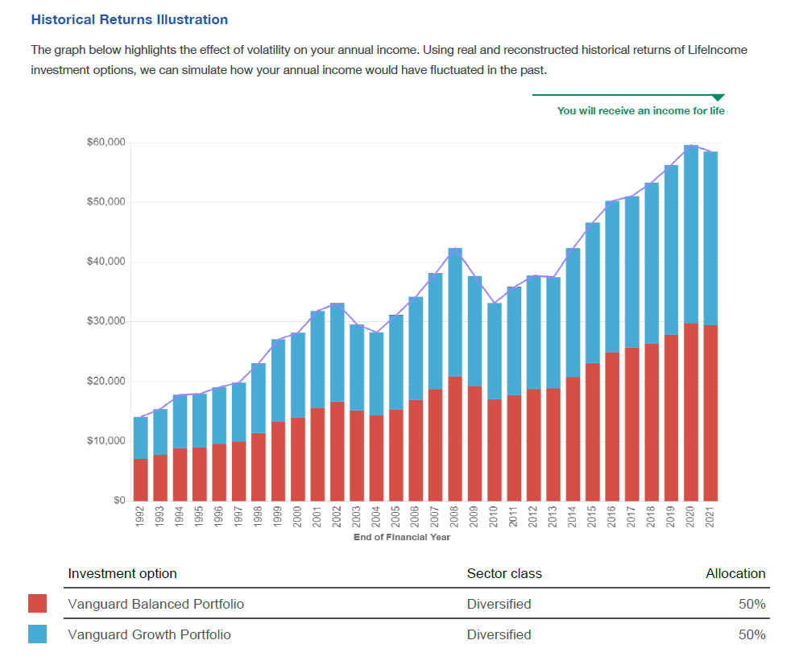
You can access the quoting tool on the Adviser Online portal.

8.3 Retirement Income Optimiser
The Retirement Income Optimiser (RIO) can be used to show the benefits of LifeIncome on a blended retirement strategy with an account-based pension and Centrelink. It will help your client make informed decisions on their retirement.
The RIO can demonstrate:
- How your client’s retirement assets could be allocated between LifeIncome and an account-based pension.
- How your client’s retirement income can be sourced from a combination of LifeIncome, an account-based pension and the Age Pension.
- How LifeIncome can improve a client’s Age pension position.
- The annual income mix year-by-year for the rest of a client’s life.
- The impact of different rates of returns on the retirement strategy.
- How different LifeBooster options impact the retirement strategy.
- The effect of advice fees on a portfolio.
- Death Benefit scenarios.
Graphs and long-term projections within the RIO can be used to insert into your SoA. We suggest using screen capture software to do this.
The RIO will produce a detailed report that can be provided to your client. However we suggest you confirm with your licensee whether this is allowed prior to presenting an SoA.
Please note that the RIO will not consider the allocation of any non-super assets to a non-super LifeIncome. Please contact Generation Life’s Technical Team to assist you with these situations.

8.4 LifeIncome – The power of LifeBooster
Access our brochure on The Power of LifeBooster

Case Study 1: Lifestyle

Overview
Jane, age 68, a single homeowner who has recently retired and now can’t wait to start ticking activities off her bucket list.
Jane would like to spend as much as she can while she is healthy and able to enjoy it, maximise her Age Pension entitlements and have a secure income for life.

Client situation

- $350,000 in super
- $50,000 in bank account; $10,000 car/contents
- $105,000 in LifeBooster 5%, $245,000 in account-based pension (APB), minimum drawdown.
- Gross investment return is 6%
- Account-based pension fees and costs 0.5% p.a.
- LifeIncome fees and costs 1.22% p.a.
- Centrelink rates as at September 2021

Outcomes
- Income for life that remains at a level that will allow her to live comfortably.
- Retains access to capital within the account-based pension and cash account.
- Receives a higher starting income so she can enjoy retirement while she’s younger.
- Improved Centrelink benefits throughout her life.
- Investment returned as income, from LifeIncome and Age Pension uplift, by year 10.

Comparison with and without LifeIncome
Breakdown | Without  LifeIncome | With  LifeIncome | Difference
ABP drawdown (minimum) | $17,500 | $12,250 | ($5,250)
Age Pension | $14,274 | $17,550 | $3,276 uplift
LifeBooster 5% rate | - | $7,555 | $7,555
Year 1 income | $31,774 | $37,355 | $5,581
Average annual income to age 100 | $57,085 | $58,979 | $1,894 p.a.
Cumulative income to age 100 | $1,883,814 | $1,946,292 | $62,478

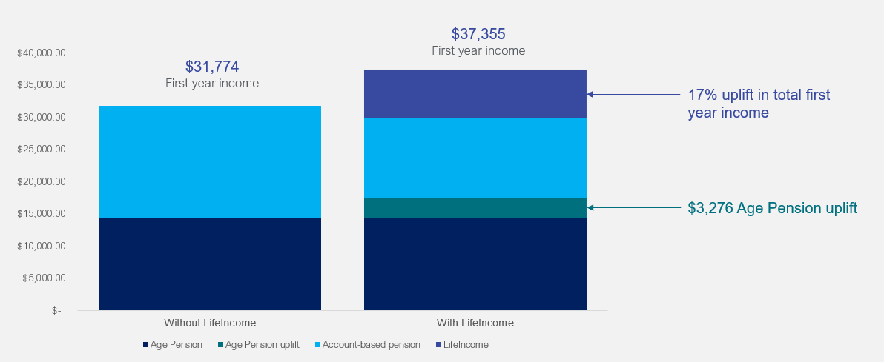

Long term projections – Xtools+

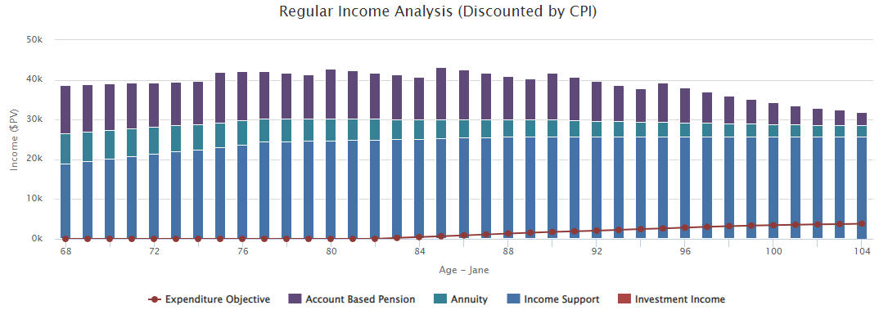

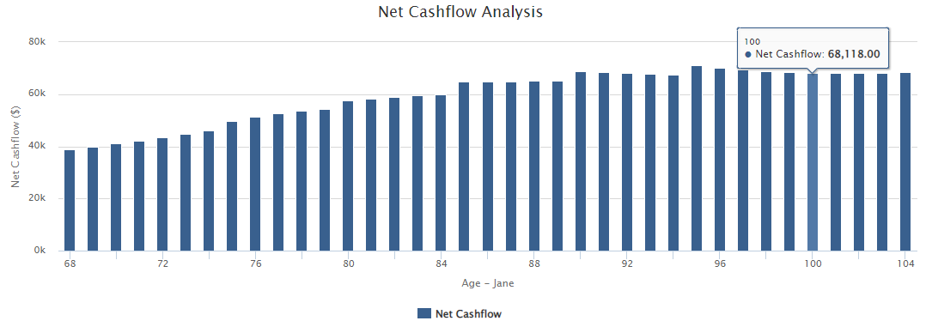

Case Study 2: Confidence

Overview
Jenny, age 70 and Mark, age 72, homeowners.
Jenny and Mark are married, healthy, self-funded retirees, who enjoyed investing throughout their working lives but are now worried to spend as they don’t know how long their assets need to last.
They would like access to the Age Pension and confidence in their retirement spending / cashflow and receive a guaranteed income for life.

Client situation

- Jenny has $210,000 in an account-based pension, Mark has $315,000 in an account-based pension.
- $100,000 in a savings account; $50,000 car/contents
- Jenny $90,000 in LifeIncome with LifeBooster 2.5% rate (Reversionary)
- Mark $135,000 in LifeIncome with LifeBooster 2.5% rate (Reversionary)
- Gross investment return is 5%
- Account-based pension fees and costs 0.5% p.a.
- LifeIncome fees and costs 1.22% p.a.
- Centrelink rates as at September 2021

Outcomes
- Access to Age Pension to improve retirement outcomes
- Guaranteed income for spouse when the annuitant dies
- Higher income initially with LifeIncome, with income growing over their lifetimes as the account-based pension is depleted.
- Investment returned as income by year 11.

Comparison with and without LifeIncome
Breakdown | Without  LifeIncome | With  LifeIncome | Difference
ABP drawdown (minimum) | $37,500 | $26,250 | ($11,250)
Age Pension | - | $6,334 | Access to Age Pension
LifeBooster 2.5% rate | - | $12,557
Year 1 income | $37,500 | $45,161 | $7,661
Average annual income to age 100 | $82,002 | $88,488 | $6,486 p.a.
Cumulative income to age 100** | $2,542,051 | $2,743,142 | $201,091

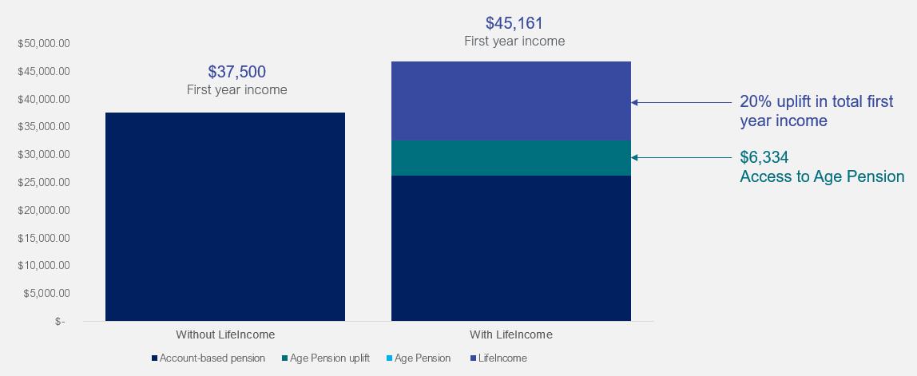

Long term projections – Xtools+
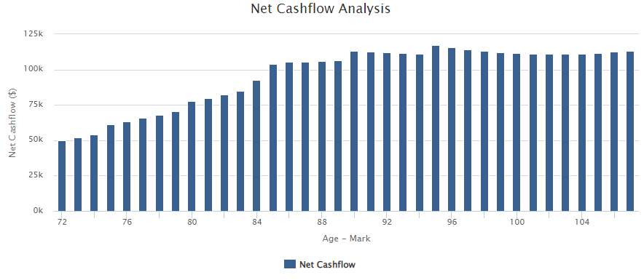
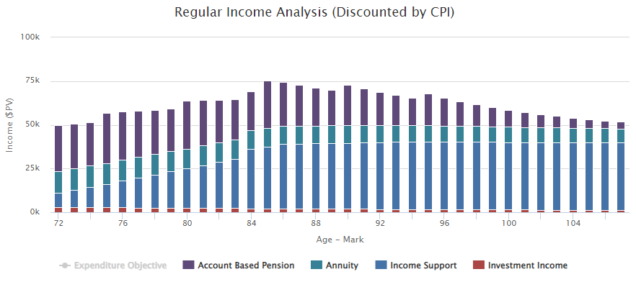

Case Study 3: A Choice to make

Overview
Mary, age 72, single homeowner
Mary has recently received an inheritance to invest and is concerned her Age Pension will be impacted. She would like to minimise the impact of her inheritance on her Age Pension entitlement whilst maximising cash flow. Mary would also like the confidence to enjoy her windfall and have secure income for life.

Client situation

- Mary has $253,000 in savings earning 0.5% p.a.
- Invests the inheritance of $100,000 into a non-super LifeIncome
- LifeBooster 5% rate
- Car/Contents $20,000
- No other income or assets.
- Gross investment return is 7%
- LifeIncome fees and costs 1.22% p.a.
- Centrelink rates as at September 2021

Outcomes
- Mary receives a higher Age Pension benefit as LifeIncome provides a greater assets test reduction than a managed fund investment.
- Mary has an uplift in income received vs a managed fund investment, with confidence that income will not run out.

Comparison with managed funds vs LifeIncome
Breakdown | Managed fund | LifeIncome | Difference
Income test | $24,054 p.a. | $22,827 p.a.
Assets test | $17,160 p.a. | $20,280 p.a.  ($60,000 assessable  immediate 40% reduction  $30,000 From 84th birthday) | Age Pension assessed under the assets test as this produces lower social security entitlement
Age Pension entitlement | $17,160 p.a. | $20,280 p.a. | $3,120 (uplift)

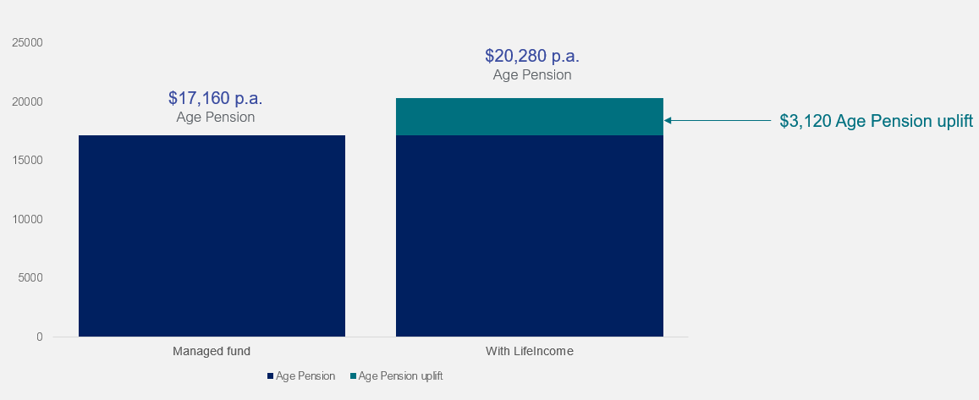

Long term projections – Xtools+
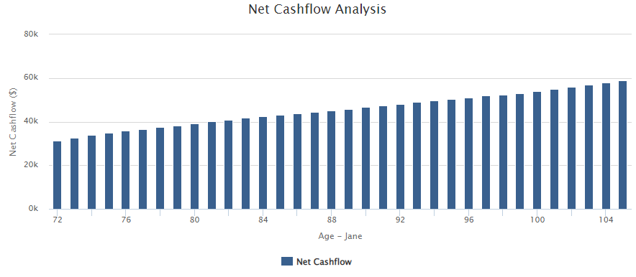
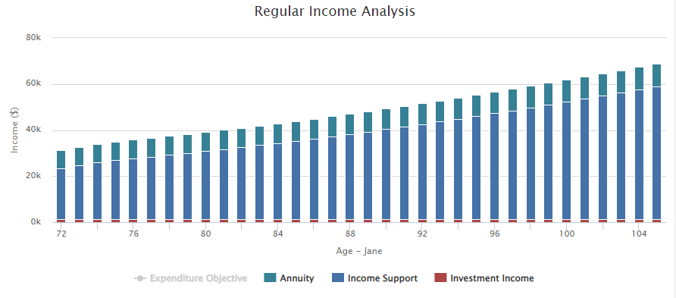

Appendix 1: APIR Codes for Underlying Investments

LifeBooster 5% rate
Fund name | LifeIncome APIR Code | Fee | Underlying APIR Code
AB Managed Volatility Equities Fund | ALL5824AU | 0.55% | ACM0006AU
Ardea Real Outcome Fund | ALL8588AU | 0.50% | HOW0098AU
Bennelong Concentrated Australian Equities Fund | ALL9486AU | 0.89% | BFL0002AU
Dimensional Global Bond Sustainability Trust | ALL4902AU | 0.35% | DFA0642AU
Dimensional World 30/70 Portfolio | ALL4289AU | 0.37% | DFA8313AU
Dimensional World 50/50 Portfolio | ALL5526AU | 0.397% | DFA0033AU
Dimensional World 70/30 Portfolio | ALL1307AU | 0.408% | DFA0029AU
Dimensional World Equity Portfolio | ALL5769AU | 0.42% | DFA0035AU
Hyperion Global Growth Companies Fund | ALL0912AU | 0.70% | WHT8435AU
iShares Hedged International Equity Index Fund | ALL6057AU | 0.10% | BGL0044AU
iShares Wholesale Australian Bond Index Fund | ALL0147AU | 0.10% | BGL0010AU
iShares Wholesale Australian Equity Index Fund | ALL0113AU | 0.10% | BGL0005AU
iShares Wholesale Australian Listed Property Index Fund | ALL4988AU | 0.10% | BGL0052AU
iShares Wholesale International Equity Index Fund | ALL1933AU | 0.10% | BGL0104AU
Magellan Infrastructure Fund | ALL5327AU | 1.05% | MGE0002AU
Pendal Sustainable Balanced Fund | ALL6289AU | 0.80% | BTA0122AU
PIMCO Wholesale Global Bond Fund | ALL0133AU | 0.53% | ETL0018AU
Schroder Real Return Fund | ALL5032AU | 0.60% | SCH0039AU
Stewart Investors Worldwide Sustainability Fund | ALL8246AU | 0.615% | FSF1675AU
Vanguard Balanced Portfolio | ALL8627AU | 0.27% | VAN0108AU
Vanguard Conservative Portfolio | ALL9456AU | 0.27% | VAN0109AU
Vanguard Growth Portfolio | ALL2116AU | 0.27% | VAN0110AU
Vanguard High Growth Portfolio | ALL0071AU | 0.27% | VAN0111AU

LifeBooster 2.5% rate
Fund name | LifeIncome APIR Code | Fee | Underlying APIR Code
AB Managed Volatility Equities Fund | ALL9708AU | 0.55% | ACM0006AU
Ardea Real Outcome Fund | ALL1579AU | 0.50% | HOW0098AU
Bennelong Concentrated Australian Equities Fund | ALL9771AU | 0.89% | BFL0002AU
Dimensional Global Bond Sustainability Trust | ALL9304AU | 0.35% | DFA0642AU
Dimensional World 30/70 Portfolio | ALL6739AU | 0.37% | DFA8313AU
Dimensional World 50/50 Portfolio | ALL9581AU | 0.397% | DFA0033AU
Dimensional World 70/30 Portfolio | ALL2824AU | 0.408% | DFA0029AU
Dimensional World Equity Portfolio | ALL3179AU | 0.42% | DFA0035AU
Hyperion Global Growth Companies Fund | ALL9871AU | 0.70% | WHT8435AU
iShares Hedged International Equity Index Fund | ALL2573AU | 0.10% | BGL0044AU
iShares Wholesale Australian Bond Index Fund | ALL6691AU | 0.10% | BGL0010AU
iShares Wholesale Australian Equity Index Fund | ALL8217AU | 0.10% | BGL0005AU
iShares Wholesale Australian Listed Property Index Fund | ALL4106AU | 0.10% | BGL0052AU
iShares Wholesale International Equity Index Fund | ALL8540AU | 0.10% | BGL0104AU
Magellan Infrastructure Fund | ALL9787AU | 1.05% | MGE0002AU
Pendal Sustainable Balanced Fund | ALL3425AU | 0.80% | BTA0122AU
PIMCO Wholesale Global Bond Fund | ALL1278AU | 0.53% | ETL0018AU
Schroder Real Return Fund | ALL3314AU | 0.60% | SCH0039AU
Stewart Investors Worldwide Sustainability Fund | ALL6153AU | 0.615% | FSF1675AU
Vanguard Balanced Portfolio | ALL2054AU | 0.27% | VAN0108AU
Vanguard Conservative Portfolio | ALL2635AU | 0.27% | VAN0109AU
Vanguard Growth Portfolio | ALL2599AU | 0.27% | VAN0110AU
Vanguard High Growth Portfolio | ALL2382AU | 0.27% | VAN0111AU

References
Gebler, J. (2018, April 23). Analysis: Retirees' spending falls faster than expected into old age. Retrieved from Milliman: https://au.milliman.com/en/insight/analysis-retirees-spending-falls-faster-than-expected-into-old-age
Grattan Institute. (2019, May 9). Using the right survey to measure retiree spending. Retrieved from Grattan Institute: https://grattan.edu.au/wp-content/uploads/2018/11/912-Money-in-retirement.pdf
Hegna, T. (2020, November 6). Focus on Retirement Happiness to Make the Annuity Case.

(Gebler, 2018)
(Grattan Institute, 2019)
Social Security rules were amended for income streams purchased after 1 July, 2019, allowing concessional treatment under the Social Services and Other Legislation Amendment (Supporting Retirement Incomes) Bill Bills Digest No. 80, 2018–19
(Hegna, 2020)
Centrelink rates as at 1 January 2022
Centrelink rates as at 1 January 2022
Increasing to age 74 from 1 July 2022

